Change Request
for the update of ISO 20022 financial repository items

- Origin of the request:
A.1 Submitter: nexo A.I.S.B.L.
A.2 Contact persons: Philippe CECE (Philippe.cece@ingenico.com) / Andrew Hamilton (Andrew.hamilton@ncr.com) / Frédéric Meignien (frederic.meignien@sfr.fr)
A.3 Sponsors: nexo A.I.S.B.L.

- Related messages:

Domain | Message Name/Message Version | Msg ID (Schema)
ATM Card Transactions | ATMCompletionAcknowledgementV02 | catp.009.001.02
ATM Card Transactions | ATMCompletionAdviceV02 | catp.008.001.02
ATM Card Transactions | ATMDepositCompletionAcknowledgementV01 | catp.015.001.01
ATM Card Transactions | ATMDepositCompletionAdviceV01 | catp.014.001.01
ATM Card Transactions | ATMDepositRequestV01 | catp.012.001.01
ATM Card Transactions | ATMDepositResponseV01 | catp.013.001.01
ATM Card Transactions | ATMInquiryRequestV02 | catp.006.001.02
ATM Card Transactions | ATMInquiryResponseV02 | catp.007.001.02
ATM Card Transactions | ATMPINManagementRequestV02 | catp.010.001.02
ATM Card Transactions | ATMPINManagementResponseV02 | catp.011.001.02
ATM Card Transactions | ATMRejectV02 | catp.005.001.02
ATM Card Transactions | ATMTransferRequestV01 | catp.016.001.01
ATM Card Transactions | ATMTransferResponseV01 | catp.017.001.01
ATM Card Transactions | ATMWithdrawalCompletionAcknowledgementV02 | catp.004.001.02
ATM Card Transactions | ATMWithdrawalCompletionAdviceV02 | catp.003.001.02
ATM Card Transactions | ATMWithdrawalRequestV02 | catp.001.001.02
ATM Card Transactions | ATMWithdrawalResponseV02 | catp.002.001.02
ATM Management | ATMDeviceControlV03 | caam.002.001.03
ATM Management | ATMDeviceReportV03 | caam.001.001.03
ATM Management | ATMDiagnosticRequestV02 | caam.005.001.02
ATM Management | ATMDiagnosticResponseV02 | caam.006.001.02
ATM Management | ATMKeyDownloadRequestV03 | caam.003.001.03
ATM Management | ATMKeyDownloadResponseV03 | caam.004.001.03
ATM Management | ATMReconciliationAcknowledgementV02 | caam.010.001.02
ATM Management | ATMReconciliationAdviceV02 | caam.009.001.02
ATM Management | HostToATMRequest | caam.007.001.01
ATM Management | HostToATMAcknowledgement | caam.008.001.01

- Description of the change request:

A new major update of the ATM protocol is created.
It is assigned version number "4.0"
It is built on the ground experiences accumulated through operating versions 1 to 3.
It brings improvements related to:
- business features,
- management features
- security features
- data rationalization.
- Purpose of the change:
Version 4, called internally "Harmonized version", aims at two main goals:
- Adaptation to user requirements
- Efficiency of the protocol regarding
  - Readability
    - Eliminate synonyms (n names for the same meaning) and homonyms (same name but n meanings)
    - Reduce the number of levels in message to facilitate understanding
  - Maintainability
As a result of this strong focus on data management, most elements have been updated, leading to a global change of all the messages.
The expected result is to obtain a protocol where:
- A component reflects a business object, conforming to a data modeling vision of the business.
  - The XML Type embodies the Object
  - The XML element’s name, wherever possible, is a copy of the XML Type name
- The number of components is reduced
- Naming rules improve clarity
An important point is that most of the current components have been modified in the new version.
- Urgency of the request:
Not urgent.
- Business examples:
- Example of data rationalization in the Security Area
Goals:
- Obtain a view of the cryptographic key such that it conforms to the business objective
- Have one and only one XML Type for the cryptographic key
- Define usage rules applicable to the object in the MUG and not via a variability of the 2 XML types which are used in the current version:
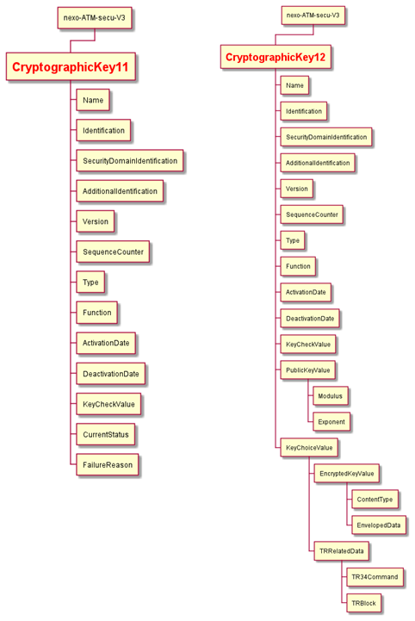

In the new version, Cryptographic Key is represented by only one object, whose XML Type is named "KEY":
- Each branch is designed to be a "sub-object" of the main one
  - KeyDetails
  - KeyStatus
  - EncryptedKeyValue
  - KeyCertificate
  - PublicKeyValue
  - TR34Token
- This first level should be sufficient to understand the object.
Such principles have been applied to all the components.

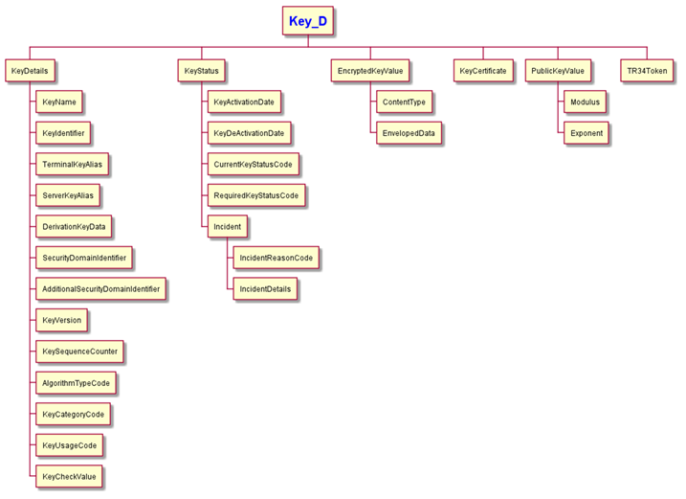

- SEG/TSG recommendation:
This section is not to be taken care of by the submitter of the change request. It will be completed in due time by the SEG(s) in charge of the related ISO 20022 messages or the TSG for changes related to the BAH.

Consider |  | X | Timing
 |  |  | - Next yearly cycle: 2021/2022  (the change will be considered for implementation in the yearly maintenance cycle which starts in 2021 and completes with the publication of new message versions in the spring of 2022) |  | X
- At the occasion of the next maintenance of the messages
(the change will be considered for implementation, but does not justify maintenance of the messages in its own right – will be pending until more critical change requests are received for the messages)
- Urgent unscheduled
(the change justifies an urgent implementation outside of the normal yearly cycle)
 |  |  | - Other timing:
Comments:

Reject
Reason for rejection:

