Change Request
for the update of ISO 20022 financial repository items
- Origin of the request:
A.1 Submitter: SWIFT
A.2 Contact person: Jacques Littré
A.3 Sponsors:
- Related messages:
seev.035 , seev.036
- Description of the change request:
- In the seev.035 (CorporateActionMovementPreliminaryAdvice), move the element “IntermediateSecuritiesDistributionType” from the “CorporateActionMovementDetails” sequence to the “CorporateActionDetails” sequence.
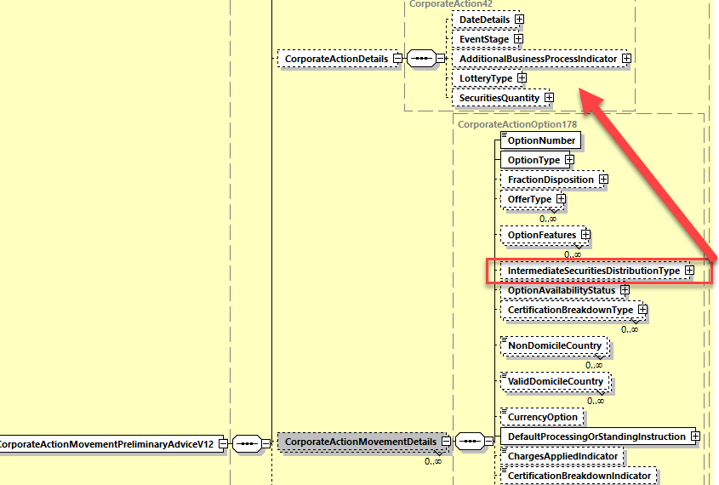
- In the seev.036 (CorporateActionMovementConfirmation), move the element “IntermediateSecuritiesDistributionType” from the “CorporateActionGeneralInformation” sequence to the “CorporateActionDetails” sequence and add a new rule “IntermediateSecuritiesDistribution1Rule“ related to the “IntermediateSecuritiesDistributionType “ element and which is equivalent to the MT566 NVR C5 rule which is missing today in the seev.036
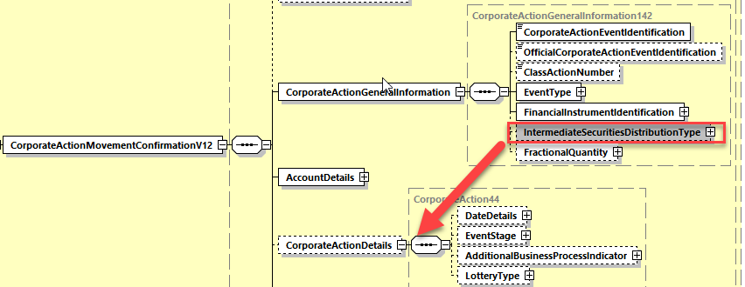

- In the seev.036 (CorporateActionMovementConfirmation), change the data type “IntermediateSecuritiesDistributionTypeFormat16Choice“ of the element “CorporateActionGeneralInformation/IntermediateSecuritiesDistributionType” by the data type “IntermediateSecuritiesDistributionTypeFormat15Choice” so as to add the missing “MRGR” event code to the data type.
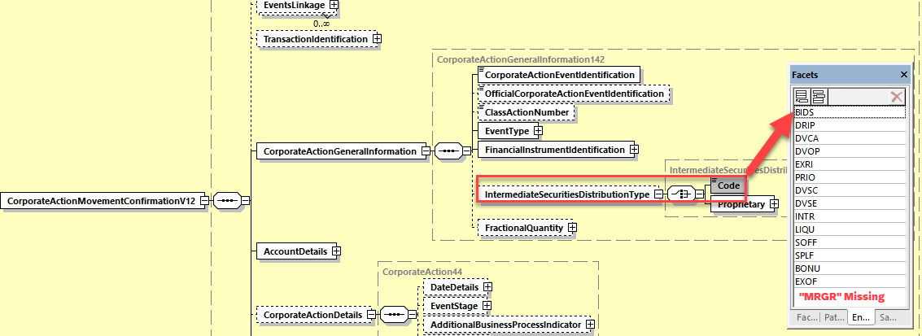

- Purpose of the change:
- In the seev.031 (corporateActionNotification) message, the “IntermediateSecuritiesDistributionType” element is positioned in the “CorporateActionDetails” sequence similarly to the ISO 15022 MT564 message. Originally, the seev.035 message did not include a “CorporateActionDetails” sequence, therefore, the element was located instead into the “CorporateActionMovementDetails” sequence.
Since a few years ago, a “CorporateActionDetails” sequence was added to the seev.035 message, it would then be better now to move this element at the right place so as to keep the message fully aligned with the MT564 message for coexistence reasons.
The main problems of leaving the “IntermediateSecuritiesDistributionType” element in the “CorporateActionMovementDetails” sequence is that:
- the sequence is repeatable while the “CorporateActionDetails” sequence is not and therefore having a repetition of the “IntermediateSecuritiesDistributionType”in the seev.035 movement sequence is a bit awkward.
- The rule equivalent to the NVR C11 in the MT564 (“IntermediateSecuritiesDistributionRule”) cannot be implemented correctly in the seev.035 message and is therefore not validating the message correctly.
- In the seev.036 (corporateActionMovementConfirmation) message, the “IntermediateSecuritiesDistributionType” element is positioned in the “CorporateActionGeneralInformation” sequence instead of the “CorporateActionDetails” sequence as in the ISO 15022 MT566 message because originally, the seev.036 message did not include a “CorporateActionDetails” sequence.
Since a few years ago a “CorporateActionDetails” sequence was added to the seev.036 message, it would then be better now to move this element at the right place so as to keep the message fully aligned with the MT566 message for coexistence reasons.
For the same coexistence reason, it is also necessary to add the missing “IntermediateSecuritiesDistribution1Rule” which is equivalent to the NVR C5 in the MT566.
- In the seev.036, for coexistence reason, we need to keep full alignment with the seev.031 and seev.035 and with the MT566 for the event codes listed for the “IntermediateSecuritiesDistributionType”; whilst the event type “MRGR” is actually missing and therefore it needs to be added.

- Urgency of the request:
For SR2022.
- Business examples:
NA.
- SEG/TSG recommendation:
This section is not to be taken care of by the submitter of the change request. It will be completed in due time by the SEG(s) in charge of the related ISO 20022 messages or the TSG for changes related to the BAH.

Consider |  |  | Timing
 |  |  | - Next yearly cycle: 2021/2022  (the change will be considered for implementation in the yearly maintenance cycle which starts in 2021 and completes with the publication of new message versions in the spring of 2022) |  | X
- At the occasion of the next maintenance of the messages
(the change will be considered for implementation, but does not justify maintenance of the messages in its own right – will be pending until more critical change requests are received for the messages)
- Urgent unscheduled
(the change justifies an urgent implementation outside of the normal yearly cycle)
 |  |  | - Other timing:
Comments:

Reject
Reason for rejection:

