Change Request
for the update of ISO 20022 financial repository items

- Origin of the request:
A.1 Submitter:
Russian National Member and User Group (ROSSWIFT)

A.2 Contact person:
Timothy Romaslovsky, Consultant, ROSSWIFT, Timothy.Romaslovsky@swift-russia.ru, +7 910 458 8897

A.3 Sponsors:
The Central Bank of the Russian Federation, Russian Corporate-to-Bank Market Practice Group (Russian CMPG) of Russian National Member and User Group (ROSSWIFT).

- Related messages:
camt.052.001.09 - BankToCustomerAccountReport.
camt.053.001.09 - BankToCustomerStatement.
camt.054.001.09 - BankToCustomerDebitCreditNotification.

- Description of the change request:
Add optional component <PaymentTypeInformation>, multiplicity [0..1], Type “PaymentTypeInformation28”, below element «References» to the messages:
Bank To Customer Account Report (camt.052.001.09) – /Document/BkToCstmrAcctRpt/Rpt/Ntry/NtryDtls/TxDtls
Bank To Customer Statement (camt.053.001.09) – /Document/BkToCstmrStmt/Stmt/Ntry/NtryDtls/TxDtls
Bank To Customer Debit Credit Notification (camt.054.001.09) – /Document/BkToCstmrDbtCdtNtfctn/Ntfctn/Ntry/NtryDtls/TxDtls
with the same structure as component <PaymentTypeInformation> in Financial Institution Credit Transfer (pacs.009.001.10),
to the parent component ReportEntry11 / EntryDetails10 / EntryTransaction11.
The optional and non-repetitive component PaymentTypeInformation28 will contain following sub-elements:

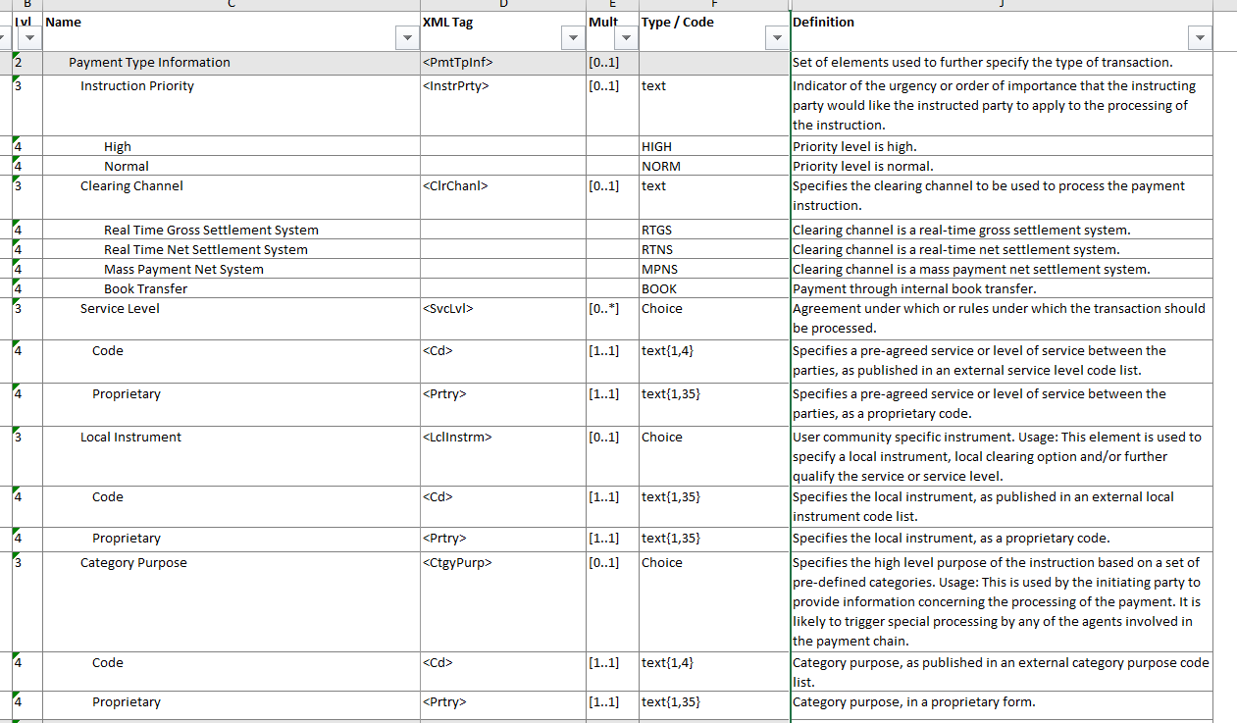

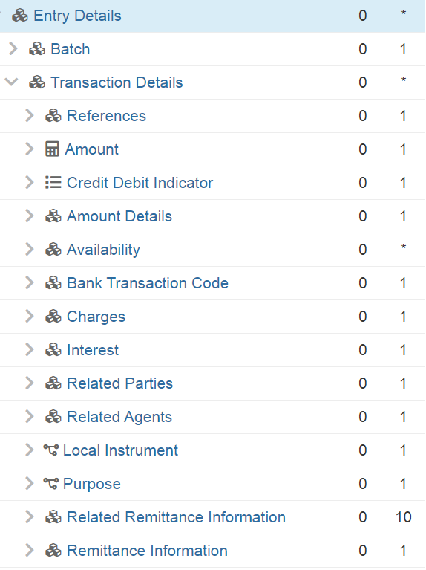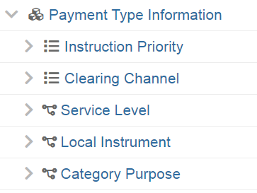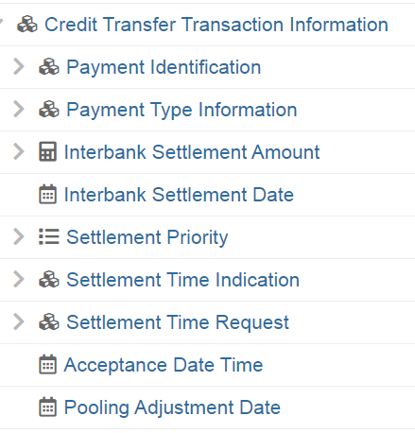

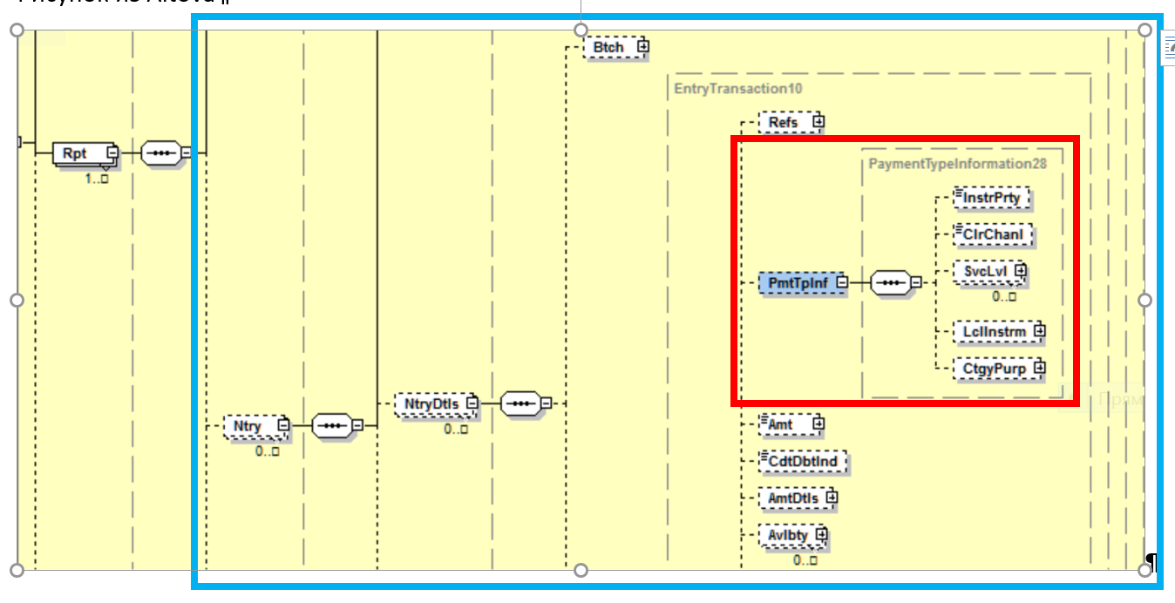

- Purpose of the change:
1. The regulatory reason - in accordance with Russian regulations Customer Statements must include not only the information for entry recording but the whole information of the initiating payment order (including CategoryPurpose, as well InstructionPriority);
2. The technical reason - impossibility to transfer pain or pacs messages already contained necessary information to customer for proper reconciliation and the complexity and inefficiency of BTC-codes adoption and mapping for all possible combinations of payment attributes;
3. The technical reason - the need of software development and maintenance for mapping and codes processing become unnecessary and the level of straight-through processing increase substantially.

- Urgency of the request:
Migration to ISO 20022 in Russia are planning now on 2022-2023.

- Business examples:

Same component Payment Type Information present in Customer Credit Transfer Initiation (pain.001.001.11) must be shown without any changes in cash management reports sent to the Account Owner/Debtor: Bank To Customer Debit Credit Notification V09 (camt.054.001.09), Bank To Customer Account Report V09 (camt.052.001.09) and Bank To Customer Statement V09 (camt.053.001.09)

Same component Payment Type Information present in Financial Institution Credit Transfer V09 (pacs.009.001.10) must be shown without any changes in cash management reports sent to the Account Owner: Bank To Customer Debit Credit Notification V09 (camt.054.001.09), Bank To Customer Account Report V09 (camt.052.001.09) and Bank To Customer Statement V09 (camt.053.001.09))

Same component Payment Type Information present in FI To FI Customer Credit Transfer V10 (pacs.008.001.10) must be shown without any changes in cash management reports sent to the Account Owner/Creditor: Bank To Customer Debit Credit Notification V09 (camt.054.001.09), Bank To Customer Account Report V09 (camt.052.001.09) and Bank To Customer Statement V09 (camt.053.001.09))

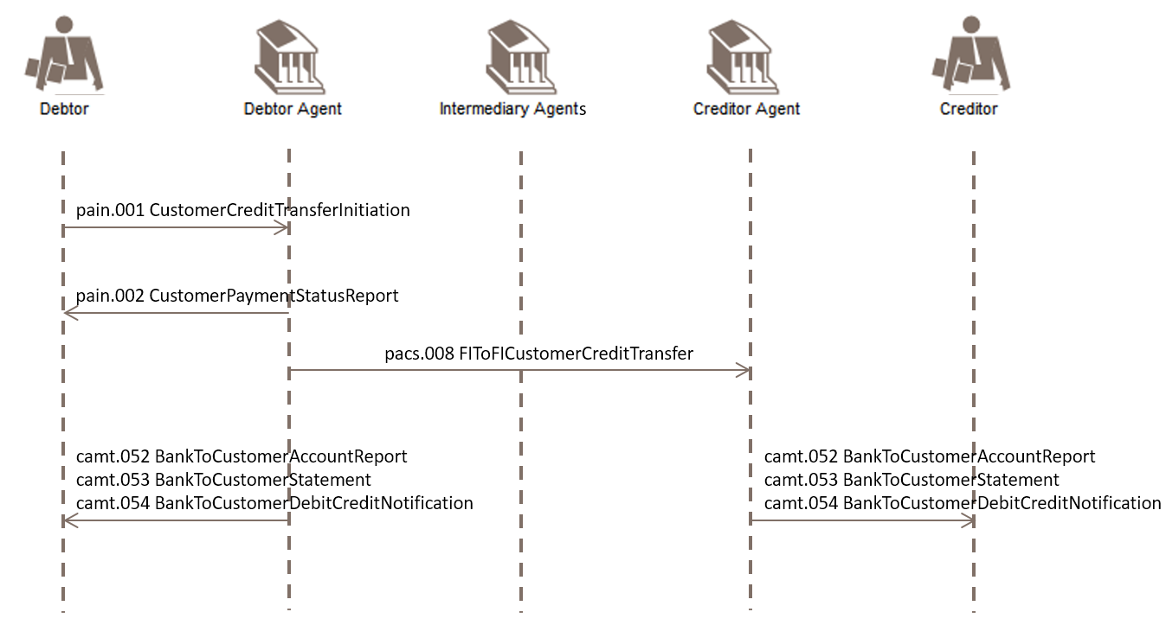

- SEG/TSG recommendation:

Consider |  | X | Timing
 |  |  | - Next yearly cycle: 2021/2022  (the change will be considered for implementation in the yearly maintenance cycle which starts in 2021 and completes with the publication of new message versions in the spring of 2022) |  | X
- At the occasion of the next maintenance of the messages
(the change will be considered for implementation, but does not justify maintenance of the messages in its own right – will be pending until more critical change requests are received for the messages)
- Urgent unscheduled
(the change justifies an urgent implementation outside of the normal yearly cycle)
 |  |  | - Other timing:
Comments: Decision made at the Payments SEG meeting on 21st June 2021.

Reject
Reason for rejection:

