Change Request
for the update of an Revolver Loan Utilisation External Code definition for CTCCR Message Set

Origin of the request:

A.1 Submitter:
Name of the company, organization, group, initiative or community that submits the change request. | Russian Corporate Market Practice Group (RU-CMPG) under aegis of Russian National Member and User Group (ROSSWIFT)

A.2 Contact person:
Person that can be contacted for additional information on the request
A.2.1.1. First name, Last name | Timothy Romaslovsky
A.2.1.2. Email address | Timothy.Romaslovsky@swift-russia.ru
A.2.1.3. Telephone | +7 499 272 0232, +7 910 458 8897
A.2.2.1. First name, Last name | Dmitry Shein
A.2.2.2. Email address | Dmitry.Shein@swift-russia.ru
A.2.2.3. Telephone | +7 499 272 0232, +7 967 266 9340
A.2.3.1. First name, Last name | Maxim Zemtsov
A.2.3.2. Email address | Maxim.Zemtsov@swift-russia.ru
A.2.3.3. Telephone | +7 499 272 0232

A.3 Sponsors:
If the submitter acts on behalf of or has gained support from other organisations, groups, initiatives or communities, these should be listed as sponsors.

The market practice which embraces the proposed changes is supported by major banks (e.g. Gazprombank, UniCredit Bank, Deutsche Bank, ING Bank, Moscow Credit Bank, ROSBANK, etc.) and implemented by these banks to interact with their customers (corporates).

Description of the change request:
Specify the request type: creation of new code set, update of existing code set, deletion of existing code set.
For the creation of a new code set or for updating an existing code set, also complete the table in section H below. For the addition of new codes, all the details must be specified, including a proposed code, a proposed code name, a clear definition, and any other indications, such as an example or format to be published with the code set.

Request type: creation, update, deletion | Update

Related External Code Set:
For updating or deleting an existing code set, indicate the exact name of the code set as indicated in the External Code Sets documents on iso20022.org. For creating a new code set, indicate a proposed name for the new code set.
A specific change request form must be completed for each code set to be updated.

ExternalContractBalanceType1Code

Purpose of the change:
Background, business context, community of users interested by the change and expected benefits/savings.
This section must explain why the existing code set needs to be changed. The reason for the update may be a business reason (e.g., evolution of market practice, or creation of new financial instruments), a technical reason (e.g., automation of the business process, or switch from a batch to a real time process), a regulatory reason (introduction, generally mandatory, of new rule/law) or the extension of the user community (newly identified business requirements).

Existing Name and Definition is not corresponding to business sense for these codes in Cross Border Transactions Currency Control Reporting (CTCCR) Message Set operations caused by the mistake during translation from Russian to English

Urgency of the request:
By default, valid change requests, subsequently approved by the SEG will be included in the following quarterly publication of External Code Sets, unless decided otherwise by the SEG.
If there is a need to have the new version of the related code set published earlier, the reason for the urgency and the expected consequences of a delay should be described here. Acceptance of such an unscheduled publication is subject to approval by the SEG.

Will be synchronized with MCR 197 of Fast Track CTCCR Message Set Maintenance 2021

Business examples:
Provide examples illustrating usage of the code set and indicate messages where the code set may be used.

In the External Code Sets Table for ExternalContractBalanceType1Code the term «Exposure» in Name and Definition has been changed by the term «Utilisation».
Illustration:
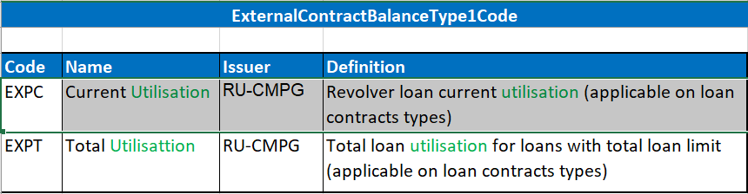

SEG recommendation:
This section will be completed by the SEG in charge of the related External Code Set.

Accept |  | X | Timing
 |  |  | Next possible quarterly release |  | X
 |  |  | Urgent request

Comments: Approved with the CTCCR fast track maintenance (RA ID: 197).

Reject

Reason for rejection:

DESCRIPTION OF THE CHANGE REQUEST

Type | Code Value | Code Name | Code Definition | Replaced By | Additional Information
Addition  Update  Deletion | 4 char |  | Clear and concise definition. Repetition of the code name is not allowed. | Code value (if applicable) | Usage, use case(s) or any additional information useful for the usage of the code.

