Change Request
for the update of an External Code Set used in ISO 20022

- Origin of the request:
A.1 Submitter: Daniele Pasqualini, the Italian Banking Community, CBPR+
A.2 Contact person: Kiyono Hasaka, SWIFT
- Related External Code Set:
ExternalCategoryPurpose1Code
Description of the change request:
Create the following codes for Category Purpose Codes:
Code Name | Classification | Name | Definition
SWEP | Cash Mgmt | CashManagement SweepAccount | Transaction relates to a cash management instruction, requesting a sweep of the account of the Debtor above an agreed floor amount, up to a target or zero balance.  The purpose is to move the funds from multiple accounts to a single bank account. Funds can move domestically or across border and more than one bank can be used.
TOPG | Cash Mgmt | CashManagement TopAccount | Transaction relates to a cash management instruction, requesting to top the account of the Creditor above a certain floor amount, up to a target or zero balance.  The floor amount, if not pre-agreed by the parties involved, may be specified.
ZABA | Cash Mgmt | CashManagement ZeroBalanceAccount | Transaction relates to a cash management instruction, requesting to zero balance the account of the Debtor.  Zero Balance Accounts empty or fill the balances in accounts at the same bank, in the same country into or out of a main account each day.
- Purpose of the change:
The purpose of this change is to support the above three new category purpose codes.
CBPR+ Working Group reviewed corporate use cases of multi-bank liquidity sweeps and found the need to register additional category purpose codes to be compatible with legacy MT 101 in preparation for MT-MX co-existence starting in Nov 2022.
Currently, corporates indicate a cash management code, “CMSW” (sweep the account), “CMZB” (zero balance the account) or “CMTO” (top the account) in MT 101 field 23E instruction code. These codes are mainly intended for the receiver of the MT 101 performing liquidity sweeps on behalf of corporates. The receiver of MT 101 may map these instruction codes to the field 70 of the MT 103 and report similar codes also in the MT 940/2 field 61.
As interbank is adopting ISO 20022, the equivalent codes should be available in the Category Purpose elements to support liquidity sweep operations and facilitate interoperability across MT and MX standards. The requested codes are fully aligned with the BTC sub-family codes.
This use case of corporate liquidity sweeps have a clear multi-bank and cross-border nature, and have strong potential for benefitting from enhanced and structured data to attain consistent multi-bank sweep operations enabled by ISO 20022.
There is a commonly used code “INTC” Intra Company Payment in the MT 101, MT 103 and ISO, however, the definition is too broad to trigger the specific liquidity sweep operation and apply the relevant pricing.
Therefore, this change request is to support the additional Category Purpose codes to consistently trigger corporate liquidity management operations globally.
Urgency of the request:
Next quarterly update of the external code list is fine.
- Business examples:
Please refer to two use cases of the interbank customer credit transfer initiation message sent by the Initiating Party to the Forwarding Agent or the Debtor Agent for corporate-initiated liquidity sweeps and FI-initiated liquidity sweeps below extract from the CBPR+ UHB:
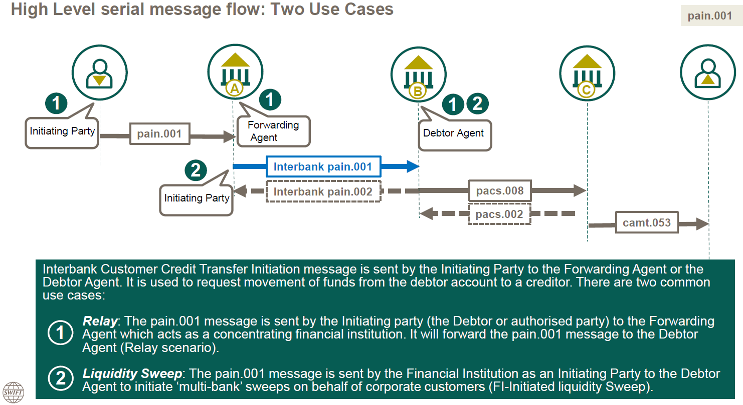
- SEG recommendation:
This section will be completed in due time by the SEG in charge of the related External Code Set.
Accept |  | X | Timing
 |  |  | - Next possible quarterly release |  | X
 |  |  | - Other timing:
Comments: Approved at Payments SEG meeting on 8th November 2021.

Reject
Reason for rejection:

