Change Request
for the update of ISO 20022 financial repository items

Origin of the request:
A.1 Submitter:
Banco Central do Brasil (Central Bank of Brazil)

A.2 Contact person:
Vicente Santana: vicente.santana@bcb.gov.br +55 51 3215-7339
Fernando Machado: fernando.cavalcanti@bcb.gov.br +55 61 3414-2589
Liliane Dutra: liliane.dutra@ipmfglobal.com.br + 55 11 98542-4421

A.3 Sponsors:
Brazilian Standards Committee ABNT -CEE 112

Related messages:
Business Domain Payments, Group Cash Management:
camt.013.001.04 GetMemberV04
camt.014.001.05 ReturnMemberV05
camt.015.001.04 ModifyMemberV04
camt.104.001.01 CreateMemberV01

- Description of the change request:
  - Raise the length of the element Name <Nm> in the camt.014.001.05 ReturnMemberV05 to 140 text.
  - Inclusion of Supplementary Data with two pieces of information about the members of the payment scheme:
1 - Full Legal Name:

The inclusion of one element Max350Text to inform the Full Legal Name of the participants in the payment scheme.
.

2 - Party Role:
Not only is it necessary to inform what type of participation the institution has in the system (direct or indirect), but also there is a need to report the institution’s role in the payment scheme. Participants can be account providers, payment initiators, settlement agents, or government entities.
This information is important as it serves as a reference for the type of payment services the institution provides in the scheme as well as its relationship and communication model with the other participants.

- Purpose of the change:
BCB created and launched, in November 2020, Pix, the Brazilian instant payment scheme that enables its users — people, companies and government entities — to send and receive payments within a few seconds at any hour of the day, including non-business days. The only centralized infrastructure for instant payment settlement between different payment service providers in Brazil is the SPI. Since its inception, Pix has developed ISO 20022 standard messages for its operation within the SPI.
In less than a year of full operation, Pix has reached almost 100 million users and the volume of transactions has increased nearly twentyfold, reaching around 30% of all the payment operations in Brazil:

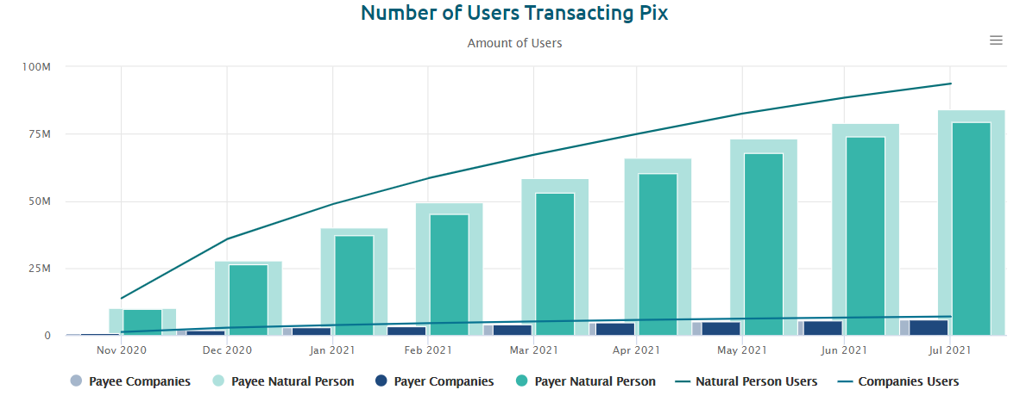
Amount accumulated of users who have already made or received at least one Pix, by user's type. Does not include Pix settled in the participant's books (transactions not sent for settlement in the SPI). Source: Instant Payment System - SPI
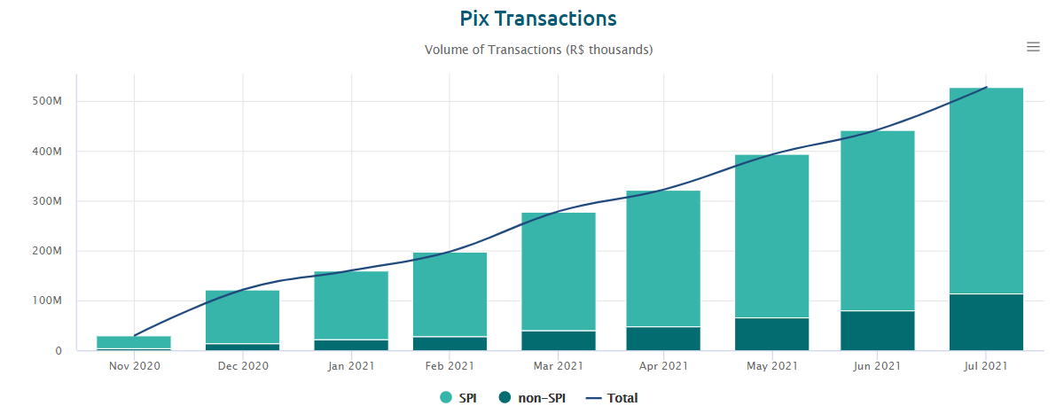
Financial volume of Pix transactions settled monthly in the SPI and non-SPI settled Pix transactions, taking into account the payment and return orders in the period. Source: Instant Payment System - SPI

Meanwhile, new modes of participation in the Pix payment scheme are being regulated, such as payment initiation service providers, and several new features are set to be launched in the near future, such as Pix withdrawal, Pix offline, installments and recurring payments.
In this context of growth and changes, more players are joining the Pix and, as the complexity of the system rises, it is important to include more information in the standard messages for an accurate description of the participants in Pix.
The camt.014 message is currently used by the SPI to broadcast information, such as inclusion or exclusion of a given party in the SPI, to all participants.
The raise in the length of the element Name <Nm> to 140Text is necessary to comply with the payment initiation and settlement messages (pain and pacs), as well as all the other cash management messages (camt), where the default number of characters to inform the name of the institution is 140Text.
Additionally, in Brazil, there is a market practice of keeping the previous full legal names, registered at the Central Bank, when there are mergers. For this reason, the resulting new names become very large. Therefore, to facilitate the search process, the BCB decided to make both kind of names available in its list of participants available on the Internet. SPI participants would like to automate the procedure of registration of the other participants with complete information, through camt messages. Thus, we need one more element to inform the Full Legal Name because the archive with the list of SPI (Instant Payment System) participants available at BCB (Banco Central do Brasil) website contains both “Name” and “Full Legal Name”.
On the other hand, by regulation, Banco Central do Brasil defines the roles that parties can play within the Pix scheme. The information of the party role within Pix is important because all the participants must take it into account when making credit transfers.

Currently, participants need to get this information and the full legal name from the SPI’s website.
Therefore, this change request aims to include information about the full legal name and the role of the Pix participant in the camt.014 message.

- Urgency of the request:
The proposal is to include this component as Supplementary Data due to the immediate need by the instant payment system in Brazil to use this information in order to function properly.
However, if any other communities in other countries also recognize a benefit in the inclusion of these two pieces of information, we will request the inclusion of this information for the next message revision cycle.

Business example:

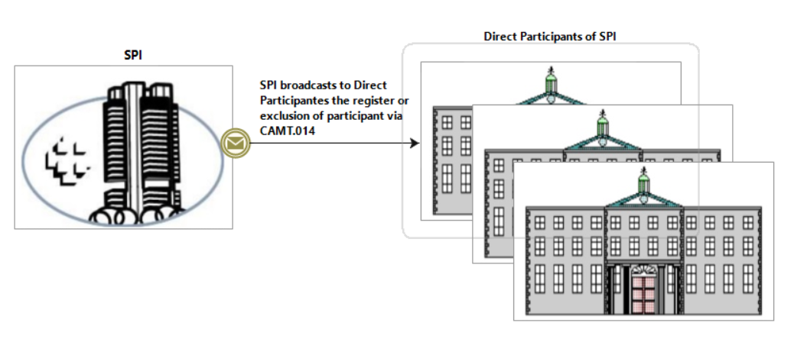
- SEG/TSG recommendation:
This section is not to be taken care of by the submitter of the change request. It will be completed in due time by the SEG(s) in charge of the related ISO 20022 messages or the TSG for changes related to the BAH.

Consider |  |  | Timing
- Next yearly cycle: 2021/2022
(the change will be considered for implementation in the yearly maintenance cycle which starts in 2018 and completes with the publication of new message versions in the spring of 2019)
- At the occasion of the next maintenance of the messages
(the change will be considered for implementation, but does not justify maintenance of the messages in its own right – will be pending until more critical change requests are received for the messages)
- Urgent unscheduled
(the change justifies an urgent implementation outside of the normal yearly cycle)
 |  |  | - Other timing:
Comments:

Reject
Reason for rejection:

