Change Request
for the update of ISO 20022 financial repository items

- Origin of the request:
A.1 Submitter:
DESSUG CA – PSG (Deutsche SWIFT Securities Market User Group - Corporate Actions - Proxy Subgroup Germany)
This group represents more than 20 different institutions including domestic and global proxy providers and registrars with a key role in the German General Meeting process.

A.2 Contact person:
PSG Chair - Hendrik Melchior (employer change to Clearstream Banking Frankfurt in July)
PSG Deputy Chair - Daniel Schäfer, Daniel.Schaefer@hsbc.de, Phone +49 211 910-2362
Sabine Wolff, Sabine.Wolff@clearstream.com, Phone +352-243-3 66 40
SEG GM-ET Member (Germany) - Sven Gunkel, sven-a.gunkel@db.com, Phone +49 69910-60715
SEG GM-ET Member (Germany) - Rainer Prior, Rainer.Prior@linkmarketservices.de, Phone +49 6196 8870 514

A.3 Sponsors:
German Market - including domestic and global proxy providers with a key role in the German General Meeting process.
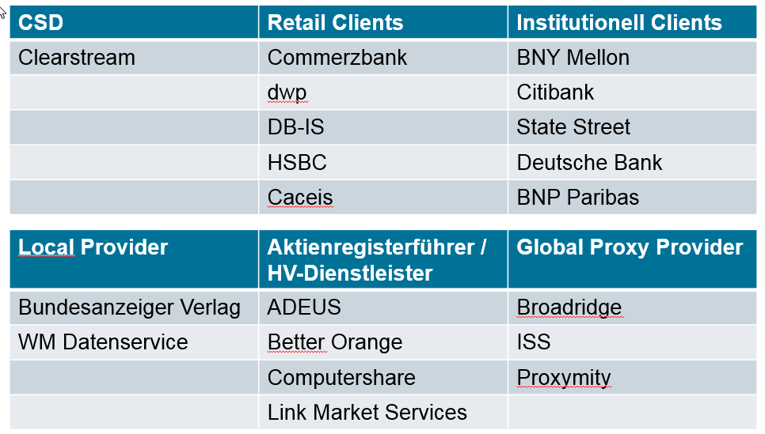
- Related messages:
Seev.003.xxx.xxx

- Description of the change request:
Two types of share classes are represented on the German market.. Bearer Shares and Registered Shares. The market working group has identified a limitation of the current messages to support Proxy services for Registered Shares.

The Balance Type <BalTp> Registered [NOMI] should be split into two different types to distinguish between a registration in the name of a nominee and in the name of the beneficial owner.

Current: Description of Balance Type “Registered NOMI”
Balance of securities that are registered (in the name of a nominee or of the beneficial owner).

Definition Change Request: Description of Balance Type <BalTp> “Registered Nominee - NOMI” should be Balance of securities that are registered in the name of a nominee.

New Balance Type <BalTp>: “Registered Beneficial Owner - BENE” with description
Balance of securities that are registered in the name of the beneficial owner.

Change to Holding Balance <HldgBal>: The repetition will increase by 1 to 0..16.

Holding Balance <HldgBal> [0..16]
Balance <Bal> [1..1]
Balance Type <BalTp> [1..1]
Blocked BLOK
Eligible ELIG
Pending Delivery PEND
Pending Receipt PENR
Registered Nominee NOMI
Registered Benefical Owner BENE
Settled SETD
Borrowed BORR
On Loan LOAN
Street Position SPOS
Traded TRAD
Collateral In COLI
Collateral Out COLO
Uninstructed Balance UNBA
Instructed Balance INBA
Out For Registration REGO

- Purpose of the change:
The shareholder in a German company share register can be registered in the name of the beneficial owner or in the name of a Nominee. A registration by the end of a day is mandatory.
As per German law the registered name in the company share register has the shareholder rights against the issuer. The Nominee registration (custodian bank on behalf of the account holder of the shares) are allowed, but in this case the Nominee execute the shareholder rights on behalf of the beneficial holder of the shares.
If no registration request has been sent to the company share register, an automatic registration of the German custodian (CSD securities account owner) as Nominee will be performed. In Germany this will be performed by the local CSD application CASCADE-RS.
Especially in case of complex sub-custodian structures, the final beneficial owner details of the settlement transaction are not known to the CSD securities account owner and therefore often just the account owner of the German custodian can be registered in the German company share register.

- Urgency of the request:
By default, valid change requests introduced by June 1 and subsequently approved by the SEG/TSG will be included in the following yearly maintenance cycle which completes with the publication of new message versions by April/May of the following year, unless decided otherwise by the SEG/TSG.
If there is a need to have the new version of the related messages published earlier, the reason for the urgency of the maintenance and the expected consequences of a delay should be described here. Acceptance of such an unscheduled maintenance for the BAH is subject to approval by TSG. Acceptance of an unscheduled maintenance for messages other than the BAH is subject to the approval of the SEG and availability of a submitting organization to develop the new version of the messages.
Note: the ISO 20022 maintenance results in the publication of a new version of an ISO 20022 message. The actual implementation of such new version on networks and in user installations is not within the purview of ISO.
N/A

- Business examples:
German custodian A holds 10,000 shares of company XYZ AG for 3 different clients
Client 1 = 500 shares, natural person Mr. Max Mustermann
Registered in the company share register in the name of the beneficial owner.
Client 2 = 6,000 shares, investment fund ABC
Registered in the company share register in the name of the beneficial owner.
Client 3 = 3,500 shares, Omnibus account of a non-German bank B
Registered in the company share register in the name of the German custodian as Nominee.
Registration in the company share register in the name of the beneficial owner is not possible, because the non-German bank B cannot be registered as beneficial owner when the shares are held in an omnibus account. Presumably bank B deposits the shares for multiple investors.

- SEG/TSG recommendation:
This section is not to be taken care of by the submitter of the change request. It will be completed in due time by the SEG(s) in charge of the related ISO 20022 messages or the TSG for changes related to the BAH.

Consider |  |  | Timing
- Next yearly cycle: 2021/2022
(the change will be considered for implementation in the yearly maintenance cycle which starts in 2021 and completes with the publication of new message versions in the spring of 2022)
- At the occasion of the next maintenance of the messages
(the change will be considered for implementation, but does not justify maintenance of the messages in its own right – will be pending until more critical change requests are received for the messages)
- Urgent unscheduled
(the change justifies an urgent implementation outside of the normal yearly cycle)
 |  |  | - Other timing:
Comments:

Reject | X
Reason for rejection:

