Change Request
for the update of ISO 20022 financial repository items

- Origin of the request:
A.1 Submitter: nexo A.I.S.B.L.
A.2 Contact person: Philippe CECE (Philippe.cece@ingenico.com) / Pierre MOURA (pierre.moura@frenchsys.com) / Bruno AIELLO (Bruno.Aiello@VERIFONE.com) / Philippe MERMOUD (philippe.mermoud@natixis.com)
A.3 Sponsors: nexo A.I.S.B.L.

- Related messages:

For the caaa related messages:
- AcceptorAuthorisationRequest V09 caaa.001.001.09
- AcceptorAuthorisationResponse V09 caaa.002.001.09
- AcceptorCompletionAdvice V09 caaa.003.001.09
- AcceptorCompletionAdviceResponse V08 caaa.004.001.08
- AcceptorCancellationRequest V09 caaa.005.001.09
- AcceptorCancellationResponse V08 caaa.006.001.08
- AcceptorCancellationAdvice V09 caaa.007.001.09
- AcceptorCancellationAdviceResponse V08 caaa.008.001.08
- AcceptorReconciliationRequest V08 caaa.009.001.08
- AcceptorReconciliationResponse V07 caaa.010.001.07
- AcceptorBatchTransfer V09 caaa.011.001.09
- AcceptorBatchTransferResponse V08 caaa.012.001.08
- AcceptorDiagnosticRequest V08 caaa.013.001.08
- AcceptorDiagnosticResponse V07 caaa.014.001.07
- AcceptorCurrencyConversionRequest V07 caaa.016.001.07
- AcceptorCurrencyConversionResponse V07 caaa.017.001.07
- AccpetorCurrencyConversionAdvice V04 caaa.018.001.04
- AcceptorCurrencyConversionAdviceResponse V03 caaa.019.001.03
- TransactionAdvice V01 caaa.020.001.01
- TransactionAdviceResponse V01 caaa.021.001.01

For the casp related messages:
- SaleToPOIServiceRequest V02 casp 001.001.02
- SaleToPOIServiceResponse V02 casp 002.001.02
- SaleToPOIReconciliationRequest V02 casp 003.001.02
- SaleToPOIReconciliationResponse V02 casp 004.001.02
- SaleToPOISessionManagementRequest V02 casp 005.001.02
- SaleToPOISessionManagementResponse V02 casp 006.001.02
- SaleToPOIAdministrativeRequest V02 casp 007.001.02
- SaleToPOIAdministrativeResponse V02 casp 008.001.02
- SaleToPOIReportRequest V02 casp 009.001.02
- SaleToPOIReportResponse V02 casp 010.001.02
- SaleToPOIAbort V02 casp 011.001.02
- SaleToPOIEventNotification V02 casp 012.001.02
- SaleToPOIMessageStatusRequest V02 casp 014.001.02
- SaleToPOIMessageStatusResponse V02 casp 015.001.02
- SaleToPOIDeviceRequest V02 casp 016.001.02
- SaleToPOIDeviceResponse V02 casp 017.001.02

- Description of the change request:

We would like to change the coding of LocationCategory1Code to avoid any misunderstanding and covering new use cases.

- Purpose of the change:

The code set value FIXED wasn't clearly understood and the codeset MOTO created misunderstanding with the TransactionChannel. So in order to remove any misunderstanding and also provide a codeset for e-commerce solution, we would like to change the values of LocationCategory1Code with the following proposal.

The updated messages are listed in a bold green font in the following diagram. Impacts on the RetailerProtocol have been also identified.

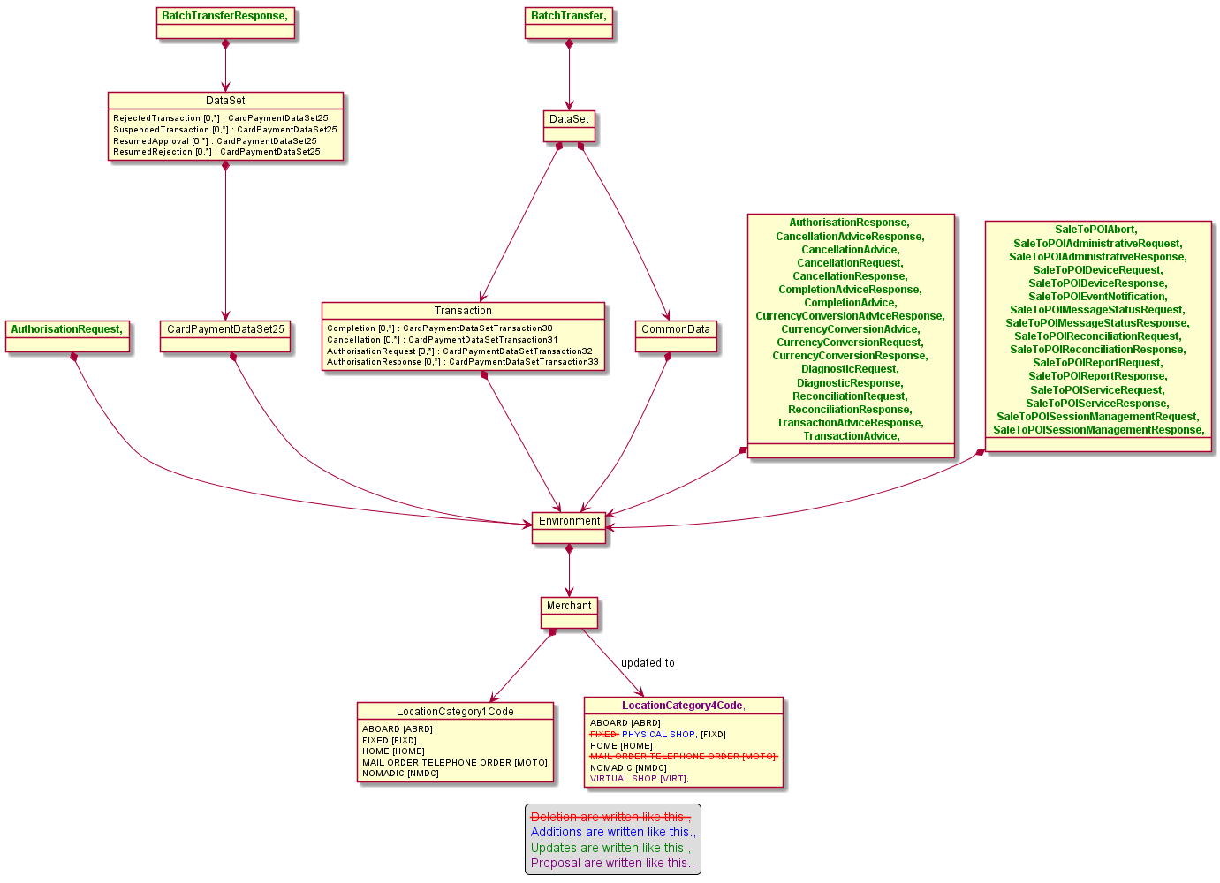

- Urgency of the request:

Urgent.

- Business examples:
Examples illustrating the change request.
- SEG/TSG recommendation:
This section is not to be taken care of by the submitter of the change request. It will be completed in due time by the SEG(s) in charge of the related ISO 20022 messages or the TSG for changes related to the BAH.

Consider |  | X | Timing
 |  |  | - Next yearly cycle: 2020/2021  (the change will be considered for implementation in the yearly maintenance cycle which starts in 2018 and completes with the publication of new message versions in the spring of 2019) |  | X
- At the occasion of the next maintenance of the messages
(the change will be considered for implementation, but does not justify maintenance of the messages in its own right – will be pending until more critical change requests are received for the messages)
- Urgent unscheduled
(the change justifies an urgent implementation outside of the normal yearly cycle)
 |  |  | - Other timing:
Comments:

Reject
Reason for rejection:

