Change Request
for the update of ISO 20022 financial repository items

- Origin of the request:
A.1 Submitter: nexo A.I.S.B.L.
A.2 Contact person: Philippe CECE (Philippe.cece@ingenico.com) / Pierre MOURA (pierre.moura@frenchsys.com) .
A.3 Sponsors: nexo A.I.S.B.L.

- Related messages:

- AcceptorReconciliationRequest V08 caaa.009.001.08
- AcceptorReconciliationResponse V07 caaa.010.001.07

- AcceptorConfigurationUpdate V09 catm 003.001.09

- Description of the change request:

Some members want to be able to check transactions totals and reconciliate according to the card brand and not only card product profile. For instance, this might be the case with contact or contactless card.
Obviously this choice of reconciliation should be enabled by the TMS protocol.

- Purpose of the change:

The proposal consists to add this option among others in the TransactionTotals message element as highlighted in the following diagram.

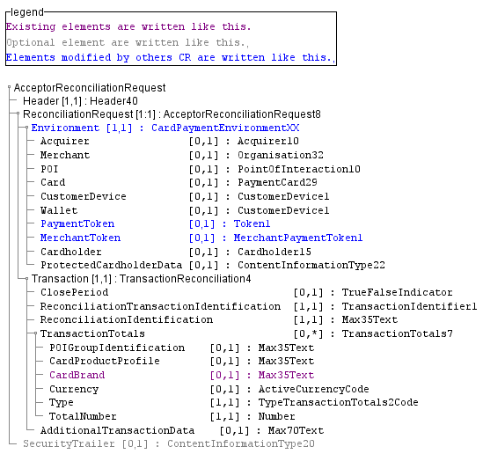

The second part of the modification is to add the settings in the AcquirerProtocolParameters, with the optional addition of up to 3 SplitTotalCriteria message element defined from a codeset.

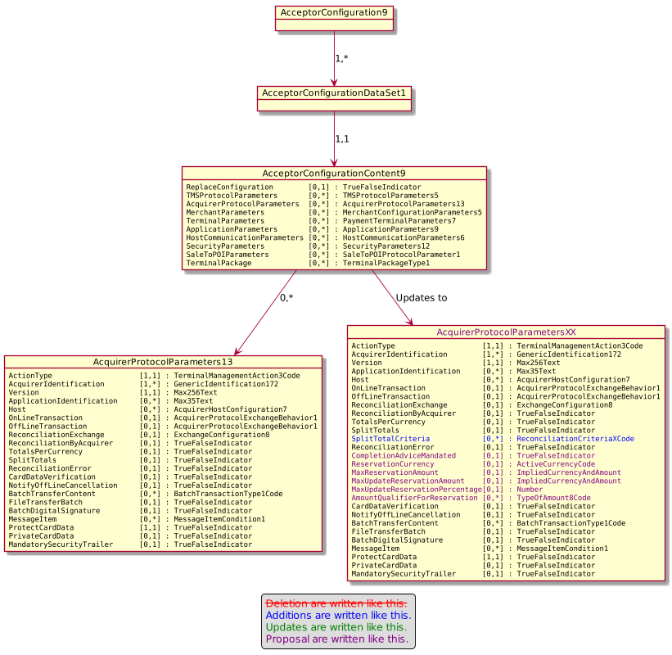
Finally, the codeset ReconciliationCriteriaXCode is defined with 3 different values.

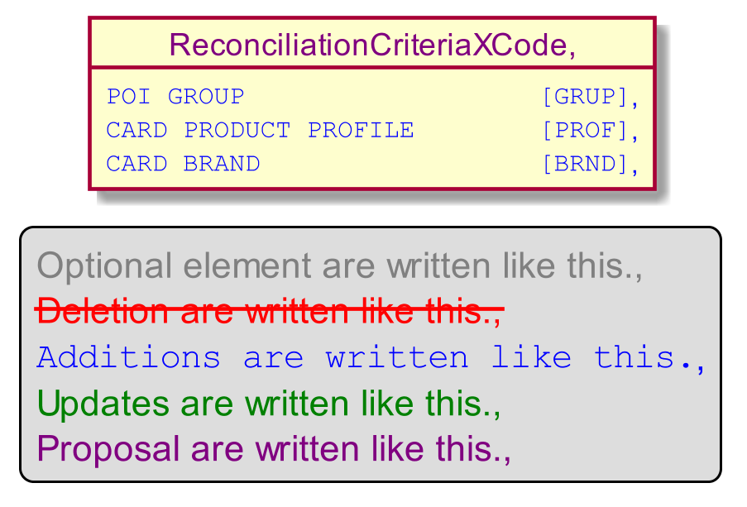

- Urgency of the request:

Urgent.

- Business examples:
Examples illustrating the change request.
- SEG/TSG recommendation:
This section is not to be taken care of by the submitter of the change request. It will be completed in due time by the SEG(s) in charge of the related ISO 20022 messages or the TSG for changes related to the BAH.

Consider |  | X | Timing
 |  |  | - Next yearly cycle: 2020/2021  (the change will be considered for implementation in the yearly maintenance cycle which starts in 2018 and completes with the publication of new message versions in the spring of 2019) |  | X
- At the occasion of the next maintenance of the messages
(the change will be considered for implementation, but does not justify maintenance of the messages in its own right – will be pending until more critical change requests are received for the messages)
- Urgent unscheduled
(the change justifies an urgent implementation outside of the normal yearly cycle)
 |  |  | - Other timing:
Comments:

Reject
Reason for rejection:

