Change Request
for the update of ISO 20022 financial repository items

- Origin of the request:
A.1 Submitter: nexo A.I.S.B.L.
A.2 Contact person: Philippe CECE (Philippe.cece@ingenico.com) / Pierre MOURA (pierre.moura@frenchsys.com)
A.3 Sponsors: nexo A.I.S.B.L.

- Related messages:

- StatusReport V09 catm 001.001.09
- ManagementPlanReplacement V08 catm 002.001.08
- AcceptorConfigurationUpdate V09 catm 003.001.09
- MaintenanceDelegationRequest V06 catm 005.001.06

- Description of the change request:

In some architectures it might be interesting to be able to split a message in multiple smaller ones. Though this functionality was currently possible in the messages listed in the previous chapter, we believe that the current solution might be in some circumstances unreliable since we are not able to identify how many messages we will receive or to identify the last one.

Additionnaly we realised that if some containers, that the AcceptorConfigurationUpdate has to vehicle, are too big, then the message might not be sent due to excessive length for the communication media. Then we need to provide a way to split these contianers in smaller chunks.

The aim of this Change Request is to correct these lacks.

- Purpose of the change:

In order to identify the lost of the penultimate message, we would like to add just after the SequenceCounter the message element LastSequence defined as Indication of the last sequence in case of split messages, with multiplicity [0,1] and type TrueFalseIndicator. Then the messages will be updated according to the following diagrams.

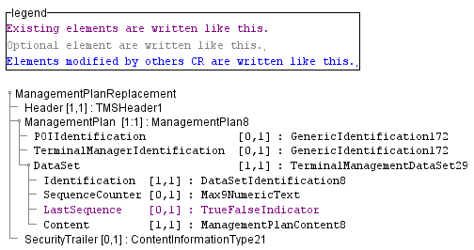

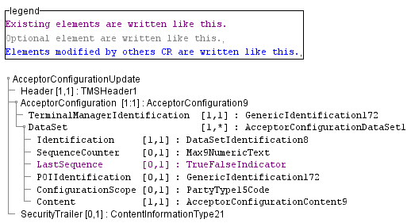

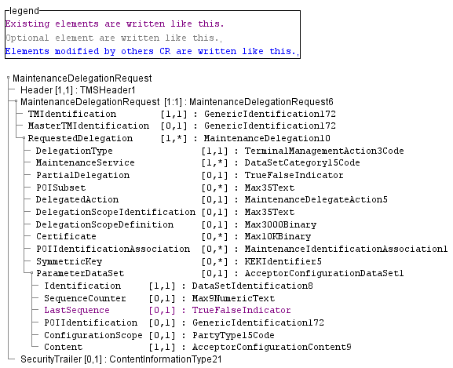

Finally, in order to divide containers in smaller parts, as depicted in the following diagram, we would like to reuse the same model than we used last year with the TerminalPackages by the addition of 3 new message elements, one to identify the full length and OffsetStart, OffsetEnd to identify where this part resides.

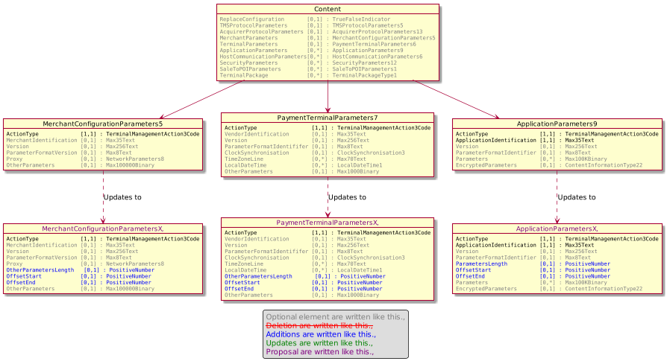

- Urgency of the request:

Urgent.

- Business examples:
Examples illustrating the change request.
- SEG/TSG recommendation:
This section is not to be taken care of by the submitter of the change request. It will be completed in due time by the SEG(s) in charge of the related ISO 20022 messages or the TSG for changes related to the BAH.

Consider |  | X | Timing
 |  |  | - Next yearly cycle: 2020/2021  (the change will be considered for implementation in the yearly maintenance cycle which starts in 2018 and completes with the publication of new message versions in the spring of 2019) |  | X
- At the occasion of the next maintenance of the messages
(the change will be considered for implementation, but does not justify maintenance of the messages in its own right – will be pending until more critical change requests are received for the messages)
- Urgent unscheduled
(the change justifies an urgent implementation outside of the normal yearly cycle)
 |  |  | - Other timing:
Comments:

Reject
Reason for rejection:

