Change Request
for the update of ISO 20022 financial repository items

- Origin of the request:
A.1 Submitter: nexo A.I.S.B.L.
A.2 Contact person: Philippe CECE (Philippe.cece@ingenico.com) / Pierre MOURA (pierre.moura@frenchsys.com)
A.3 Sponsors: nexo A.I.S.B.L.

- Related messages:

- AcceptorConfigurationUpdate V09 catm 003.001.09
- MaintenanceDelegationRequest V06 catm 005.001.06

- Description of the change request:

In regards of Reservation, some acquirers may expect to receive a completion advice message after each reservation update, and a maximum amount might be set for reservation update too.

The aim of this Change Request is to back these functions.

- Purpose of the change:

In order to achieve this, we would like to update the AcquirerProtocolParameters13 by adding new elements as highlighted by the following diagram.

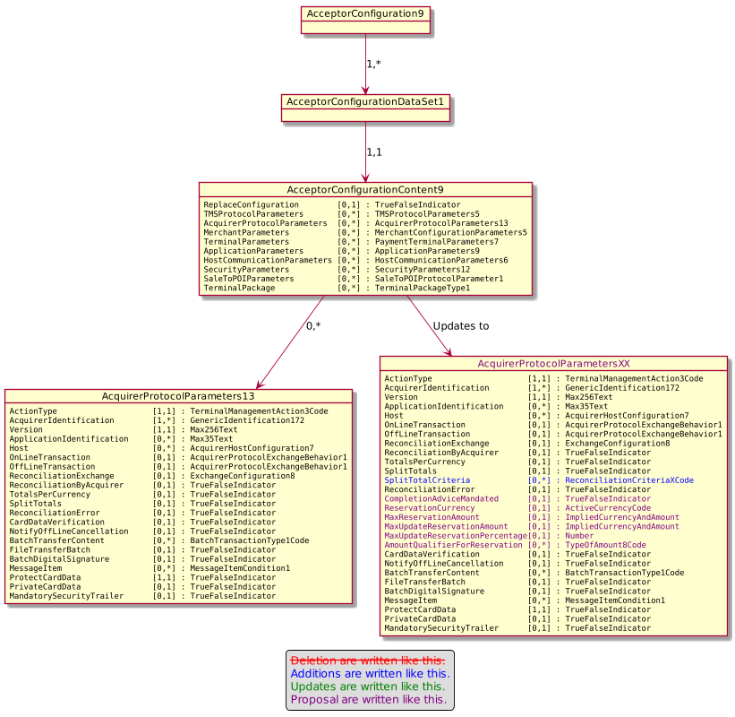

- Urgency of the request:

Urgent.

- Business examples:
Examples illustrating the change request.
- SEG/TSG recommendation:
This section is not to be taken care of by the submitter of the change request. It will be completed in due time by the SEG(s) in charge of the related ISO 20022 messages or the TSG for changes related to the BAH.

Consider |  | X | Timing
 |  |  | - Next yearly cycle: 2020/2021  (the change will be considered for implementation in the yearly maintenance cycle which starts in 2018 and completes with the publication of new message versions in the spring of 2019) |  | X
- At the occasion of the next maintenance of the messages
(the change will be considered for implementation, but does not justify maintenance of the messages in its own right – will be pending until more critical change requests are received for the messages)
- Urgent unscheduled
(the change justifies an urgent implementation outside of the normal yearly cycle)
 |  |  | - Other timing:
Comments:

Reject
Reason for rejection:

