Change Request
for the update of ISO 20022 financial repository items

- Origin of the request:
A.1 Submitter: nexo A.I.S.B.L.
A.2 Contact person: Philippe CECE (Philippe.cece@ingenico.com) / Pierre MOURA (pierre.moura@frenchsys.com)
A.3 Sponsors: nexo A.I.S.B.L.

- Related messages:

- AcceptorBatchTransfer V09 caaa.011.001.09

- AcceptorConfigurationUpdate V09 catm.003.001.09
- MaintenanceDelegationRequest V06 catm 005.001.06

- Description of the change request:

In order to cover new use cases, it would be interesting to include 2 couples of new messages in the caaa protocols:
- AcceptorNonFinancialRequest / AcceptorNonFinancialResponse
- AcceptorTransactionLogReportRequest / AcceptorTransactionLogReportResponse

The goal of the AcceptorNonFinancialRequest/Response is to allow the development of pre-acquiring services, in addition to the acquiring services performed by the Acquirer. These pre-acquiring services may include (but are not limited to) Risk management, final Acquirer selection and Routing. These pre-acquiring services could be performed by the Acquirer or an Agent. In order to foster usage of tokens between acceptor and acquirer and limit the usage of sensitive information, we also propose to support token and PAR inquiries in the request, and received them back in the response, since the PAR is an element of a the Card message component.

The second couple of messages AcceptorTransactionLogReportRequest/Response allow detailed reconciliation through reports between an Acceptor and an Agent.

The creation of these new messages implies the update of the TMS protocol to still clearly identify which messages a POI might sent to an acquirer. An additional update of the BatchTransfer messages is also considered to be able to request a batch of Tokens.

- Purpose of the change:

- AcceptorNonFinancialRequest

The proposal is based on the same message element used in an authorization request coupled with a clear indication of the requested services and flags to identify which token are expected in the response.
The diagram below highlights the proposed structure of the message schema.

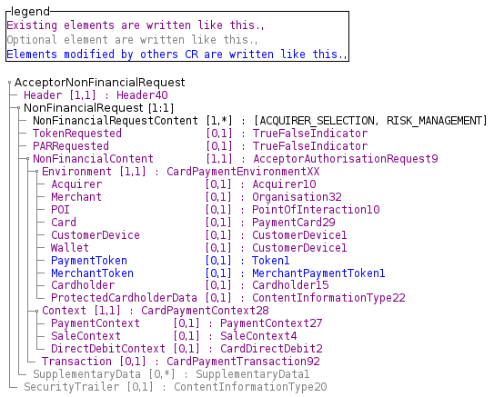

- AcceptorNonFinancialResponse

The response should provide the result of the requested services and the environment to provide tokens or PAR in the Card message element.
The diagram below highlights the proposed structure of the message schema.

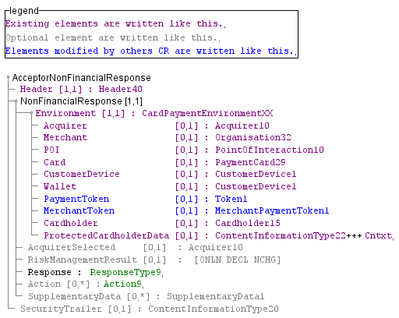

- TokenRequest through BatchTransfer

In order to manage a batch of token, we want to create a TokenRequestComponent message component which holds a TransactionSeuquenceCounter which might act as an identifier like in any other message component in a CardPaymentDataSetTransaction8Choice of a BatchTrasnfer.

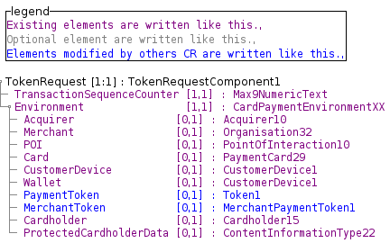

The message component, which brings the response, is made with the same component.

Then, in order to allow request/response through the BatchTransfer message, we will update the CardPaymentDataSetTransaction8Choice with the following proposal.

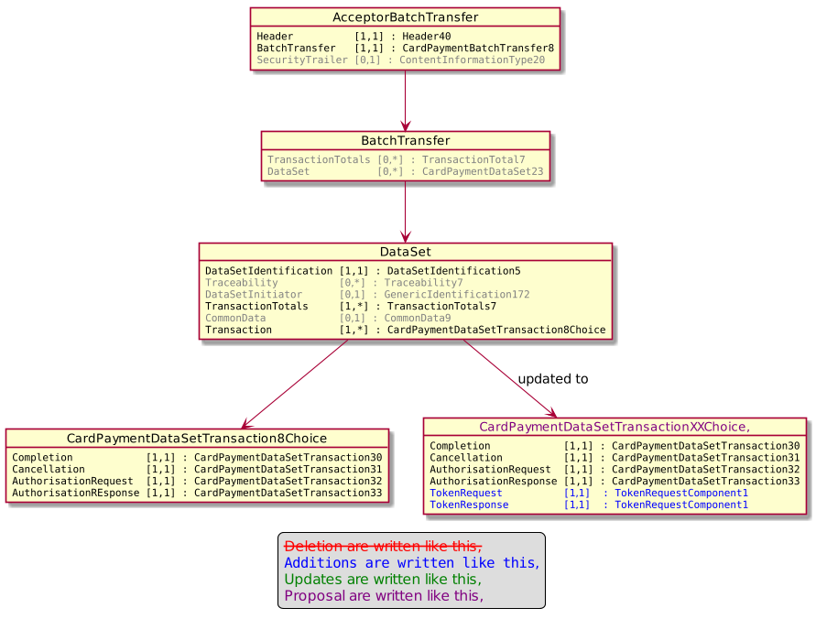
The BatchTransferResponse doesn't need to evolve since the SequenceCounter of the request could be set in the RejectedTransaction\TransactionCounter or SuspendedTransaction\TransactionCounter of the response.

- AcceptorTransactionLogReportRequest

The proposal aims to reuse a message defined in the casp domain.
The diagram below highlights the proposed structure of the message schema.

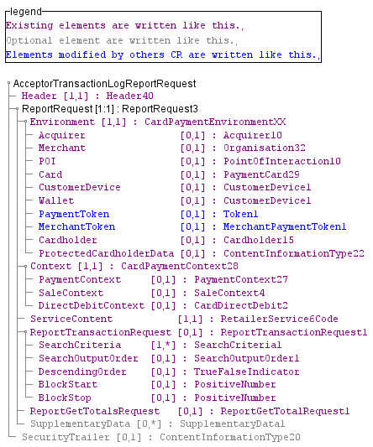

- AcceptorTransactionLogReportResponse

Obviously, we follow the same idea for the response and reuse the message from casp domain.
The diagram below highlights the proposed structure of the message schema.

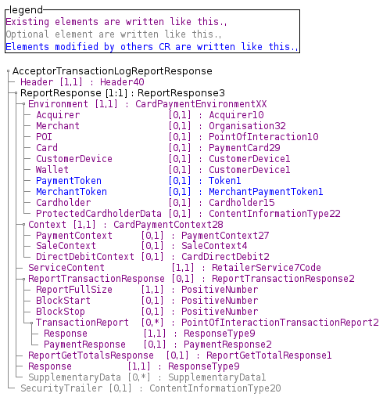

- Update on TMS message

Then the TMS messages have to be updated in order to clearly identify which acquirer messages a POI may send to an acquirer.
This update only aims the MessageToSend message element of type MessageFunction16Code as highlighted by the following diagram.
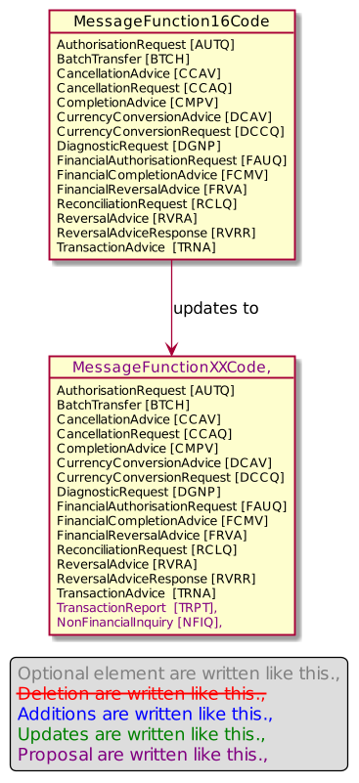

- Urgency of the request:

Urgent.

- Business examples:
Examples illustrating the change request.
- SEG/TSG recommendation:
This section is not to be taken care of by the submitter of the change request. It will be completed in due time by the SEG(s) in charge of the related ISO 20022 messages or the TSG for changes related to the BAH.

Consider |  | X | Timing
 |  |  | - Next yearly cycle: 2020/2021  (the change will be considered for implementation in the yearly maintenance cycle which starts in 2018 and completes with the publication of new message versions in the spring of 2019) |  | X
- At the occasion of the next maintenance of the messages
(the change will be considered for implementation, but does not justify maintenance of the messages in its own right – will be pending until more critical change requests are received for the messages)
- Urgent unscheduled
(the change justifies an urgent implementation outside of the normal yearly cycle)
 |  |  | - Other timing:
Comments:

Reject
Reason for rejection:

