Change Request
for the update of ISO 20022 financial repository items

- Origin of the request:
A.1 Submitter: nexo A.I.S.B.L.
A.2 Contact person: Philippe CECE (Philippe.cece@ingenico.com) / Pierre MOURA (pierre.moura@frenchsys.com)
A.3 Sponsors: nexo A.I.S.B.L.

- Related messages:

- AcceptorAuthorisationRequest V09 caaa.001.001.09
- AcceptorAuthorisationResponse V09 caaa.002.001.09
- AcceptorCompletionAdvice V09 caaa.003.001.09
- AcceptorCompletionAdviceResponse V08 caaa.004.001.08
- AcceptorCancellationRequest V09 caaa.005.001.09
- AcceptorCancellationResponse V08 caaa.006.001.08
- AcceptorCancellationAdvice V09 caaa.007.001.09
- AcceptorCancellationAdviceResponse V08 caaa.008.001.08
- AcceptorReconciliationRequest V08 caaa.009.001.08
- AcceptorReconciliationResponse V07 caaa.010.001.07
- AcceptorBatchTransfer V09 caaa.011.001.09
- AcceptorBatchTransferResponse V08 caaa.012.001.08
- AcceptorDiagnosticRequest V08 caaa.013.001.08
- AcceptorDiagnosticResponse V07 caaa.014.001.07
- AcceptorCurrencyConversionRequest V07 caaa.016.001.07
- AcceptorCurrencyConversionResponse V07 caaa.017.001.07
- AccpetorCurrencyConversionAdvice V04 caaa.018.001.04
- AcceptorCurrencyConversionAdviceResponse V03 caaa.019.001.03
- TransactionAdvice V01 caaa.020.001.01
- TransactionAdviceResponse V01 caaa.021.001.01

- StatusReport V09 catm 001.001.09
- ManagementPlanReplacement V08 catm 002.001.08
- AcceptorConfigurationUpdate V09 catm 003.001.09
- MaintenanceDelegationRequest V06 catm 005.001.06
- MaintenanceDelegationResponse V04 catm 006.001.04
- CertificateManagementRequest V03 catm 007.001.03
- CertificateManagementResponse V03 catm 008.001.03

- SaleToPOIServiceRequest V02 casp 001.001.02
- SaleToPOIServiceResponse V02 casp 002.001.02
- SaleToPOIReconciliationRequest V02 casp 003.001.02
- SaleToPOIReconciliationResponse V02 casp 004.001.02
- SaleToPOISessionManagementRequest V02 casp 005.001.02
- SaleToPOISessionManagementResponse V02 casp 006.001.02
- SaleToPOIAdministrativeRequest V02 casp 007.001.02
- SaleToPOIAdministrativeResponse V02 casp 008.001.02
- SaleToPOIReportRequest V02 casp 009.001.02
- SaleToPOIReportResponse V02 casp 010.001.02
- SaleToPOIAbort V02 casp 011.001.02
- SaleToPOIEventNotification V02 casp 012.001.02
- SaleToPOIMessageStatusRequest V02 casp 014.001.02
- SaleToPOIMessageStatusResponse V02 casp 015.001.02
- SaleToPOIDeviceRequest V02 casp 016.001.02
- SaleToPOIDeviceResponse V02 casp 017.001.02

- Description of the change request:

We would like to extend the length of some message element Names since currently we are not able to transport their full value.

For instance, when a TMS sends parameters to a POI, Identification brings all the information through a DataSetIdentification8 message component. The Name included in Identification is a Max256Text. When the POI wants to report the presence of this parameters, it has to set the identification of a POIComponent defined with the PointOfInteractionComponentIdentification1. But currently the Identification (the name field) of this message component is currently defined as a Max35Text.

The same inconsistency applies on SerialNumber of the SignerIdentification of the CMS structure. Generally speaking this one is set with the ASCII representation of a result of SHA1 (160 bits) computation with ":" between each byte value (e.g : 41:9D:CF:A5:FD:30:24:C0:C9:80:85:9E:2D:2D:22:9D:1D:78:8F:4A) leading to 39 ASCII values that we have to fit into a Max35Binary.

Finally, we would like to correct our previous model for elliptic curve signature in order to match the corresponding model encoded in ASN.1

Since we will have to update the CMS structure, all messages, except rejection, will have to be updated.

- Purpose of the change:

As previously explained, the first modification will target the PoinOfInteractionComponentIdenticiation1 as highlighted by the following diagram.

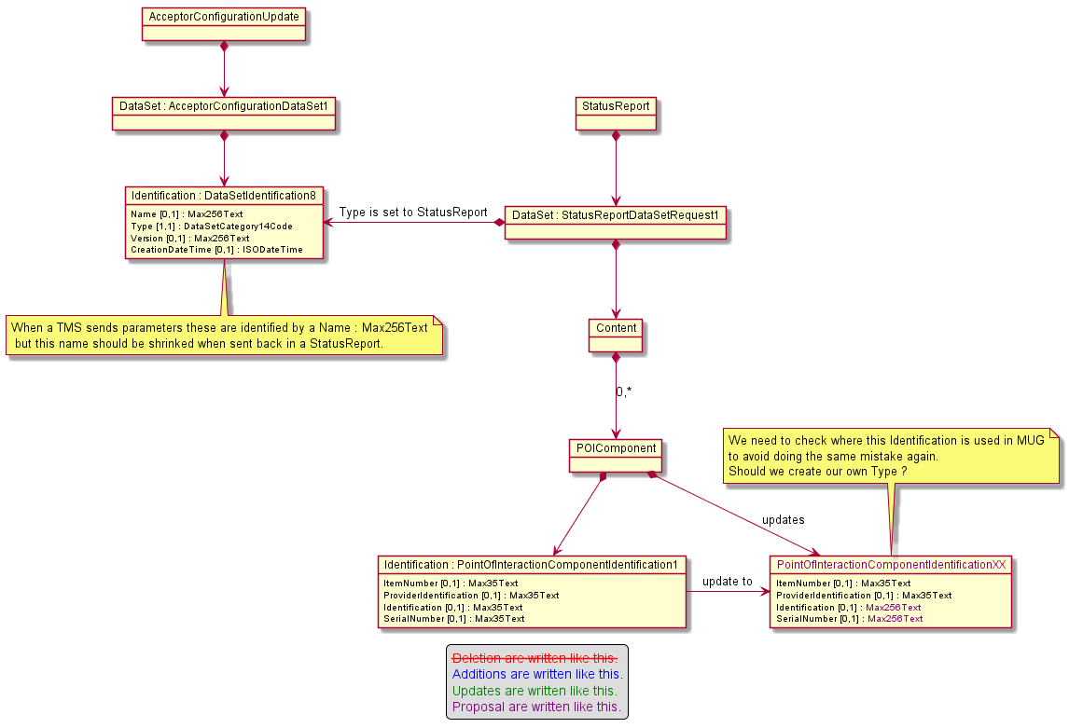

The second update targets CryptographicKey14 message component in order to extend size of message elements.

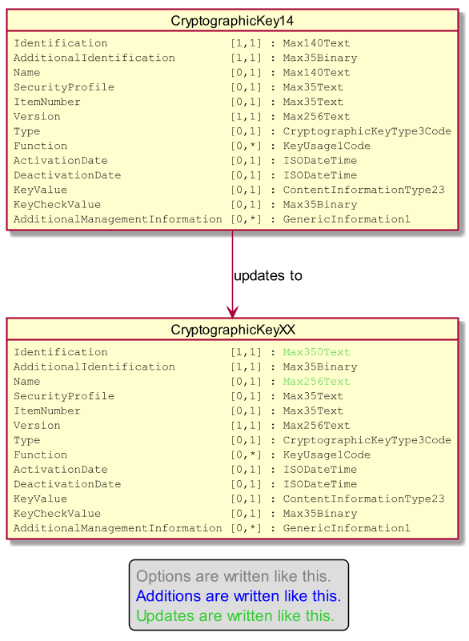

Then we want to change the type of the message element SerialNumber from Max35Binary to Max350Text. Then we will be able to set the value in any identification message element.
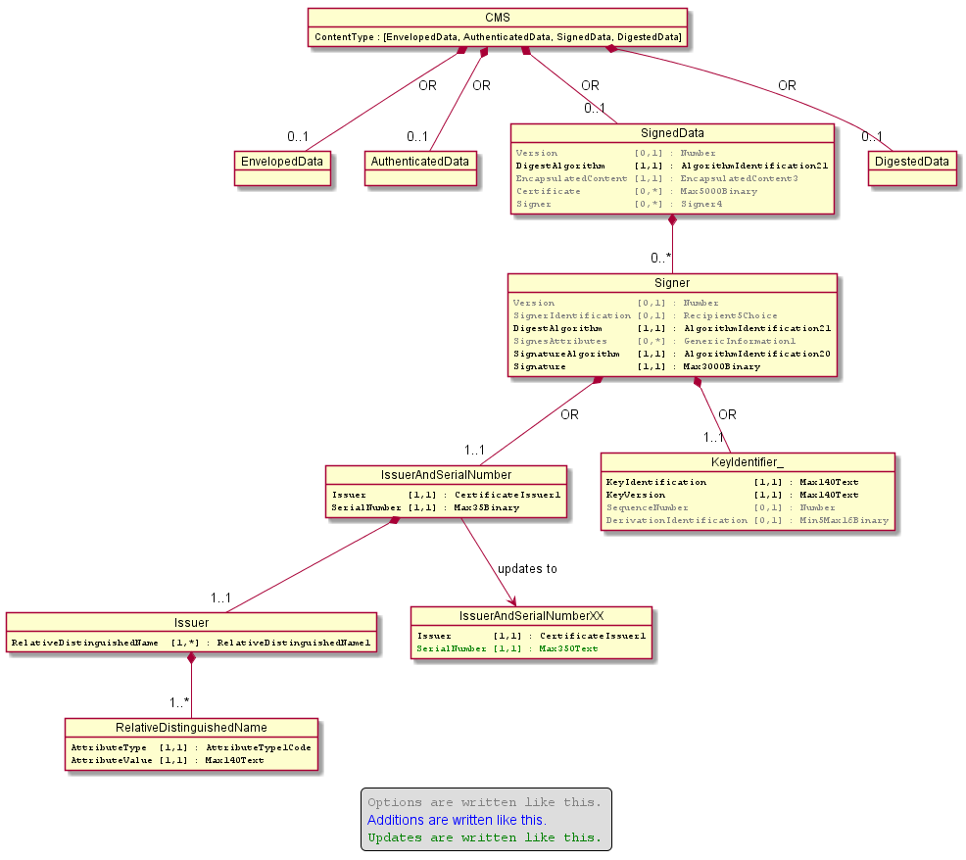

We won't change the size of the AttributeValue of the message component RelativeDistinguishedName since according to the RFC3280 the maximum length should be limited to 64.

Finally we want to change the way we identify signature computed through elliptic curve algortihm. Currently our design uses a codeset to identify the curve and the digest might be provided by a Parameter. Except the error, in the cardinality inside the message component Parameter, the classical and standardized ASN.1 way to define this kind of algorithm is to define a codeset identifying the digest algorithm and a parameter to identify the name of the curve. To avoid any misunderstanding regarding the name of the curve, the corresponding OID value will be provided in a text manner (e.g 1.2.840.10045.4.3.2).
The following diagram explains the modifications.

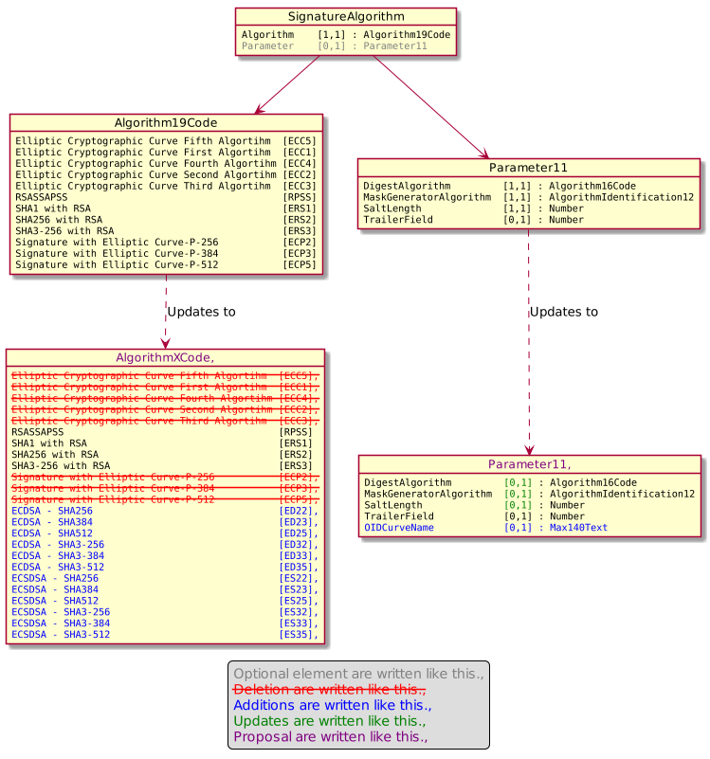

- Urgency of the request:

Urgent.

- Business examples:
Examples illustrating the change request.
- SEG/TSG recommendation:
This section is not to be taken care of by the submitter of the change request. It will be completed in due time by the SEG(s) in charge of the related ISO 20022 messages or the TSG for changes related to the BAH.

Consider |  | X | Timing
 |  |  | - Next yearly cycle: 2020/2021  (the change will be considered for implementation in the yearly maintenance cycle which starts in 2018 and completes with the publication of new message versions in the spring of 2019) |  | X
- At the occasion of the next maintenance of the messages
(the change will be considered for implementation, but does not justify maintenance of the messages in its own right – will be pending until more critical change requests are received for the messages)
- Urgent unscheduled
(the change justifies an urgent implementation outside of the normal yearly cycle)
 |  |  | - Other timing:
Comments:

Reject
Reason for rejection:

