Change Request
for the update of ISO 20022 financial repository items

- Origin of the request:
A.1 Submitter: nexo A.I.S.B.L.
A.2 Contact person: Philippe CECE (Philippe.cece@ingenico.com) / Bruno AIELLO (Bruno.Aiello@VERIFONE.com) / Philippe MERMOUD (philippe.mermoud@natixis.com)
A.3 Sponsors: nexo A.I.S.B.L.

- Related messages:

- SaleToPOIServiceResponse V02 casp 002.001.02
- SaleToPOIReconciliationResponse V02 casp 004.001.02
- SaleToPOISessionManagementResponse V02 casp 006.001.02
- SaleToPOIAdministrativeResponse V02 casp 008.001.02
- SaleToPOIReportResponse V02 casp 010.001.02
- SaleToPOIMessageStatusResponse V02 casp 015.001.02
- SaleToPOIDeviceResponse V02 casp 017.001.02

- Description of the change request:

When we defined the SaleToPOI messages, we tried to reuse as much as possible existing codeset or component. Unfortunately, we realize that this could sometimes create misundertanding, like the reuse of PARTIAL_APPROVAL to notify a successful processing of a request with some warnings. The aim of this Change Request is to correct this misunderstanding.

- Purpose of the change:

A new codeset will be defined in the ResponseCode as SUCCESS WITH WARNING, and the Response5Code will be updated to replace the current PARTIAL APPROVED by this new codeset. This new resulting ResultXXCode will be used in every response message of the Retailer protocol.

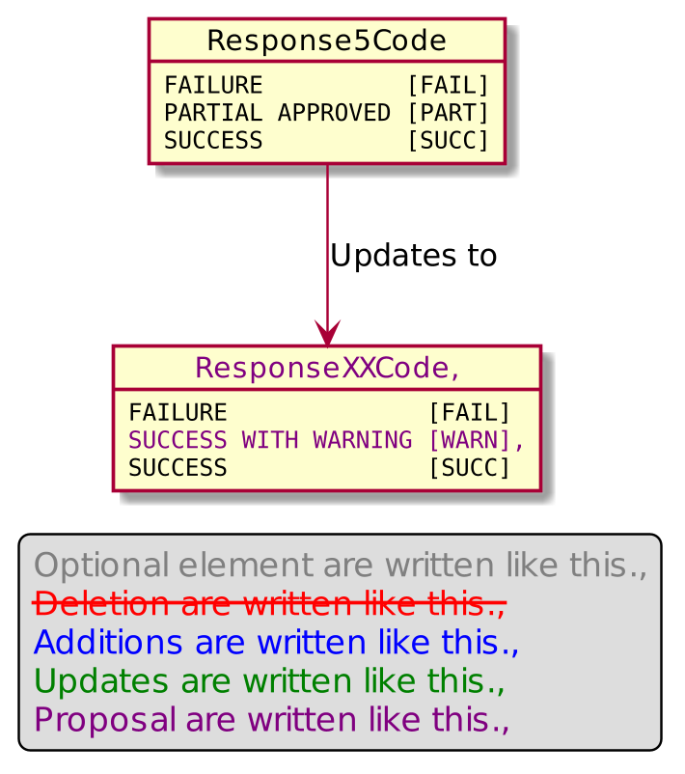

- Urgency of the request:

Urgent.

- Business examples:
Examples illustrating the change request.
- SEG/TSG recommendation:
This section is not to be taken care of by the submitter of the change request. It will be completed in due time by the SEG(s) in charge of the related ISO 20022 messages or the TSG for changes related to the BAH.

Consider |  | X | Timing
 |  |  | - Next yearly cycle: 2020/2021  (the change will be considered for implementation in the yearly maintenance cycle which starts in 2018 and completes with the publication of new message versions in the spring of 2019) |  | X
- At the occasion of the next maintenance of the messages
(the change will be considered for implementation, but does not justify maintenance of the messages in its own right – will be pending until more critical change requests are received for the messages)
- Urgent unscheduled
(the change justifies an urgent implementation outside of the normal yearly cycle)
 |  |  | - Other timing:
Comments:

Reject
Reason for rejection:

