Change Request
for the update of ISO 20022 financial repository items

- Origin of the request:
A.1 Submitter: nexo A.I.S.B.L.
A.2 Contact person: Philippe CECE (Philippe.cece@ingenico.com) / Bruno AIELLO (Bruno.Aiello@VERIFONE.com) / Philippe MERMOUD (philippe.mermoud@natixis.com)
A.3 Sponsors: nexo A.I.S.B.L.

- Related messages:

- SaleToPOIDeviceRequest V02 casp 016.001.02

- Description of the change request:

When we defined the SaleToPOI messages, we defined a PlaySound command. But we realize that it would be more interesting to defined a more universal command like a PlayResource, with a sound, or movie resource.
The aim of this Change Request is to introduce this PlayResource command

- Purpose of the change:

The proposal consists to revamp the existing PlaySoundRequest to a PlayResourceRequest. Consequently to this renaming, we need to change the codeset SoundEnd to EndOfPlay in the message component ResponseModeCode. The codesets StartSound and StopSound are also renamed Play and Stop in the message component SoundActionCode. Finally the SoundAction is renamed ResourceAction.
The generalization created by this new name also creates new actions identified by the codeset PlayInLoop, Pause, Resume in the SoundActionXCode.
Even if this current proposal is based on the reuse of the message component SoundActionCode, we might create a ResourceActionCode for repository consistency.

Since the resource could be a video, we need to provide additional information like the DisplayResolution or the TimeSlot when the resource needs to be played. This timeslot, that could be before, during or after the transaction or not in the transaction aiming the idle state is defined thanks to the ProcessingPosition2Code already defined in the repository.

Finally, the ResourceContent message component allows to define the resource to play. This could be a TextToSpeech with a relevant language or the identifier of this resource (UniformResourceIdentifier).

The following diagram depicts this proposal.

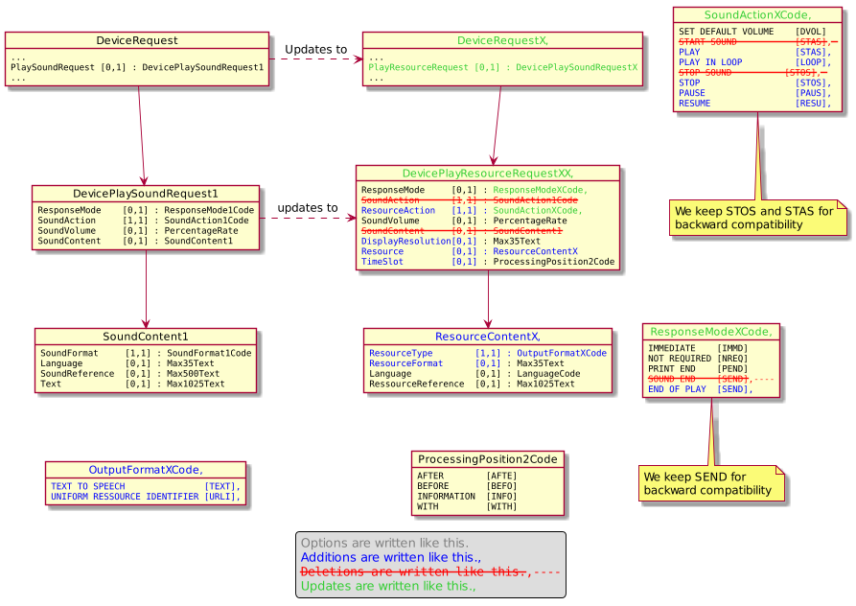

- Urgency of the request:

Urgent.

- Business examples:
Examples illustrating the change request.
- SEG/TSG recommendation:
This section is not to be taken care of by the submitter of the change request. It will be completed in due time by the SEG(s) in charge of the related ISO 20022 messages or the TSG for changes related to the BAH.

Consider |  | X | Timing
 |  |  | - Next yearly cycle: 2020/2021  (the change will be considered for implementation in the yearly maintenance cycle which starts in 2018 and completes with the publication of new message versions in the spring of 2019) |  | X
- At the occasion of the next maintenance of the messages
(the change will be considered for implementation, but does not justify maintenance of the messages in its own right – will be pending until more critical change requests are received for the messages)
- Urgent unscheduled
(the change justifies an urgent implementation outside of the normal yearly cycle)
 |  |  | - Other timing:
Comments:

Reject
Reason for rejection:

