Change Request
for the update of ISO 20022 financial repository items

- Origin of the request:
A.1 Submitter: nexo A.I.S.B.L.
A.2 Contact person: Philippe CECE (Philippe.cece@ingenico.com) / Pierre MOURA (pierre.moura@frenchsys.com) / Bruno AIELLO (Bruno.Aiello@VERIFONE.com) / Philippe MERMOUD (philippe.mermoud@natixis.com).
A.3 Sponsors: nexo A.I.S.B.L.

- Related messages:

For the caaa related messages:
- AcceptorAuthorisationRequest V09 caaa.001.001.09
- AcceptorAuthorisationResponse V09 caaa.002.001.09
- AcceptorCompletionAdvice V09 caaa.003.001.09
- AcceptorCompletionAdviceResponse V08 caaa.004.001.08
- AcceptorCancellationRequest V09 caaa.005.001.09
- AcceptorCancellationResponse V08 caaa.006.001.08
- AcceptorCancellationAdvice V09 caaa.007.001.09
- AcceptorCancellationAdviceResponse V08 caaa.008.001.08
- AcceptorReconciliationRequest V08 caaa.009.001.08
- AcceptorReconciliationResponse V07 caaa.010.001.07
- AcceptorBatchTransfer V09 caaa.011.001.09
- AcceptorBatchTransferResponse V08 caaa.012.001.08
- AcceptorDiagnosticRequest V08 caaa.013.001.08
- AcceptorDiagnosticResponse V07 caaa.014.001.07
- AcceptorCurrencyConversionRequest V07 caaa.016.001.07
- AcceptorCurrencyConversionResponse V07 caaa.017.001.07
- AccpetorCurrencyConversionAdvice V04 caaa.018.001.04
- AcceptorCurrencyConversionAdviceResponse V03 caaa.019.001.03
- TransactionAdvice V01 caaa.020.001.01
- TransactionAdviceResponse V01 caaa.021.001.01

For the casp related messages:
- SaleToPOIServiceRequest V02 casp 001.001.02
- SaleToPOIServiceResponse V02 casp 002.001.02
- SaleToPOIReconciliationRequest V02 casp 003.001.02
- SaleToPOIReconciliationResponse V02 casp 004.001.02
- SaleToPOISessionManagementRequest V02 casp 005.001.02
- SaleToPOISessionManagementResponse V02 casp 006.001.02
- SaleToPOIAdministrativeRequest V02 casp 007.001.02
- SaleToPOIAdministrativeResponse V02 casp 008.001.02
- SaleToPOIReportRequest V02 casp 009.001.02
- SaleToPOIReportResponse V02 casp 010.001.02
- SaleToPOIAbort V02 casp 011.001.02
- SaleToPOIEventNotification V02 casp 012.001.02
- SaleToPOIMessageStatusRequest V02 casp 014.001.02
- SaleToPOIMessageStatusResponse V02 casp 015.001.02
- SaleToPOIDeviceRequest V02 casp 016.001.02
- SaleToPOIDeviceResponse V02 casp 017.001.02

- Description of the change request:

In order to foster the adoption of iso20022 protocols, we would like to harmonize the token message component with the one defined by the ATICA protocol. This update will simplify the usage of tokens from the acceptor devices until the issuer domain.

Additionally to the introduction, last year, of new codeset related to 3DS v2.2, we realize that the authorization response, asking for ConsumerDeviceCardholderVerificationMethod, may require change the CustomerDevice1 message component.

- Purpose of the change:

Regarding the update of the message component CustomerDevice1, we only have to extend the length of the message element CustomerDevice/Type from Max35Text to Max70Text.

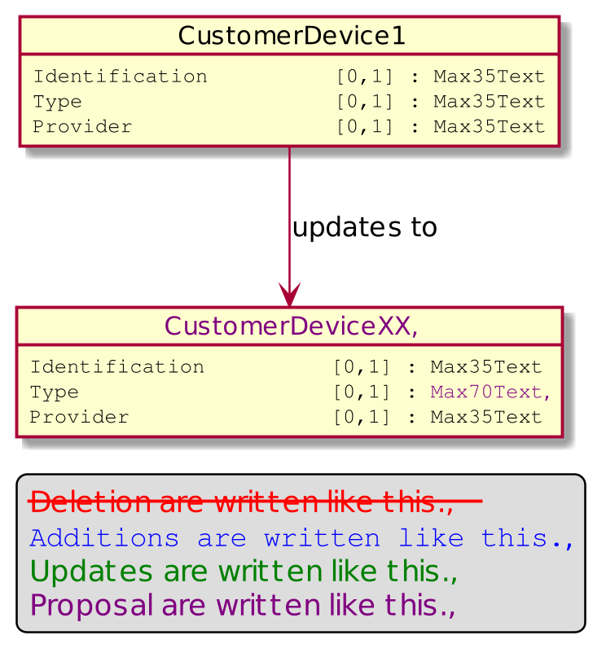

Currently, acceptor to acquirer message transports token through a message element named PaymentToken defined with the message component CardPaymentToken5. The aim of this proposal is to split the current usage of PaymentToken in two parts. The first part will focused on credit card token with the same use cases than the token defined by ATICA protocol. So the first part, still named PaymentToken will be defined with the ATICA message component, which might, as far as we know, be named Token1. The second part of the former PaymentToken message element, will cover use cases that are not managed by the ATICA protocol. This element will be named MerchantPaymentToken and will be defined by the message component MerchantPaymentToken1. This later message component will be a copy from CardPaymentToken5. The introduction of this new message component should underline that the scope of this token is not the same as the card payment token defined by ATICA.

The updated messages are listed in a bold green font in the following diagram. Impacts on the RetailerProtocol have been also identified.

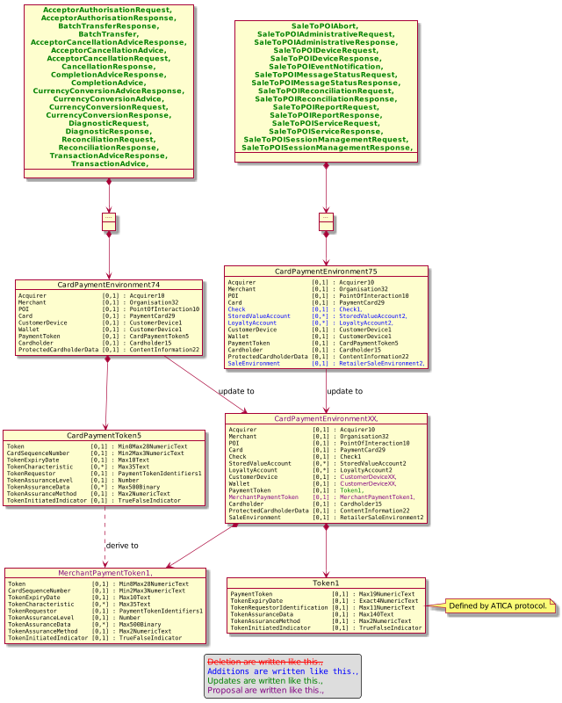

- Urgency of the request:

Not urgent.

- Business examples:
Examples illustrating the change request.

- SEG/TSG recommendation:
This section is not to be taken care of by the submitter of the change request. It will be completed in due time by the SEG(s) in charge of the related ISO 20022 messages or the TSG for changes related to the BAH.

Consider |  | X | Timing
 |  |  | - Next yearly cycle: 2020/2021  (the change will be considered for implementation in the yearly maintenance cycle which starts in 2018 and completes with the publication of new message versions in the spring of 2019) |  | X
- At the occasion of the next maintenance of the messages
(the change will be considered for implementation, but does not justify maintenance of the messages in its own right – will be pending until more critical change requests are received for the messages)
- Urgent unscheduled
(the change justifies an urgent implementation outside of the normal yearly cycle)
 |  |  | - Other timing:
Comments:

Reject
Reason for rejection:

