Change Request
for the update of ISO 20022 financial repository items

- Origin of the request:
A.1 Submitter: nexo A.I.S.B.L.
A.2 Contact person: Philippe CECE (Philippe.cece@ingenico.com) / Pierre MOURA (pierre.moura@frenchsys.com)
A.3 Sponsors: nexo A.I.S.B.L.

- Related messages:

- AcceptorAuthorisationRequest V09 caaa.001.001.09
- AcceptorCompletionAdvice V09 caaa.003.001.09
- AcceptorCompletionAdviceResponse V08 caaa.004.001.08
- AcceptorCancellationRequest V09 caaa.005.001.09
- AcceptorCancellationResponse V08 caaa.006.001.08
- AcceptorCancellationAdvice V09 caaa.007.001.09
- AcceptorCancellationAdviceResponse V08 caaa.008.001.08
- AcceptorReconciliationResponse V07 caaa.010.001.07
- AcceptorBatchTransfer V09 caaa.011.001.09
- AcceptorCurrencyConversionAdviceResponse V03 caaa.019.001.03
- TransactionAdvice V01 caaa.020.001.01
- TransactionAdviceResponse V01 caaa.021.001.01

- Description of the change request:

We would like to add TechnicalError to the Reponse4Code, and by extend to replace this codeset by the existing Response6Code.

- Purpose of the change:

The authorisation response sent by an acquirer to an acceptor ise set by a Response6Code. But in a CompletionAdvice message, the authorization response sent back from the acceptor to the acquirer, is set amongst Response4Code. The subject of this update, is to reuse Response6Code in any messages.

The updated messages are listed in a bold green font in the following diagram.

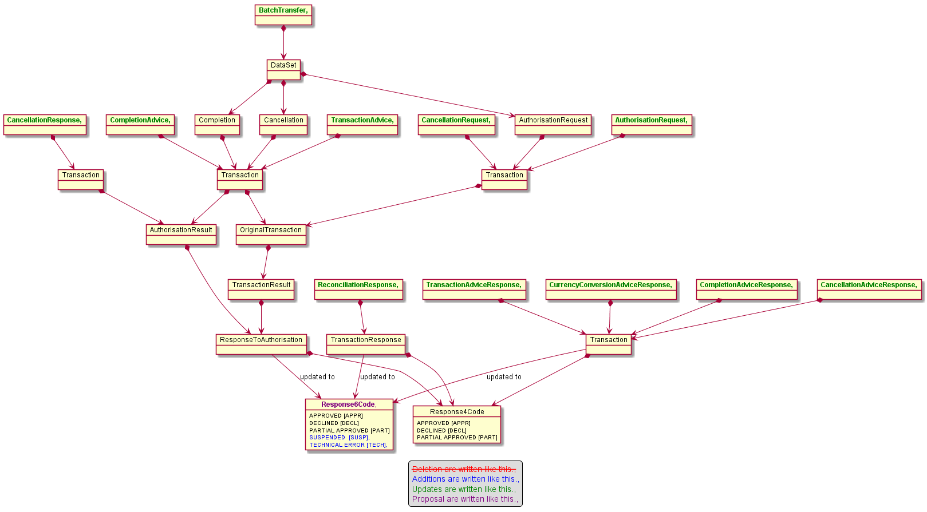

The addition, of the value TechnicalError will also impact the message component ActionType8Code with new values that are still under study. These new values will be provided later.

- Urgency of the request:

Urgent.

- Business examples:
Examples illustrating the change request.
- SEG/TSG recommendation:
This section is not to be taken care of by the submitter of the change request. It will be completed in due time by the SEG(s) in charge of the related ISO 20022 messages or the TSG for changes related to the BAH.

Consider |  | X | Timing
 |  |  | - Next yearly cycle: 2020/2021  (the change will be considered for implementation in the yearly maintenance cycle which starts in 2018 and completes with the publication of new message versions in the spring of 2019) |  | X
- At the occasion of the next maintenance of the messages
(the change will be considered for implementation, but does not justify maintenance of the messages in its own right – will be pending until more critical change requests are received for the messages)
- Urgent unscheduled
(the change justifies an urgent implementation outside of the normal yearly cycle)
 |  |  | - Other timing:
Comments:

Reject
Reason for rejection:

