Change Request
for the update of ISO 20022 financial repository items

- Origin of the request:
A.1 Submitter:
DESSUG CA – PSG (Deutsche SWIFT Securities Market User Group - Corporate Actions - Proxy Subgroup Germany)
This group represents more than 20 different institutions including domestic and global proxy providers and registrars with a key role in the German General Meeting process.

A.2 Contact person:
Chair - Hendrik Melchior (employer change to Clearstream Banking Frankfurt on July 1)
Deputy Chair - Daniel Schäfer, Daniel.Schaefer@hsbc.de, Phone +49 211 910-2362
Sabine Wolff, Sabine.Wolff@clearstream.com, Phone +352-243-3 66 40
SEG GM-ET (Germany) - Sven Gunkel, sven-a.gunkel@db.com, Phone +49 69910-60715
SEG GM-ET (Germany) - Rainer Prior, Rainer.Prior@linkmarketservices.de, Phone +49 6196 8870 514

A.3 Sponsors:
German Market - including domestic and global proxy providers with a key role in the German General Meeting process.
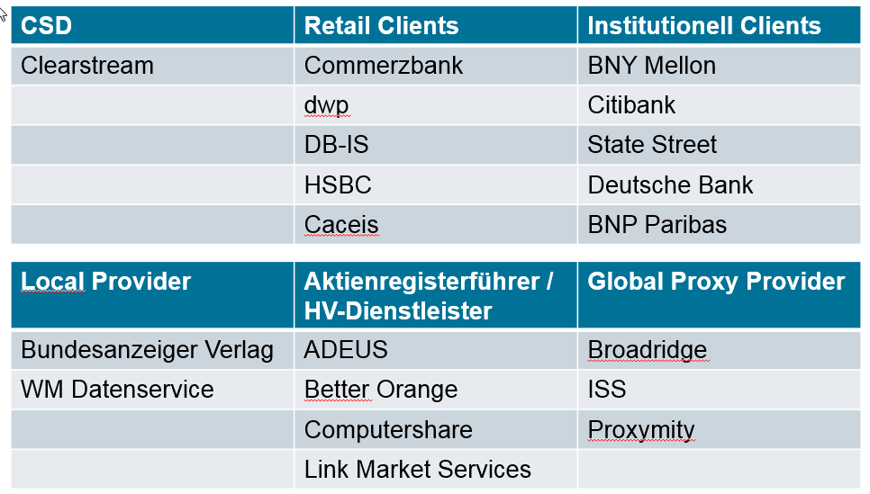

- Related messages:
seev.001.xxx.xxx

- Description of the change request:
This is Change Request #1 of 3 ParticipationMethod/Deadline+VoteDeadline

Issuer Deadline for Voting is captured under Participation methods and does not allow to distinguish different deadlines applicable to different participation methods, i.e. electronic voting can be up to and during the meeting whereas votes per mail need to be processed manually and hence, afford a buffer before the meeting takes place.
The Implementation Regulation (EU) 2018/1212, better known as SRD II, clearly distinguishes
- Issuer Deadline for the notification of participation (table 3 D2) and
- Issuer Deadline for Voting (table 3 D3)

Description and Definition Change:
Rename “Issuer Deadline for Voting” under Participation Method to
“Issuer Deadline for the notification of Participation” according to the Implementation Regulation, because the current description is misleading.

Current Description of Issuer Deadline for Voting: Deadline for voting on agenda resolutions at the general meeting.

New Description of Issuer Deadline for the notification of Participation: Deadline for participation at the general meeting.

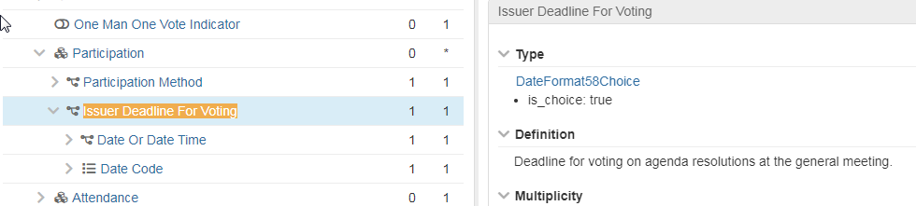

As per page 13 of the SMPG_MP_Final_v1.1 from August 28, 2020, the “IssuerDeadlineForVoting“ that refers to table 3 – D3 of the Implementation Regulation (EU) 2018/1212, appears to be incorrect for a STP notification and processing.
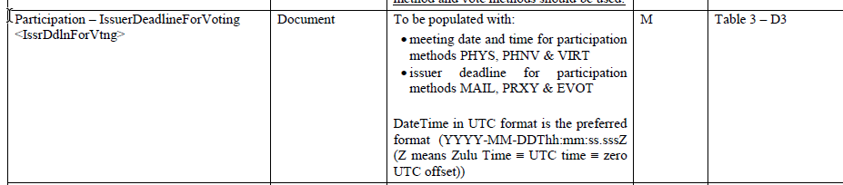

The SMPG recommendation on page 19 referring to table 3 – D2 of the Implementation Regulation (EU) 2018/1212 seems to be incorrect as well.
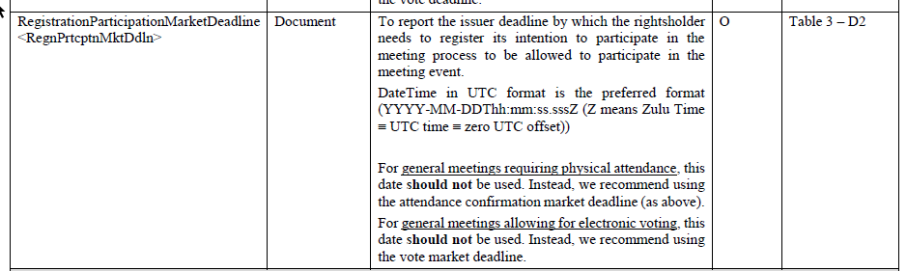

The Issuer Deadline for Voting (table 3 D3) of the Implementation Regulation (EU) 2018/1212 should be populated in Section Vote – Vote Market Deadline (Path: /Document/MtgNtfctn/Vote/VoteDdln)

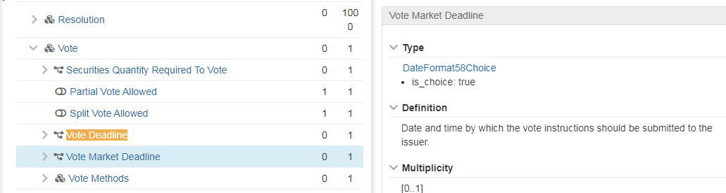

- Purpose of the change:
The participants of the German User Group agreed that the naming shall be changed as creates uncertainty on how to distinguish specific deadlines, i.e. participation deadline versus vote market deadline.
Risk: The current set up may lead to late votes received that cannot be processed and hence, is not in line with the SRD II requirement.

- Urgency of the request:
N/A

- Business examples:

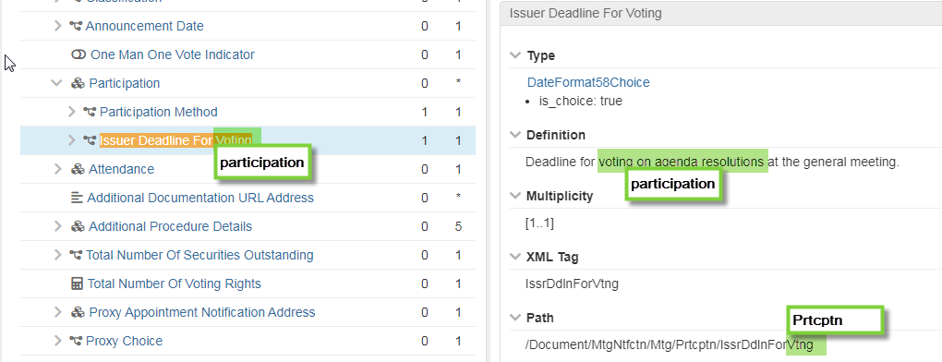

- SEG/TSG recommendation:
This section is not to be taken care of by the submitter of the change request. It will be completed in due time by the SEG(s) in charge of the related ISO 20022 messages or the TSG for changes related to the BAH.

Consider |  |  | Timing
- Next yearly cycle: 2021/2022
(the change will be considered for implementation in the yearly maintenance cycle which starts in 2021 and completes with the publication of new message versions in the spring of 2022)
- At the occasion of the next maintenance of the messages
(the change will be considered for implementation, but does not justify maintenance of the messages in its own right – will be pending until more critical change requests are received for the messages)
- Urgent unscheduled
(the change justifies an urgent implementation outside of the normal yearly cycle)
 |  |  | - Other timing:
Comments:

Reject
Reason for rejection:

