Change Request
for the update of ISO 20022 financial repository items

- Origin of the request:
A.1 Submitter: Mastercard.
A.2 Contact person:
Heike Strasser (Director, Product Architecture) – heike.strasser@mastercard.com
tel +44(0)203 818 4364 | mobile +44(0)781 4681510
A.3 Sponsors:
- Related messages:
- Identification Modification – acmt.022
- Identification Verification Request – acmt.023
- Identification Verification Report – acmt.024
- Description of the change request:
For the Modification Advice and Verification Identification it is beneficial that the newly adapted element for proxy / alias information introduced in the 2019 Version to be used for account information.
Existing – AccountIdentification4Choice
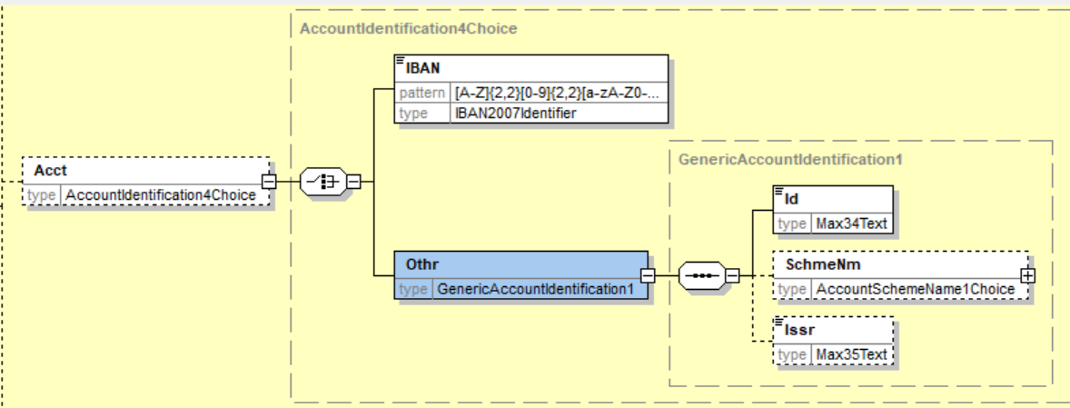
New (replaced) – CashAccount38
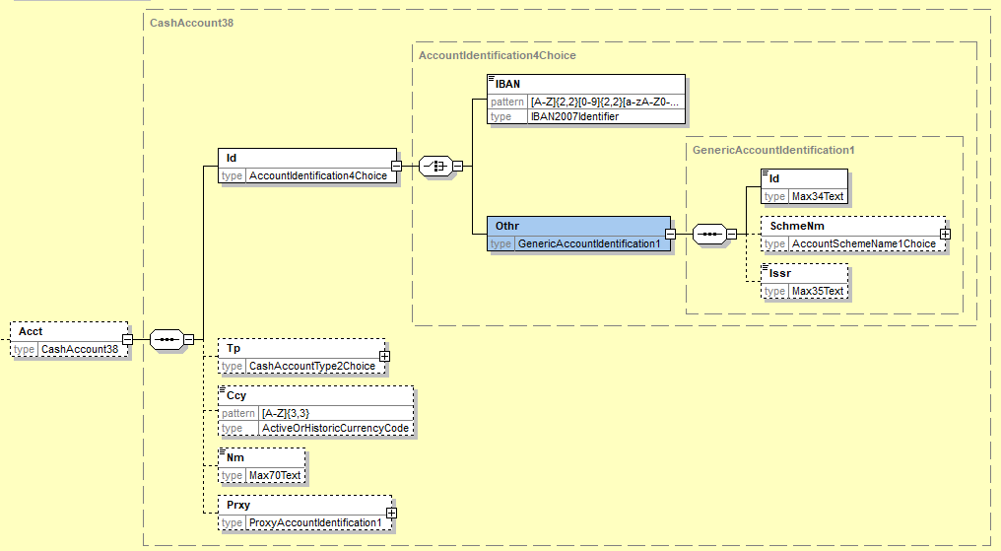
acmt.022
Existing
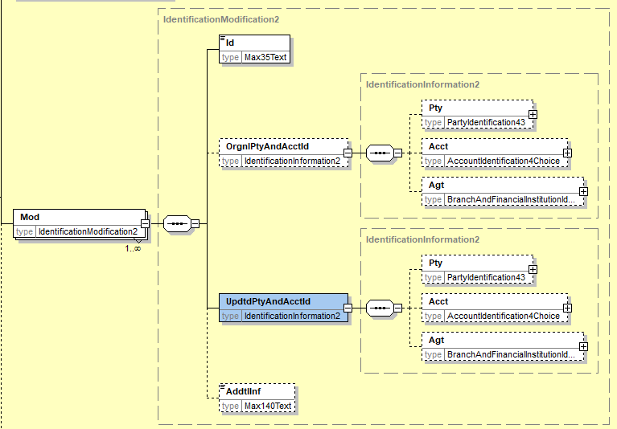
New
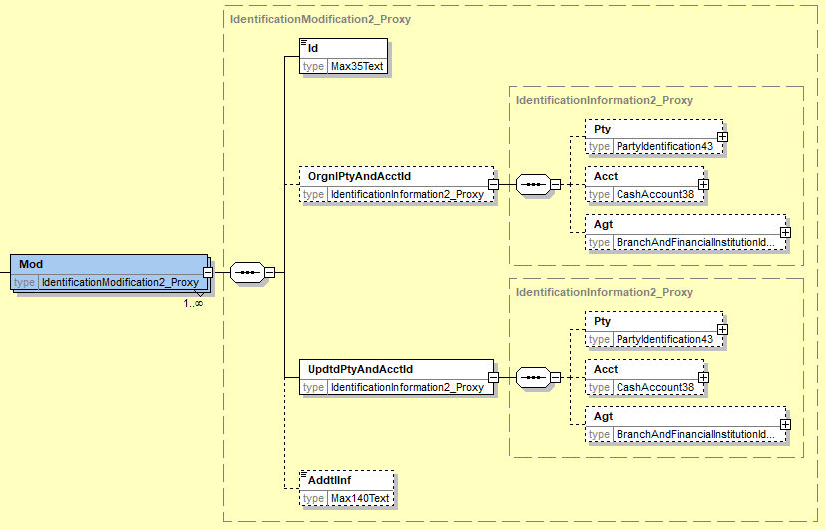

acmt.023
Existing
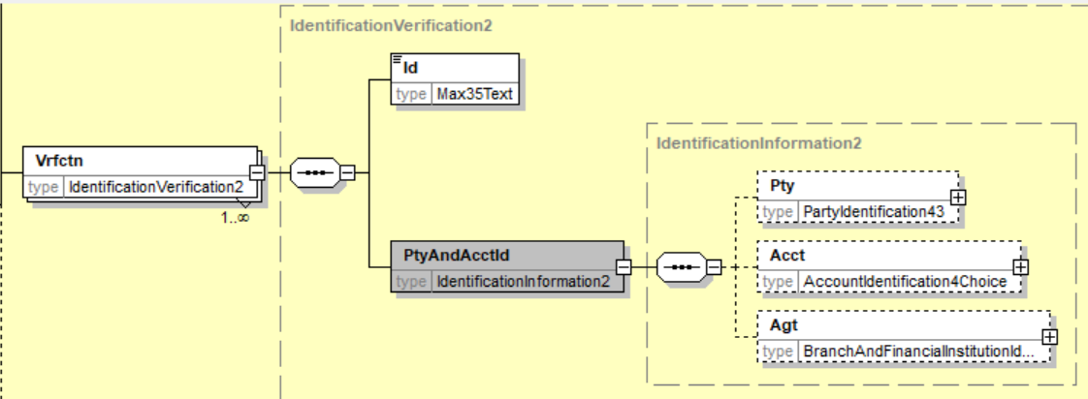

New
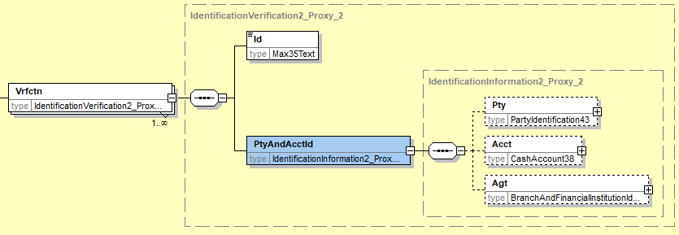
acmt.024
Existing

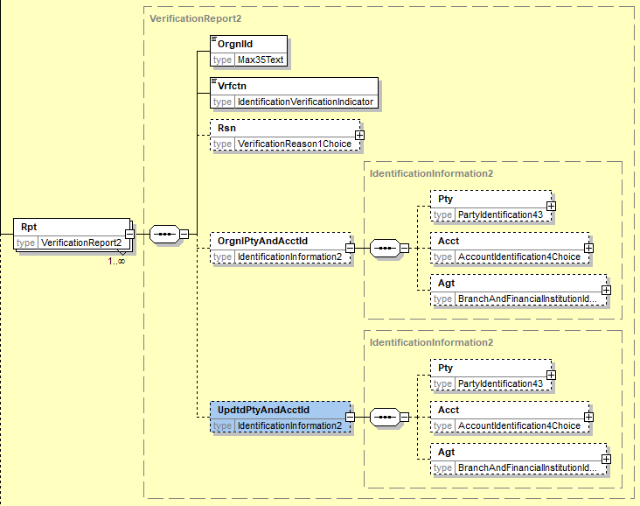
New
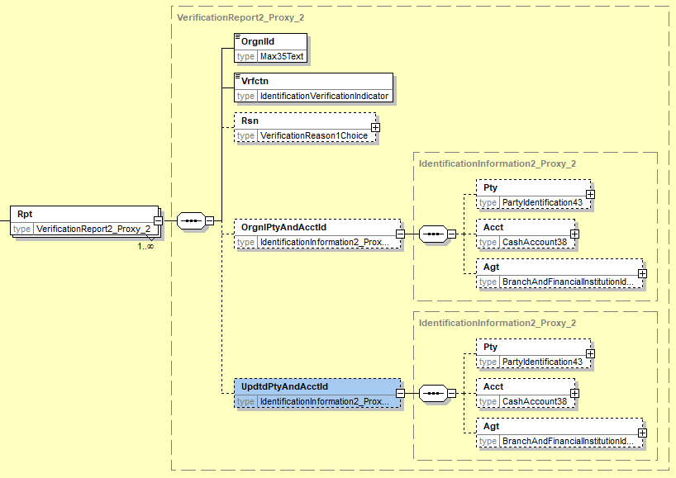

- Purpose of the change:
The adaptation for the CashAccount38 in the 2019 versions for payments is being established in different regions. Closely linked to payment are automatically functions to inform the sender about changes in the account details (mainly account holder). With the new introduction of the proxy/alias information some of these updates are now linked to these new additional data fields. With the existing set of acmt.022/023 and 024 there are no relevant fields available.
- Urgency of the request:
Request to be implemented in the next ISO release
- Business examples:
Credit Transfer – pacs.008 – was executed with information of account details with proxy information. The creditor agent accepted the payment with information to the debtor agent that the proxy information was updated.

pacs.008 with proxy:
<ct:MsgId>M2020030200110011BTRF00000000011</ct:MsgId>
<ct:CreDtTm>2020-03-02T10:05:00</ct:CreDtTm>
:
:
<ct:DbtrAcct>
<ct:Id>
<ct:Othr>
<ct:Id>01196000999999999999</ct:Id>
</ct:Othr>
</ct:Id>
<ct:Prxy>
<ct:Tp>
<ct:Cd>EMAL</ct:Cd>
</ct:Tp>
<ct:Id>maxmuster@info.com</ct:Id>
</ct:Prxy>
</ct:DbtrAcct>

Modification Information acmt.022 with proxy:
<OrgnlTxRef>
<MsgId>M2020030200110011BTRF00000000011</MsgId>
<MsgNmId>pacs.008.001.08</MsgNmId>
<CreDtTm>2020-03-02T10:05:00</CreDtTm>

<Mod>
<Id>2020030300550055BACVR0000001</Id>
<OrgnlPtyAndAcctId>
<Pty>
<Nm>Max Muster</Nm>
<PstlAdr>
</Pty>
<Acct>
<Id>
<Othr>
<Id>01196000999999999999</Id>
</Othr>
</Id>
<Prxy>
<Tp>
<Cd>EMAL</Cd>
</Tp>
<Id>maxmuster@info.com</Id>
</Prxy>
</Acct>
</OrgnlPtyAndAcctId>
<UpdtdPtyAndAcctId>
<Pty>
<Nm>Max Muster-Smith</Nm>
</Pty>
<Acct>
<Id>
<Othr>
<Id>01196000999999999999</Id>
</Othr>
</Id>
<Prxy>
<Tp>
<Cd>EMAL</Cd>
</Tp>
<Id>max@muster-smith.com</Id>
</Prxy>
</Acct>
</UpdtdPtyAndAcctId>
- SEG/TSG recommendation:

Consider |  | X | Timing
 |  |  | - Next yearly cycle: 2020/2021  (the change will be considered for implementation in the yearly maintenance cycle which starts in 2018 and completes with the publication of new message versions in the spring of 2019) |  | X
- At the occasion of the next maintenance of the messages
(the change will be considered for implementation, but does not justify maintenance of the messages in its own right – will be pending until more critical change requests are received for the messages)
- Urgent unscheduled
(the change justifies an urgent implementation outside of the normal yearly cycle)
 |  |  | - Other timing:
Comments:

Reject
Reason for rejection:

