Change Request
for the update of ISO 20022 financial repository items

- Origin of the request:
A.1 Submitter: Payments Canada
A.2 Contact persons:
Malene McMahon – mmcmahon@payments.ca (+1 613 315 4991)
Isak Penttila – ipenttila@payments.ca (+1 613 315 4075)
A.3 Sponsors: U.S. Federal Reserve Bank (Frank Vandriessche)

- Related messages:
pacs.008, pacs.009, pacs.004 and any other message with a tax component.

- Description of the change request:
This is a request to change the data type for an element in the Tax and Tax Remittance components in the pacs.008, pacs.009 (Underlying) and pacs.004 (Original Transaction Reference). For illustration, we will refer to the pacs.008 but it is the same element for the pacs.009 and the pacs.004.
Under pacs.008/CreditTransferTransactionInformation/Tax/Record/Period, there is an element called “Year” which is defined as the “Year related to the tax payment”. Unfortunately, the data type is ISODate (Date). We believe this should be changed to reflect only a ‘year’ data type where you can only put the 4-digit year as the value. With the ISODate (Date) data type you are forced to put an actual calendar date.
The same anomaly occurs under pacs.008/CreditTransferTransactionInformation/RemittanceInformation/Structured/TaxRemittance/Record/Period. We believe “Year” under this component should be typed as only a year and not a full date.
- Purpose of the change:
We believe that this is simply an error in the assignment of the data type and should be corrected to reflect the appropriate data type for the definition of the element.

- Urgency of the request:
This correction should be made during the next maintenance cycle.

- Business examples:
Below is a snippet of the component (from RmtInf/Strd in pacs.008, highlighted in blue) that we believe should be changed to properly reflect a ‘year’ and not a ‘date’.

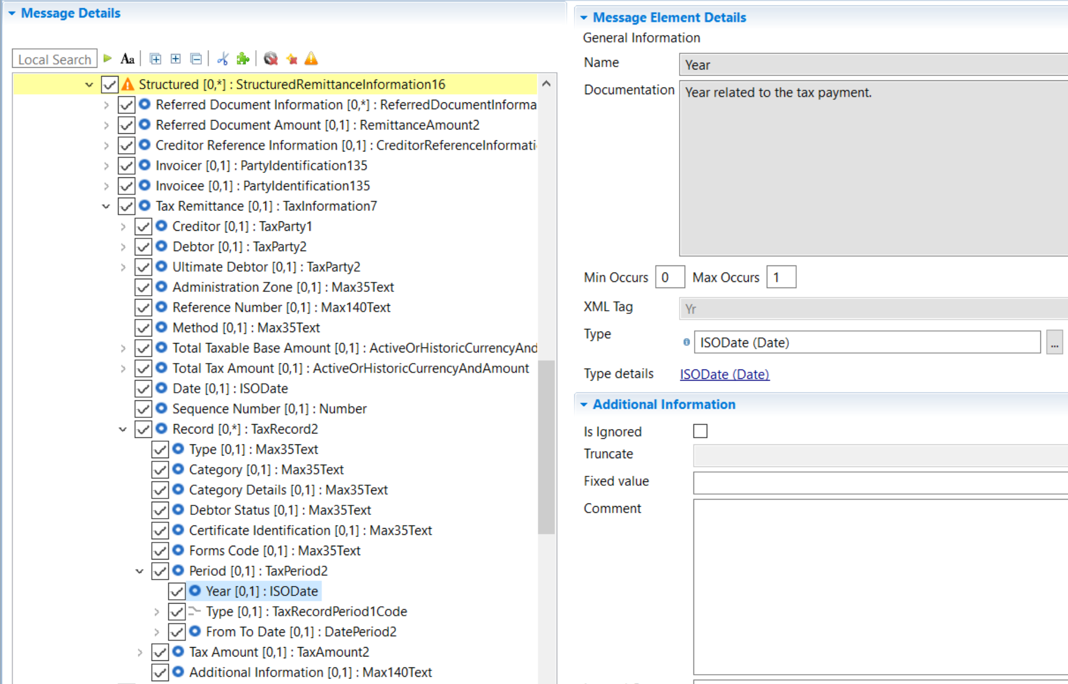

- SEG/TSG recommendation:

Consider |  | X | Timing
 |  |  | - Next yearly cycle: 2020/2021  (the change will be considered for implementation in the yearly maintenance cycle which starts in 2018 and completes with the publication of new message versions in the spring of 2019) |  | X
- At the occasion of the next maintenance of the messages
(the change will be considered for implementation, but does not justify maintenance of the messages in its own right – will be pending until more critical change requests are received for the messages)
- Urgent unscheduled
(the change justifies an urgent implementation outside of the normal yearly cycle)
 |  |  | - Other timing:
Comments:

Reject
Reason for rejection:

