Change Request
for the update of ISO 20022 financial repository items

- Origin of the request:
A.1 Submitter: SMPG (Securities Market Practice Group)
A.2 Contact person:
Christine Strandberg: christine.strandberg@seb.se - +46 (8) 763 60 74
Mariangela Fumagalli: mariangela.fumagalli@bnpparibas.com - +442075954988
Jacques Littré: jacques.littre@swift.com - +3226554335
A.3 Sponsors:
Securities Market Practice Group

- Related messages:
seev.031.00x.10 and seev.001.001.07

- Description of the change request:
In the seev.031 message,
- in the sequence CorporateActionDetails/AdditionalInformation, make the element URLAddress repeatable and change the data type UpdatedURLInformation2 by adding a mandatory element named Language typed with the data type ISO2ALanguageCode as illustrated below:
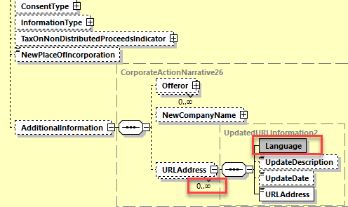

- In the sequence CorporateActionOptionDetails/AdditionalInformation, make all narrative type elements repetitive and change the data type UpdatedURLInformation3 by adding a mandatory element named Language typed with the data type ISO2ALanguageCode as illustrated below:
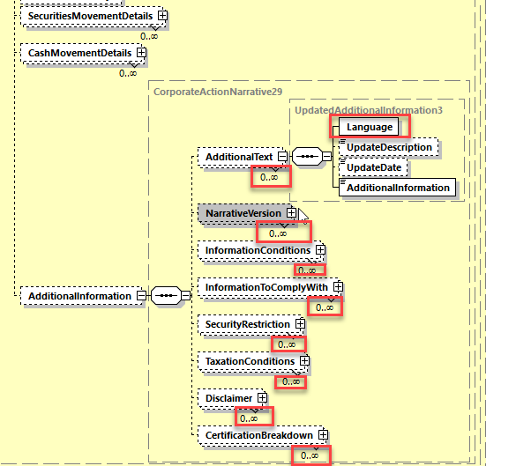
- In the sequence AdditionalInformation, make all narrative type elements repetitive and change the data type UpdatedURLInformation8 by adding a mandatory element named Language typed with the data type ISO2ALanguageCode and for the URLAddress element, change the data type Max2048 Text by the new data type used to type the URLAddress in the CorporateActionDetails sequence as illustrated below:
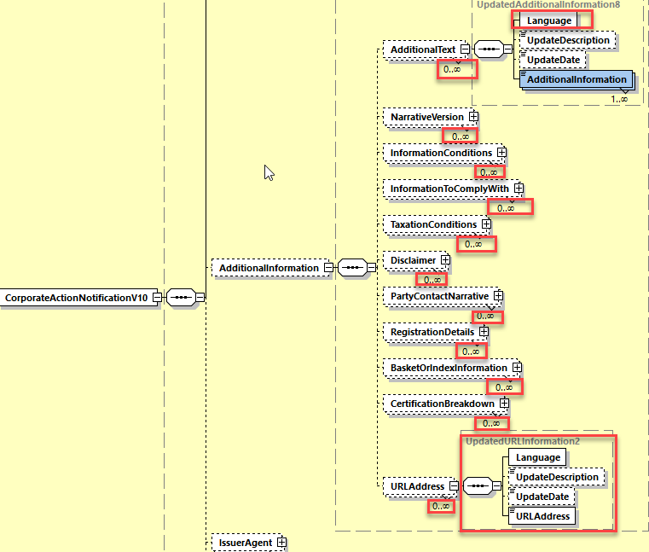
In the seev.001 message,
- In the Resolution sequence, Create a new subsequence containing the elements Description, Title and a new element Language typed by the data type ISO2ALanguageCode as illustrated below:
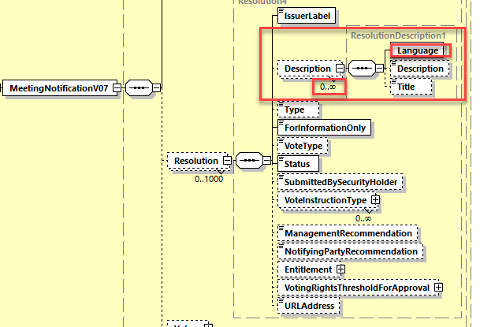
- In the AdditionalInformation sequence, replace the data type of the Disclaimer element by a new data type containing the mandatory element Language typed by ISO2ALanguageCode and the element AdditionalInformation typed by Max8000Text (similarly to the seev.031 Corporate Action Notification message).
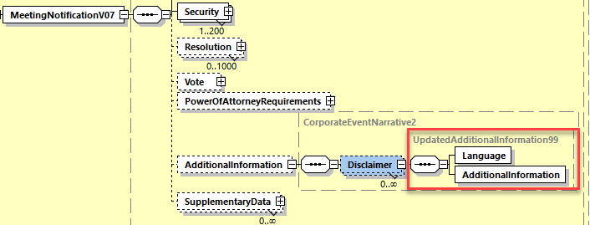
- Purpose of the change:
The Shareholder Rights Directive (SRD) Implementation Regulation EU 2018/1212 specifies in article 2 paragraph 2 for corporate action events and general meetings that “The information shall be provided by the issuer in the language in which it publishes its financial information pursuant to Directive 2004/109/EC of the European Parliament and of the Council (1) and, unless not justified taking into account the issuer's shareholder base, also in a language customary in the sphere of international finance.”
This means that the announcement messages for corporate actions and general meetings in the scope of SRDII must be able to accommodate in addition to English the same narrative information in one or more other languages used in the EU/EEA countries and be able identify the language itself.
It should also be possible to provide references to a web site via URL addresses with information in different languages. Therefore it is also necessary to enable the repetition of the URL address element in the announcement and be able to identify the language of the provided information to which the URL is pointing.
- Urgency of the request:
For SR2021.
- Business examples:
N/A
- SEG/TSG recommendation:
This section is not to be taken care of by the submitter of the change request. It will be completed in due time by the SEG(s) in charge of the related ISO 20022 messages or the TSG for changes related to the BAH.

Consider |  | X | Timing
 |  |  | - Next yearly cycle: 2020/2021  (the change will be considered for implementation in the yearly maintenance cycle which starts in 2018 and completes with the publication of new message versions in the spring of 2019) |  | X
- At the occasion of the next maintenance of the messages
(the change will be considered for implementation, but does not justify maintenance of the messages in its own right – will be pending until more critical change requests are received for the messages)
- Urgent unscheduled
(the change justifies an urgent implementation outside of the normal yearly cycle)
 |  |  | - Other timing:
Comments:

Reject
Reason for rejection:

