Change Request
for the update of ISO 20022 financial repository items
- Origin of the request:
A.1 Submitter: Janice Chapman, on behalf of SMPG IF.
A.2 Contact person: Janice.chapman@swift.com
A.3 Sponsors:
- Related messages:
# | Name | Message Identifier
1 | Transfer In Cancellation Request | sese.006.001.08
- Description of the change request:
Add the following element:
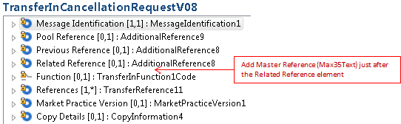
- Purpose of the Change:
A structural change was made to the funds transfer (sese) cancellation messages (sese.002 & sese.006) in the 2017-2018 maintenance cycle. By mistake, the Master Reference was dropped and so needs to be restored.
- Urgency of the request:
For the next maintenance when sese.001, 003, 005 and 007 are maintained.
- Business examples:

- SEG/TSG recommendation:
This section is not to be taken care of by the submitter of the change request. It will be completed in due time by the SEG(s) in charge of the related ISO 20022 messages or the TSG for changes related to the BAH.
Consider |  |  | Timing
- Next yearly cycle: 2018/2019
(the change will be considered for implementation in the yearly maintenance cycle which starts in 2018 and completes with the publication of new message versions in the spring of 2019)
- At the occasion of the next maintenance of the messages
(the change will be considered for implementation, but does not justify maintenance of the messages in its own right – will be pending until more critical change requests are received for the messages)
- Urgent unscheduled
(the change justifies an urgent implementation outside of the normal yearly cycle)
 |  |  | - Other timing:
Comments:
WITHDRAWN

Reject
Reason for rejection:

