Addition of Triparty Collateral Transaction Instruction Processing Status Advice Identification, Triparty Collateral Status Advice Identification and Triparty Collateral and Exposure Report Identification at Reference Level
for the update of ISO 20022 financial repository items
Note: the purpose of this document is to give guidelines to parties who want to introduce a request to change an existing ISO 20022 message(s), or update other items of the ISO 20022 financial repository. Such change requests are subject to the approval of the ISO 20022 Standards Evaluation Group(s) in charge of the related message/item or to the approval of the Technical Support Group (TSG), if the requested change relates to the Business Application Header (BAH). Please consult the iso20022.org website for additional details on the maintenance process. Change requests are to be sent to iso20022ra@iso20022.org. All change requests conforming to this template received by June 1st will be considered for development in the following yearly ISO 20022 maintenance cycle which completes with publication of new message versions in April/May of the following year.
- Origin of the request:
A.1 Submitter: Banco de España on behalf of 4CB for ECMS; SWIFT.
A.2 Contact person: Manuel Huete, manuel.huete@bde.es, +34 91 585 5237
Karine Taquet, karine.taquet@swift.com, +32 2 655 37 84
A.3 Sponsors:
The Eurosystem’s Advisory Group on Market Infrastructures for Securities and Collateral (AMI-SeCo) agreed to introduce a single, harmonised triparty model for Europe that would be based on the global ISO20022 messaging standard.
There is broad endorsement of the Standards by all TPAs, central banks and other market participants.
- Related messages:
semt.020 (Securities Message Cancellation Advice)
- Description of the change request:
In the context of the reverse engineering of the ISO 15022 Triparty Collateral Management messages, the MT558 and MT569 cancellation functions will be done through the existing ISO 20022 existing message semt.020. Therefore, the colr.020 Triparty Collateral Transaction Instruction Processing Status Advice, the colr.023 Triparty Collateral Status Advice and the colr.022 Triparty Collateral And Exposure Report will be cancelled with the semt.020. Despite the fact that this message is generic, some changes are required in order to meet the requirements of Triparty Collateral Management business.

- At the Reference level the following identifications must be added:
  - Triparty Collateral Transaction Instruction Processing Status Advice Identification
  - Triparty Collateral Status Advice Identification
  - Triparty Collateral and Exposure Report Identification.

- Purpose of the change:

The Eurosystem’s Advisory Group on Market Infrastructures for Securities and Collateral (AMI-SeCo) agreed to introduce a single, harmonised triparty model for Europe that would be based on the global ISO20022 messaging standard. In the light of the harmonisation needs identified by the AMI-SeCo in December 2017, a harmonised triparty model (the Single Triparty Model for Europe) was developed in June 2018 covering all relevant business processes and workflows. Key data elements were then mapped to ISO20022-compliant messages.

The Standards cover the communication of the triparty agents (TPAs) with relevant stakeholders based solely on the latest ISO20022-compliant messaging. The Triparty Collateral Management Standards defined requirements cover all existing triparty business processes and workflows and introduce enhanced features that will facilitate improved reporting capabilities to support the needs of treasurers and to meet regulatory requirements.

The Triparty Collateral Management Standards cover triparty processes offered to commercial and central banks. There is a single set of processes applicable for central banks and commercial banks. A few processes are more relevant in the context of the collateralisation of central bank operations (e.g.unilateral increase), while a number of other processes are more relevant for commercial banks (e.g.future-dated processing or customised baskets).

Implementation of theTriparty Collateral Management Standards will be mandatory for all TPAs (regardless of whether they are regulated as an (international) central securities depository ((I)CSD) or as a bank). (I)CSDs and custodian banks acting as TPAs are key stakeholders and are obliged to comply. It will also be mandatory for Eurosystem central banks and central counterparties (CCPs) as key users to implement the Triparty Collateral Management Standards. For collateral givers and collateral takers (unless they are Eurosystem central banks or CCPs), the use of existing messaging standards other than those based on ISO20022 remains possible.
The Triparty Collateral Management Standards should be implemented by November 2022 by all TPAs, CCPs and Eurosystem central banks (for triparty activities between key stakeholders in AMI-SeCo markets covered by the Standards). Timely implementation of the Triparty Collateral Management Standards by other actors (e.g.custodians not acting as TPAs but as collateral takers/givers) is also greatly encouraged in order to foster broader harmonisation across the industry.
- Urgency of the request:
To be included as part of the annual maintenance cycle.

- Business examples:
Examples illustrating the change request.
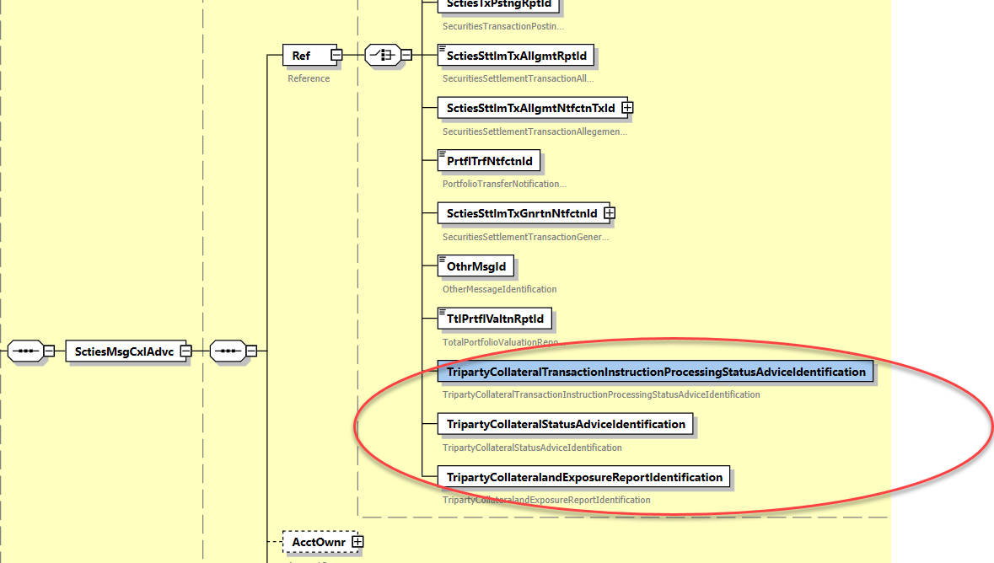

SEG/TSG recommendation:
This section is not to be taken care of by the submitter of the change request. It will be completed in due time by the SEG(s) in charge of the related ISO 20022 messages or the TSG for changes related to the BAH.

Consider |  | X | Timing
 |  |  | - Next yearly cycle: 2020/2021  (the change will be considered for implementation in the yearly maintenance cycle which starts in 2018 and completes with the publication of new message versions in the spring of 2019) |  | X
- At the occasion of the next maintenance of the messages
(the change will be considered for implementation, but does not justify maintenance of the messages in its own right – will be pending until more critical change requests are received for the messages)
- Urgent unscheduled
(the change justifies an urgent implementation outside of the normal yearly cycle)
 |  |  | - Other timing:
Comments:

Reject
Reason for rejection:

