Change Request
for the update of an External Code Set used in ISO 20022

- Origin of the request:
A.1 Submitter:

Brazilian Standards Commission – ABNT/CEE-112
A.2 Contact person:

Liliane Reis Dutra | Murilo Cesar Rabusky
Phone: +55 11 3368-7548 | Phone: +55 49 99978-0954
Mail: liliane.dutra@ipmfglobal.com.br | Mail: murilo.rabusky@ipmfglobal.com.br
José Vicente Mattos Santana | Renata Modesto Barretto
Phone: +55 51 3215-7339 | Phone:+55 61 3414-2666 / +55 61 3553-2666
Mail: vicente.santana@bcb.gov.br | Mail: renata.barreto@bcb.gov.br

A.3 Sponsors:

Banco Central do Brasil (Central Bank of Brazil)
Setor Bancário Sul - Quadra 3 - Bloco B – Edifício Sede - Brasília – DF – Brazil

- Related External Code Set:
ExternalStatusReason1Code
- Description of the change request:
Addition of new status reason code values in the 16-StatusReason tab of the ISO 20022 February 2020 External Code Sets file (ExternalCodeSets_1Q2020_February2020_v1.xls).:

 | Code | Name | Definition
237 | AB11 | TimeoutDebtorAgent | Transaction stopped due to timeout at the Debtor Agent.
238 | AG12 | NotAllowedBookTransfer | Payment orders made by transferring funds from one account to another at the same financial institution (bank or payment institution) are not allowed.
239 | AG13 | ForbiddenReturnPayment | Returned payments derived from previously returned transactions are not allowed.

- Purpose of the change:

This document proposes the addition of three codes to include specific events for pacs.002 messages that are currently not covered by the ExternalStatusReason1Code list. The proposed codes are related to the implementation of the Brazilian Instant Payment System (SPI), scheduled go into operation in November 2020. The Instant Payment clearing and settlement infrastructure is managed by the SPI, at the Central Bank of Brazil.
AB11 code - Transaction stopped due to timeout at the Debtor Agent:
The SPI´s business model determines that a payment transaction will be rejected when the elapsed time between the Debtor´s Payment Service Provider (PSP) acceptance of the payment order from the user (AcceptanceDateTime <AccptncDtTm> in the pacs.008 message) and the time when the Debtor´s PSP sends the payment message to the SPI (CreationDateTime <CreDtTm> in the pacs.008 message) is greater than the accepted maximum time.
Ideally, the Debtor Agent (Debtor´s PSP) will identify and cancel timed out transactions before sending pacs.008 messages to the SPI. In cases where the Debtor Agent sends pacs.008 messages of timed out transactions to the SPI, the former will verify the error and send a pacs.002 message with the AB11 code to inform that the transaction was stopped due to timeout at the Debtor Agent.
AG12 code – Payment orders made by transferring funds from one account to another at the same financial institution (bank or payment institution) are not allowed.
The SPI business model defines that the Payment Service Providers are divided in two categories. A direct PSP holds a specific purpose account at the Central Bank of Brazil (Instant Payment account at the SPI). Direct PSPs directly exchange ISO 20022 messages with the SPI for settlement of transactions and Instant Payment account management.
Indirect PSPs, on the other hand, are entities that can provide Instant Payment services to customers, but are not holders of Instant Payment accounts at the SPI. Therefore, every indirect PSP must be associated with a direct PSP, which will be responsible for settling the transactions inside the SPI on behalf of the indirect PSP.
The new AG12 code also arises from the SPI´s business model, which determines that only transactions between two distinct entities (holders of Instant Payment accounts at the SPI) shall be settled inside the SPI system.
Transactions involving the same direct PSP for the Creditor and the Debtor (book transactions) must be settled inside the PSP´s Instant Payment account books, without communication to the SPI.
Transactions involving Indirect PSPs must abide to the same rule. Since indirect PSPs must have a related direct PSP to act as his settlement agent on instant payment transactions, payments involving indirect PSP´s with the same direct PSP acting as the settlement agent are also considered book transactions and shall not involve exchange of communication with the SPI.
If a PSP improperly communicates a book transaction to the SPI, a pacs.002 message with the AG12 reason code will be returned and the transaction will not be processed.
AG13 code - Returned payments are not allowed to be re-returned.
The SPI regulation states that within 90 days the Creditor of any given Instant Payment transaction has the option to return to the Debtor, in full or in part, the credit from this transaction. Reasons for this return can include, for example, a mistake in the original payment or the return of a purchased product from a dissatisfied customer that made the original purchase through the Instant Payment System. When a return order is issued, the Debtor´s PSP (Creditor of the original transaction) sends a pacs.004 message to the SPI, the message is then processed and sent to the Creditor´s PSP, who recovers the data from the original transaction, checks for consistency and makes a provisional credit at the Creditor´s account. A pacs.002 message is then sent to the SPI, where the transfer of funds occurs and the return transaction is settled.
The objective of the AG13 code is to avoid a loop in the returned transactions. Returned transactions are necessarily linked to a specific instant payment order and are one-way transactions in which the Creditor of the instant payment order can return funds to the Debtor up to the specific initial instant payment order amount. In the pacs.004 message, the OriginalEndToEndIdentification <OrgnlEndToEndId> element brings the unique identification assigned by the original initiating party that will be used to unambiguously identify the original transaction.
If the Debtor´s PSP starts a return payment order linked to a previously returned transfer in which the same Debtor was the receiver of the transferred funds, the Creditor´s PSP will verify the error and send a pacs.002 message with the AG13 code to the SPI. The SPI will then send the pacs.002 message with the AG13 error code to the Debtor´s PSP and the transaction will be canceled.
- Urgency of the request:
The SPI is scheduled to be launched in November 2020, therefore the request is urgent.

- Business examples:
Examples of a transaction stopped due to timeout at the Debtor´s agent. In the first example, the Debtor Agent (PSP) identifies the timeout and does not send the transaction to the SPI:
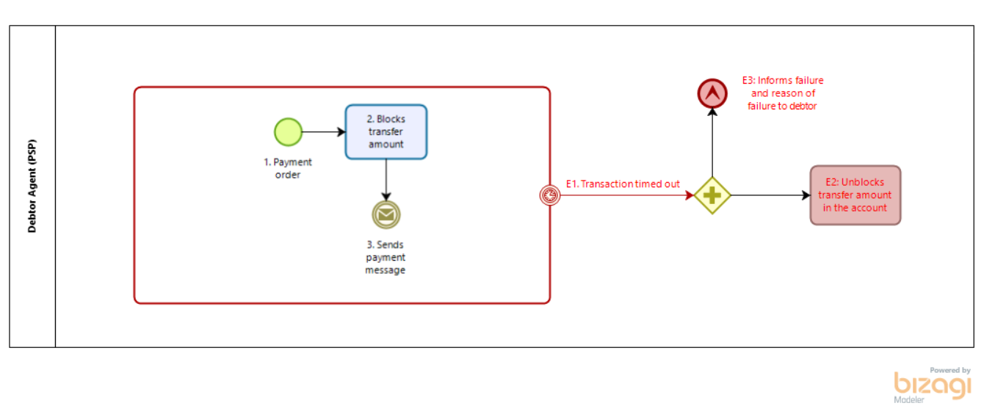

In the second example, the Debtor Agent fails to identify the timeout and sends a pacs.008 message to the SPI. The SPI verifies the timeout and informs the Debtor Agent that the transaction failed due to a timeout at the Debtor Agent (AB11 code in the pacs.002 message):
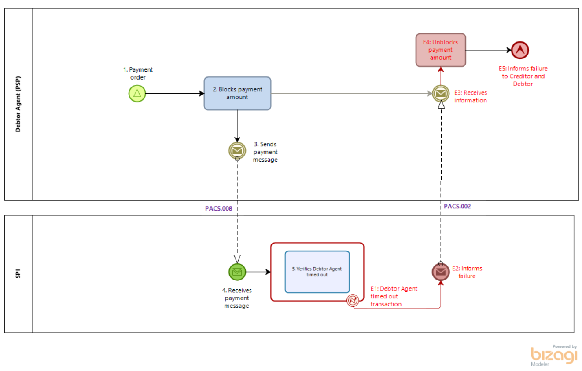

Examples of regular “Book transactions” not sent to the SPI:
Direct PSP:
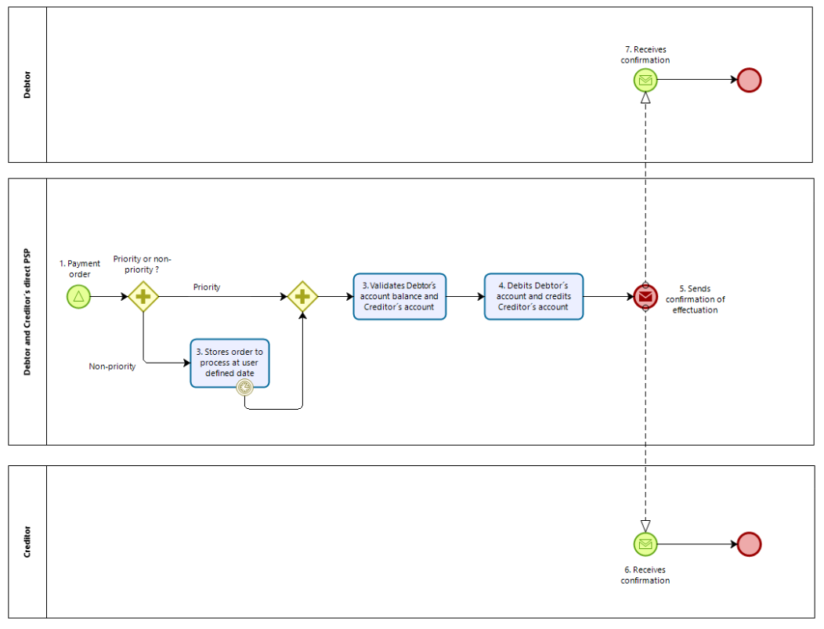
1: Debtor´s direct PSP receives the payment order
2: If the payment order is a non-priority (for a future time and date), the PSP stores the order for processing at a future date
3: PSP blocks the ammount to be transferred from the Debtor´s PI account and checks the Creditor´s account information
4: If the account balance and account information are successful, the PSP debts the Debtor´s account and credits the Creditor´account without communication of the transaction to the SPI
5: PSP sends communication of successful transaction to the Debtor and to the Creditor
6: Creditor receives message confirming transaction
7: Debtor receives message confirming transaction
Indirect PSPs with the same PSP as the settlement agent:
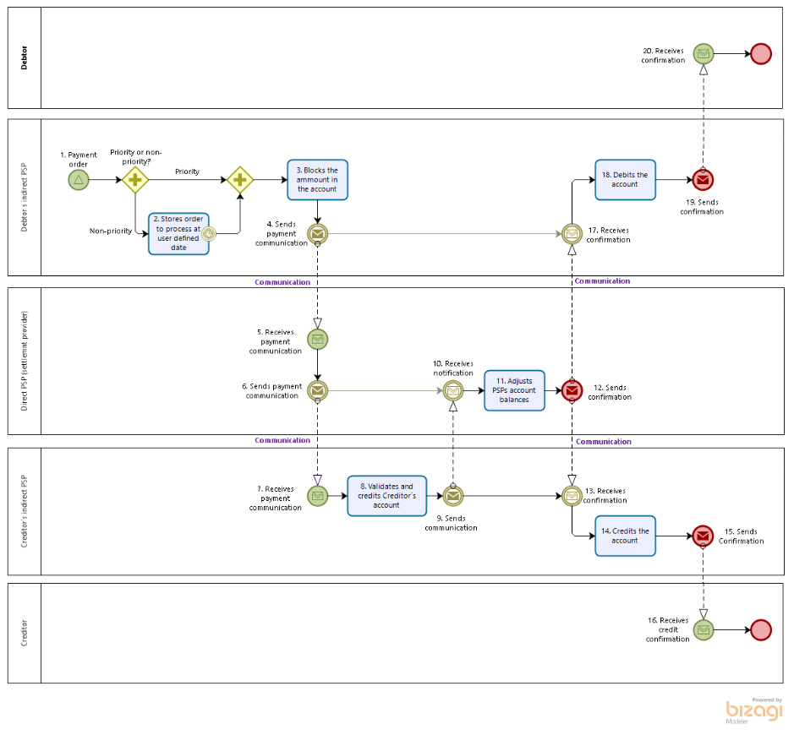
1: Debtor´s indirect PSP receives the payment order
2: If the payment order is a non-priority (for a future time and date), the indirect PSP stores the order for processing at a future date. At that date, the indirect PSP sends the order to the direct PSP for settlement
3: Debtor´s indirect PSP blocks the ammount to be transferred from the Debtor´s account and checks the Creditor´s account information
4: Debtor´s indirect PSP sends communication to the direct PSP acting as settlement agent instructing the exchange of balances at the PI accounts.
5: Direct PSP acting as settlement agent receives message from indirect PSP
6: Direct PSP identifies that the Creditor´s indirect PSP has the same direct PSP as settlement agent and sends communication to the Creditor´s indirect PSP informing the transfer
7: Creditor´s indirect PSP receives communication with transfer details
8: Creditor´s indirect PSP validates the details of the Creditor´s account. If validation is successful, Creditor´s indirect PSP makes a provisional credit at the Creditor´s account
9: Creditor´s indirect PSP sends communication to the direct PSP acting as settlement agent with permission to process the payment
10: Direct PSP acting as settlement agent receives communication from Creditor´s indirect PSP for processing the payment
11: Direct PSP acting as settlement agent adjusts the balances: reduces the balance at the Debtor´s indirect PSP and increases the balance at the Creditor´s indirect PSP by the transaction amount
12: Direct PSP acting as settlement agent sends confirmation of conclusion of transaction to indirect Creditor´s PSP and indirect Debtor´s PSP
13: Creditor´s indirect PSP receives confirmation of conclusion of transaction
14: Creditor´s indirect PSP credits Creditor´s account
15: Creditor´s indirect PSP sends communication of conclusion of transaction to Creditor
16: Creditor receives communication of conclusion of transaction
17: Debtor´s indirect PSP receives confirmation of conclusion of transaction
18: Debtor´s indirect PSP debits Debtor´s account
19: Debtor´s indirect PSP sends communication of conclusion of transaction to Debtor
20: Debtor receives communication of conclusion of transaction
If a book transaction is incorrectly sent to the SPI through a pacs.008 message, the SPI will verify the book transaction and inform the PSP through an AG12 error code in a pacs.002 message that the transaction was not processed:
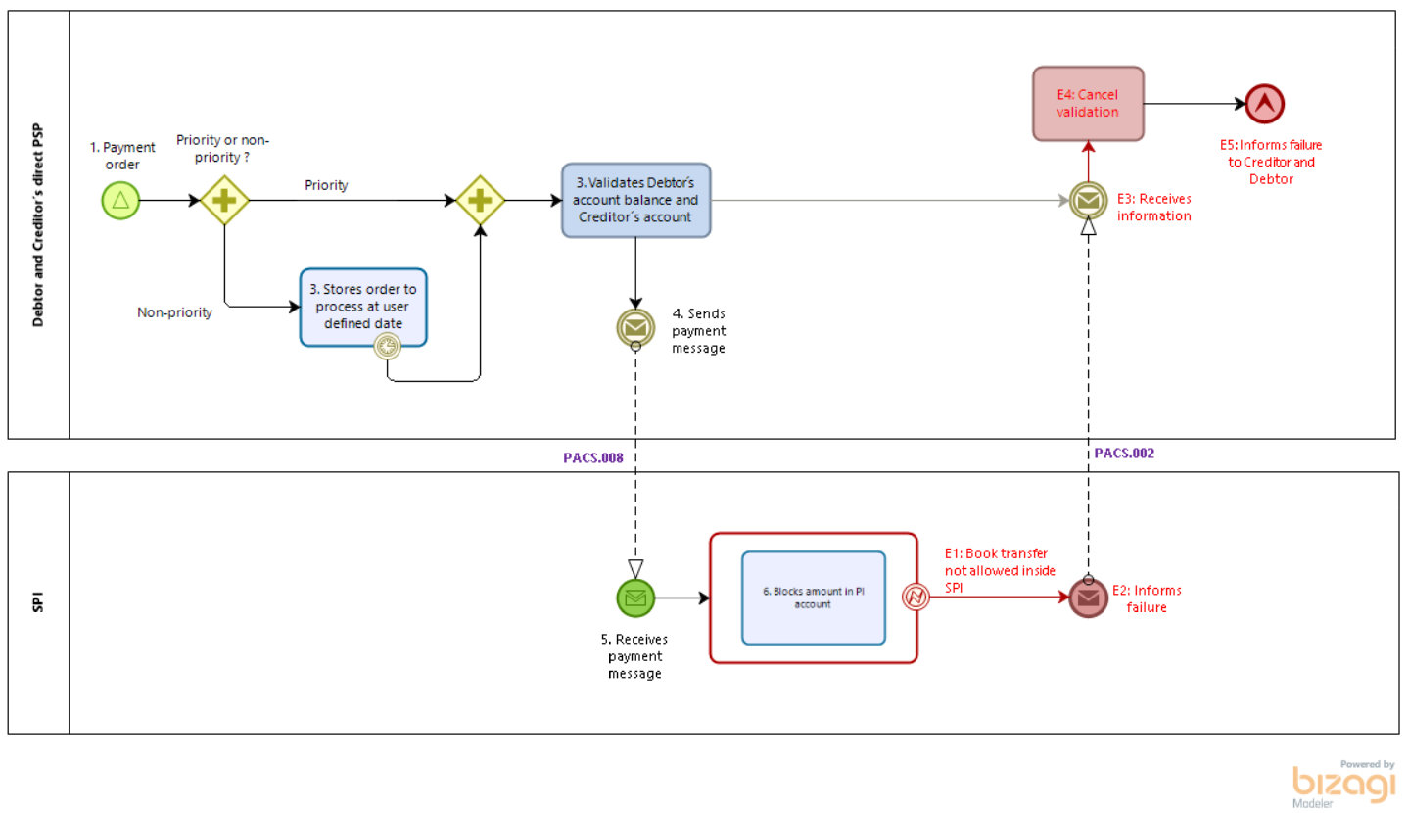
Example of a regular “Return transaction”
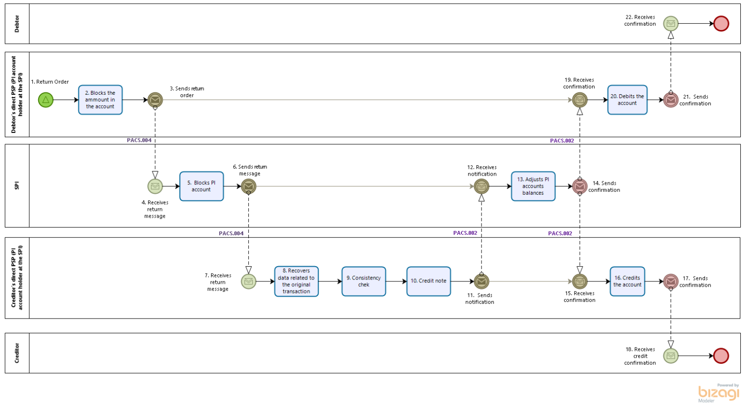
1: Debtor´s PSP receives return order
2: Debtor´s PSP blocks the amount to be returned in Debtor´s account
3: Debtor´s PSP sends message to SPI soliciting exchange of funds in the PI account to proceed with the return
4: SPI receives message from the Debtor´s PSP soliciting exchange of funds in the PI account to proceed with the return
5: SPI blocks the amount to be returned in PSP´s PI account
6: SPI sends message to the Creditor´s PSP informing the return transaction details
7: Creditor´s PSP receives the message with the return transaction details
8: Creditor´s PSP recovers the original transaction details: date, amount and account details from the Creditor´s account (the Debtor of the original transaction)
9: Creditor´s PSP validates the return: checks if the return is from a transaction that took place less than 90 days in the past, if the Creditor holds an account at the Creditor´s PSP, if the amount is correct and if the Creditor´s account is active
10: If the validation is successful, Creditor´s PSP makes a provisional credit at the Creditor´s account
11: Creditor´s PSP sends a message to the SPI requesting to proceed with the return transaction
12: SPI receives the message from the Creditor´s PSP requesting to proceed with the return transaction
13: SPI exchange funds at the PI accounts: reduces the PI account balance at the Debtor´s PSP e increases the PI account balance at the Creditor´s PSP by the return transaction amount
14: SPI sends confirmation of conclusion of transaction to Creditor´s and Debtor´s PSP
15: Creditor´s PSP receives message of confirmation of conclusion of return transaction
16: Creditor´s PSP credits the Creditor account
17: Creditor´s PSP sends confirmation of conclusion of return transaction to Creditor
18: Creditor receives communication of conclusion of return transaction
19: Debtor´s PSP receives message of confirmation of conclusion of return transaction
20: Debtor´s PSP debits the Debtor account
21: Debtor´s PSP sends confirmation of conclusion of return transaction to Debtor
22: Debtor receives communication of conclusion of return transaction
If a PSP starts a return order derived from a previously returned transaction, the Creditor´s PSP will identify that the attempted return is derived from a previously returned transaction. An error message will be sent to the SPI, which in turn will inform the PSP that the transaction was rejected with an AG13 code in a pacs.002 message:
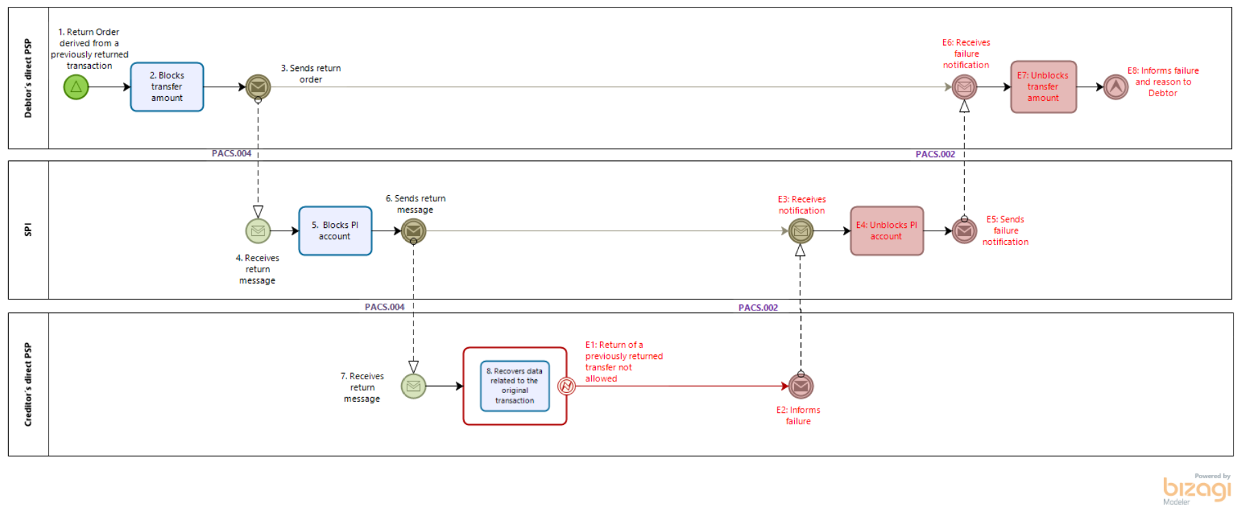
- SEG recommendation:

Accept |  | X | Timing
 |  |  | - Next possible quarterly release |  | X
 |  |  | - Other timing:
Comments:

Reject
Reason for rejection:

