Change Request
for the update of ISO 20022 financial repository items

- Origin of the request:
A.1 Submitter: nexo A.I.S.B.L.
A.2 Contact person: Philippe CECE (Philippe.cece@ingenico.com) / Pierre MOURA (pierre.moura@frenchsys.com)
A.3 Sponsors: nexo A.I.S.B.L.

- Related messages:

- AcceptorAuthorisationRequest V08 caaa.001.001.08
- AcceptorCompletionAdvice V08 caaa.003.001.08
- AcceptorCancellationRequest V08 caaa.005.001.08
- AcceptorCancellationAdvice V08 caaa.007.001.08
- AcceptorReconciliationRequest V07 caaa.009.001.07
- AcceptorBatchTransfer V08 caaa.011.001.08
- AcceptorCurrencyConversionRequest V06 caaa.016.001.06
- AcceptorCurrencyConversionAdvice V03 caaa.018.001.03

- Description of the change request:

We would like to update the caaa messages to be compliant with 3DS version 2 expectations.

- Purpose of the change:

Regarding, the 3DSecure v2 specifications, even if we haven't yet fulfil the gap analysis of current caaa messages with these specifications, we know that some new elements have been added and should be exchanged like:
- Identification of 3DS specifications
- DSTransactionId
- ACSTransactionId

These modifications should impact the message component cardholderAuthentication with the introduction of new code set and probably new elements as illustrated in the image below.

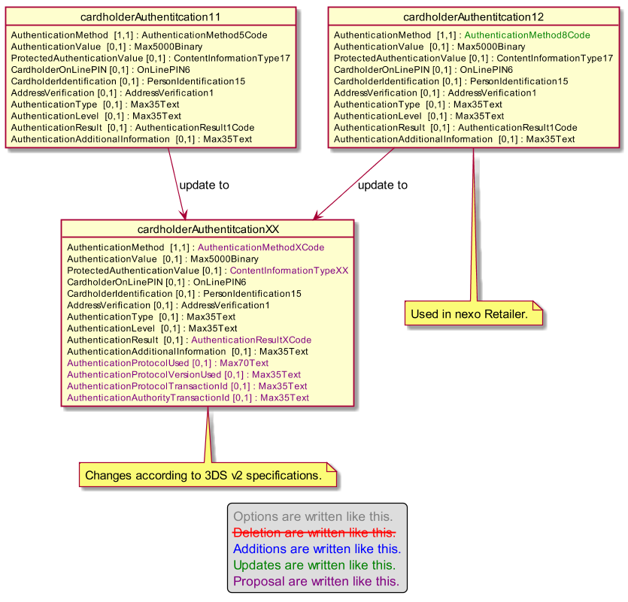

- Urgency of the request:

Not urgent.

- Business examples:
Examples illustrating the change request.
- SEG/TSG recommendation:
This section is not to be taken care of by the submitter of the change request. It will be completed in due time by the SEG(s) in charge of the related ISO 20022 messages or the TSG for changes related to the BAH.

Consider |  | X | Timing
 |  |  | - Next yearly cycle: 2019/2020  (the change will be considered for implementation in the yearly maintenance cycle which starts in 2019 and completes with the publication of new message versions in the spring of 2020) |  | X
- At the occasion of the next maintenance of the messages
(the change will be considered for implementation, but does not justify maintenance of the messages in its own right – will be pending until more critical change requests are received for the messages)
- Urgent unscheduled
(the change justifies an urgent implementation outside of the normal yearly cycle)
 |  |  | - Other timing:
Comments:

Reject
Reason for rejection:

