Change Request
for the update of ISO 20022 financial repository items
- Origin of the request:
A.1 Submitter:
SIX Interbank Clearing Ltd, Zurich (Switzerland)
A.2 Contact person:
SIX Interbank Clearing, Ltd Hardturmstrasse 201, 8021 Zurich
Istvan Teglas | istvan.teglas@six-group.com | +41 58 399 4238
A.3 Sponsors:
UBS AG, CH-8098 Zurich
Credit Suisse, CH-8070 Zurich
Postfinance, CH-3000 Bern
Zürcher Kantonalbank, CH-8001 Zurich
Raiffeisen Schweiz, CH-9001 St.Gallen
SIX Interbank Clearing Ltd, CH-8021 Zurich

- Related messages:
- pain.001.001.09

- Description of the change request:
Add a new optional element "Software" in Group Header
The new element “Software” should be added as the last element in “Group Header” (Path: Document/CstmrCdtTrfInitn/GrpHdr/Sftw)

The element "Software" has 3 mandatory child elements
- Software Provider (Document/CstmrCdtTrfInitn/GrpHdr/Sftw/Prvid)
- Software Name (Document/CstmrCdtTrfInitn/GrpHdr/Sftw/Nm)
- Software Version (Document/CstmrCdtTrfInitn/GrpHdr/Sftw/Vs)
The elements "Provider" and "Version" have both 35 alphanumeric characters, the element "Name" has 140 characters (using the already existing element “Nm”).

pain.001.001.09 Group Header:
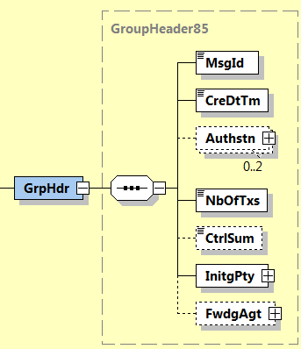
Supplemented with new element "Software":
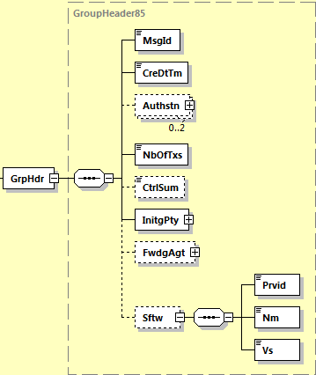

- Purpose of the change:
In the current pain messages there is no element to indicate which software has been used to create the message.
There is a strong market need for this element. With the introduction of new payment products or new ISO 20022 message versions the account service provider is committed to support his customers’ transition. With the data about the software used the client servicer is able to
- recognize the readiness of the new payment product
- selectively contact customers for information about the necessary software update
- offer faster support in case of issues

- Urgency of the request:

By default, publication April/May 2020

- Business examples:

- A community introduces a new payment product, a structured bill that can be used paper-based and electronically. The planned go live date can only be kept if 95% of market participants are able to pay, therefore the software provider informs about the software version that supports this new payment product. The account servicer can get in touch with the customers that have software versions in place that don't support the new payment product.

- The migration from national legacy format to ISO 20022 is a huge project that needs an intensive support from the account servicer and third parties. Support cases can be handled more efficiently if the software provider and software version is known. E.g., in case of recurring errors with multiple customers the account servicer can directly contact the software provider.

.

- SEG recommendation:

Consider |  | X | Timing
 |  |  | - Next yearly cycle: 2019/2020  (the change will be considered for implementation in the yearly maintenance cycle which starts in 2019 and completes with the publication of new message versions in the spring of 2020) |  | X
- At the occasion of the next maintenance of the messages
(the change will be considered for implementation, but does not justify maintenance of the messages in its own right – will be pending until more critical change requests are received for the messages)
- Urgent unscheduled
(the change justifies an urgent implementation outside of the normal yearly cycle)
 |  |  | - Other timing:
Comments:
Decided during Payments SEG on 1 July 2019

Reject
Reason for rejection:

