Change Request
for the current reservation type element type change in camt.046

- Origin of the request:
A.1 Submitter:
CMA Small Systems AB
A.2 Contact person:
E-mail: denis.smirnov@cma.ru
Phone: +46 8 566 30 800
A.3 Sponsors: N/A

- Related messages:

camt.046 Get Reservation

- Description of the change request:
Request change element type in camt.046 /Document/GetRsvatn/RsvatnQryDef/RsvatnCrit/NewCrit/SchCrit/CurRsvatnTp from ReservationType1Code to ReservationType1Choice to comply with related element in camt.047 “Return reservation” message and possibility to use Proprietary codes when requesting reserve.

Current type:
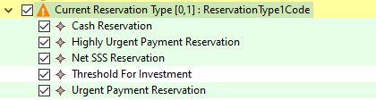

Requested type (like in camt.047):
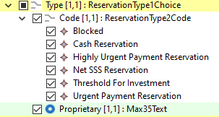

Proposed definition:
“Nature of the reservation.”

- Purpose of the change:
Introduction of possibility to use Proprietary codes of Reservation type.

- Urgency of the request:
Request can be supported in a new maintenance release.

- Business examples:
As per current business schema.
- SEG/TSG recommendation:

Consider |  | X | Timing
 |  |  | - Next yearly cycle: 2020/2021  (the change will be considered for implementation in the yearly maintenance cycle which starts in 2018 and completes with the publication of new message versions in the spring of 2019) |  | X
- At the occasion of the next maintenance of the messages
(the change will be considered for implementation, but does not justify maintenance of the messages in its own right – will be pending until more critical change requests are received for the messages)
- Urgent unscheduled
(the change justifies an urgent implementation outside of the normal yearly cycle)
 |  |  | - Other timing:
Comments:

Reject
Reason for rejection:

