Change Request
for the update of ISO 20022 financial repository items
- Origin of the request:
A.1 Submitter:

NPP Australia
Suite 4, Level 9
420 George Street
Sydney NSW 2000
Australia
A.2 Contact person(s):

Paul Nicholas
NPP Technology Lead
NPP Australia Limited
E: pnicholas@nppa.com.au
P: +61 419 259 073

David Dobbing
Manager, APAC Standards
SWIFT
E: david.dobbing@swift.com
P: + 61 447 253 634

A.3 Sponsors:
NPP Australia

- Related messages:
pain.001.001.09 Customer Credit Transfer Initiation
pain.013.001.07 Creditor Payment Activation Request
pain.014.001.07 Creditor Payment Activation Request Status Report
pacs.008.001.08 FI To FI Customer Credit Transfer

- Description of the change request:
The pain.001, pain.013, pain.014 and pacs.008 are required to be enhanced by NPP in order to enable future processing requirements. It is requested to add the Mandate Related Information component to all four messages, and to add one existing component and one new data element to Mandate Related Information. These requested changes are depicted below:

C.1 pain.001.001.09 Customer Credit Transfer Initiation
Add the MandateRelatedInformation, component, optional and non-repetitive, to CreditTransferTransactionInformation component, suggest immediately above ChequeInstruction :
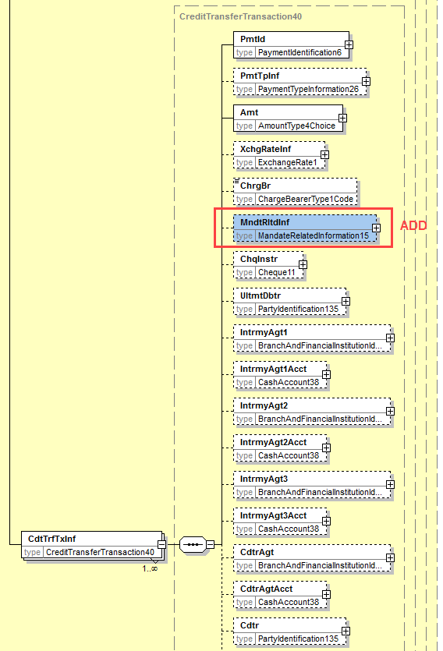.

C.2 pain.013.001.07 Creditor Payment Activation Request
Similar to C.1 above, add the MandateRelatedInformation component, optional and non-repetitive, to CreditTransferTransaction component, suggest immediately above ChequeInstruction.
C.3 pain.014.001.07 Creditor Payment Activation Request Status Report
In line with pain.002, pain.008 and pacs.003, add the Mandate Related Information component, optional and non-repetitive, in the OriginalTransactionReference component, suggest immediately above RemittanceInformation component.

C.4 pacs.008.001.08 FI To FI Customer Credit Transfer
Similar to C.1 above, add the MandateRelatedInformation, component, optional and non-repetitive, to CreditTransferTransactionInformation component, suggest immediately above PreviousInstructingAgent:

C.5 Mandate Related Information component
a) Add one existing component MandateTypeInformation and b) one new data element, DateTimeOfVerification, to the MandateRelatedInformation component, both optional and non-repetitive.
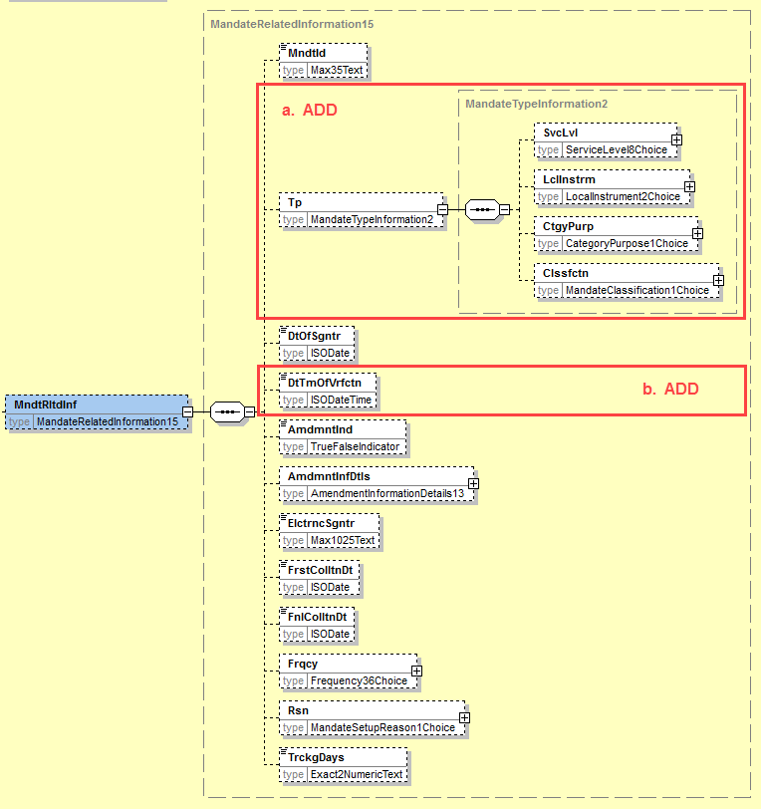
New Element: DateTimeOfVerification
Date Time on which the mandate has been verified.
ISODateTime (Date Time)

- Purpose of the change:
NPPA seek to uplift the capability of payment initiation messages for a credit transfer (push) payment.
The ability to use the pain.001 and pain.013 to undertake payment initiation under a designated mandate authority is a desired enhancement to the New Payments Platform messaging capabilities. In order to deliver this capability it is requested that a dedicated, existing Mandate Related Information component, be added to pain.001, pain.013, pain.014 and pacs.008.
This would facilitate processing whereby the conventional direct debit ‘pull’ scenario would be complemented with a payment initiation with authority ‘push’ scenario.
This may facilitate payments where the Debtor Agent receives and processes payment requests from a payment initiator under a Mandate authority between the Debtor (Corporate) and Payment Initiator using a pain.001 customer payment initiation message.
Another example is where the Creditor requests payment through a pain.013 which in turn is forwarded by the Creditor Agent to the Debtor Agent to make the payment under a Mandate authority that has been established between the Debtor and Creditor. This payment may be requested with authority triggered using a pain.013 customer payment initiation message.
Mandate Related Information already exists in the pain.002, it is requested that Mandate Related Information component be similarly added to pain.014.

- Urgency of the request:
Requested for SR 2019/20020.
NPP is introducing the above change through a Supplementary Data Component. Formalisation in the ISO 20022 pain.001 and pain.013 messages is the desirable outcome.

- Business examples:
/
- SEG/TSG recommendation:
This section is not to be taken care of by the submitter of the change request. It will be completed in due time by the SEG(s) in charge of the related ISO 20022 messages or the TSG for changes related to the BAH.

Consider |  | X | Timing
 |  |  | - Next yearly cycle: 2019/2020  (the change will be considered for implementation in the yearly maintenance cycle which starts in 2018 and completes with the publication of new message versions in the spring of 2019) |  | X
- At the occasion of the next maintenance of the messages
(the change will be considered for implementation, but does not justify maintenance of the messages in its own right – will be pending until more critical change requests are received for the messages)
- Urgent unscheduled
(the change justifies an urgent implementation outside of the normal yearly cycle)
 |  |  | - Other timing:
Comments:
Decided during Payments SEG on 1 July 2019

Reject
Reason for rejection:

