Change Request
for the update of ISO 20022 financial repository items
- Origin of the request:
A.1 Submitter:
China Foreign Exchange Trade System
A.2 Contact person:
HuBingbing，hubingbing_zh@chinamoney.com.cn，021-38585653
A.3 Sponsors:
China Foreign Exchange Trade System
- Related messages:
camt.017. 001.04
- Description of the change request:
Request to add the following new optional element to camt.017，the new elements are: Exchange Rate High Limit and Exchange Rate low Limit.
- Exchange Rate High Limit
Path:
/Document/RtrCcyXchgRate/RptOrErr/CcyXchgRpt/CcyXchgOrErr/CcyXchg/ XchgRateHiLmt
Datatype:
Percentage Rate [0,1]
Proposed definition:
“The currency authority publishes the exchange rate based on the price formed in the foreign exchange market, allowing it to float up and down within the prescribed fluctuation range. It is the highest exchange rate supported in foreign exchange market transactions.”
- Exchange Rate Low Limit
Path:
/Document/RtrCcyXchgRate/RptOrErr/CcyXchgRpt/CcyXchgOrErr/CcyXchg/ XchgRateLowLmt
Datatype:
PercentageRate [0,1]
Proposed definition:
“The currency authority publishes the exchange rate based on the price formed in the foreign exchange market, allowing it to float up and down within the prescribed fluctuation range. It is the lowest exchange rate supported in foreign exchange market transactions.”
- Purpose of the change:
Currency authorities publish exchange rates based on prices formed in the foreign exchange market. It needs to limit exchange rate fluctuations in settlement,sales and foreign exchange operations. Therefore, it is necessary to add the exchange rate high limit and exchange rate low limit elements in the camt.017 message.
- Urgency of the request:
Subject to normal maintenance cycle.
- Business examples:
There is no exchange rate high limit and exchange rate low limit on CAMT.017 message:
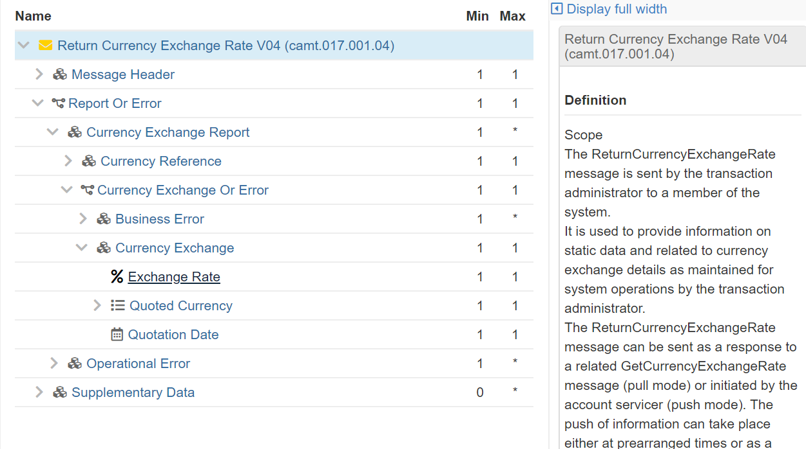
- SEG/TSG recommendation:
This section is not to be taken care of by the submitter of the change request. It will be completed in due time by the SEG(s) in charge of the related ISO 20022 messages or the TSG for changes related to the BAH.

Consider |  |  | Timing
- Next yearly cycle: 2020/2021
(the change will be considered for implementation in the yearly maintenance cycle which starts in 2020 and completes with the publication of new message versions in the spring of 2021)
- At the occasion of the next maintenance of the messages
(the change will be considered for implementation, but does not justify maintenance of the messages in its own right – will be pending until more critical change requests are received for the messages)
- Urgent unscheduled
(the change justifies an urgent implementation outside of the normal yearly cycle)
 |  |  | - Other timing:

Comments:

Reject
Reason for rejection:

