Standards
Standards MT Release 2020
Discussion paper and Minutes
Settlement and Reconciliation
Distribution: Settlement & Reconciliation Maintenance Working Group
Author: Alexandre Hotat

Date Issued: June 2019
Meeting Date: 21 August 2019

Table of Contents
1 Introduction 3
2 Overview of User Change requests 4
2.1 CR 001519: Modify Penalties sequence 4
2.2 CR 001520: Add qualifiers for CSD-R buy-ins 16
2.3 CR 001521: Add fields to allow use as payment preadvice message for CSDR Settlement Penalties 21
2.4 CR 001522: New fields for follow-up of buy-in process 24
2.5 CR 001532: Add new narrative field 28
3 Overview of SWIFT Change requests 30

Introduction

Maintenance working group members: |  | Representing: | SR2020
Hiroaki Okumura Mitsubishi bank |  | Japan
Annemie Loose/Quentin de Saint-Aubert – Euroclear |  | ICSD
Jason Brasile – Statestreet |  | United States of America
Robin Leary – Citibank |  | United Kingdom
Denis Andrejew – DB |  | Germany
Ton Van Andel – ABN Amro |  | Netherlands
Stephan Schuetter – UBS |  | Switzerland
Monica Chow – HSBC |  | Honk Kong
Vacant |  | Belgium
Axelle Wurmser – BNP Paribas |  | France
Arnaud Jochems – Clearstream |  | ICSD / Luxembourg

Overview of User Change requests

CR 001519: Modify Penalties sequence
Origin of request
Requesting Group: | Euroclear Group, Clearstream, SMPG
Sponsors
Euroclear Group, Clearstream, SMPG
Message type(s) impacted
MT 537 / MT548
Complies with regulation
Regulation (EU) no 909/2014 of the European Parliament and of the Council of 23 July 2014 on improving securities settlement in the European Union and on central securities depositories and amending Directives 98/26/EC and 2014/65/EU and Regulation (EU) No 236/2012 (“EU CSD-Regulation”).
Delegated Regulation (DR) 2018/1229, supplementing Regulation (EU) No 909/2014 of the European Parliament and of the Council with regard to regulatory technical standards on the settlement discipline regime (SDR)2.
RTS: Regulatory Technical Standard, which are endorsed by the European Commission by means of a delegated act supplementing an EU Regulation or a Directive
Business impact of this request
low
Commitment to implement the change
Number of messages sent and received: /
Percentage of messages impacted: /
Commits to implement and when: Euroclear Group, SMPG in 2020
Business context
The regulation will come in effect in September 2020. As the regulation is very descriptive and complex to implement, ECSDA, ECB/4CB have set-up a taskforce and hold regular workshops to agree on how CSDs have to implement the regulation. The ECSDA Settlement Fails Penalties Framework describes the practical implementation of the regulation. To implement the required reporting T2S will use the new ISO 20022 message semt.044. For SR2019 the ISO 15022 messages MT 548 and MT 537 have been created. Due to the timing constraints and ongoing discussions, the current message MT 537 message is no longer in line with the requirements as described in the ECSDA Framework. Moreover, the MT 537 is not 100% in line with the definition of the semt.044, the message that will be used by T2S.
The changes described in the change request are needed to ensure reporting in line with the regulation and compatibility between the ISO 20022 message and the ISO 15022 messages.
Nature of change
There are 3 types of changes:
- new fields, qualifiers or codes
- updates of definitions
- some changes to the structure of the message.

New fields, qualifiers or codes required in MT537/MT548:
Sequence | Field, qualifier or code in MT537/MT548 | Change requested | Comment
D1 | :19A: | Add a new qualifier  GBNT Global Net Amount  The global net amount for a party is the sum  of all cash penalties in this currency that this party is entitled to receive minus the sum of all cash penalties in this currency that are imposed to the party.  A positive amount indicates that the party will be credited with this amount, a negative amount indicates that the amount will be debited.  Please remove the usage rule, the use of the sign is in the definition. | Evolution of the ECSDA Framework. The 2 existing qualifiers should not be deleted as they may still be needed in some scenarios.
D1 | :22F::TRCA | Add a new code  NAPI Natural person  Provided when the failing or non-failing party of the penalty/claim isneither a CSD nor a CCP but is a CSD Participant that is a natural person.  The code CSDP could be updated to indicate  Provided when the failing or non-failing party of the penalty/claim is neither a CSD nor a CCP but it is legal entity that is CSD Participant. | In the UK natural persons can also open an account in EUI. Where they have settlement penalties calculated against them, we will include them in the bilateral net per counterparty but not in the global net, as these natural persons do not have the possibility to pay the penalty (they work via a custodian). So the processing is similar as for a CCP: we report the details of the penalty, the amount to be paid or received, is also included in the bilateral net calculation and reporting but is not included in the global net calculation and the cash is not collected via the CSD.
D1a1 | :20C: | Add 2 new qualifiers:  PPCM Previous Penalty Common Reference  If the penalty for which the details are provided was created from a re-allocation, this field provides the common identification of the penalty that is re-allocated. This is the penalty that existed previously but was removed when the re-allocated penalty was created.  PPRF Previous Penalty Reference  If the penalty for which the details are provided was created from a re-allocation, this field provides the common identification of the penalty that is re-allocated. | To be in line with semt.044:
D1a1 | :24B::REMO | Add new codes:  INSO  Insolvency  Penalty was removed because insolvency proceedings are opened against the failing participant.  SESU  Settlement Suspended  Penalty was removed because ISIN is suspended from settlement due to a reconciliation issue.  TECH  Technical Impossibilities  Penalty was removed because there were technical impossibilities at the CSD level that prevent settlement, such as: a failure of the infrastructure components, a cyber-attack, network problems.  SUSP  Trading Suspended  Penalty was removed because of ISIN suspension from trading. | New codes provided by ESMA
D1a1A1 | :17B: | New qualifier  Security subject to penalties.  This flag indicates if the security is subject to penalties. It is used to indicate an exceptional situation. Absence of the flag indicates a value Yes, meaning that the security is subject to penalties | Field present in semt.044
D1a1A1 | :92B::EXCH | Field should become repetitive | Exchange rate has to be provided with respect to the EUR, e.g. USD => GBP has to be provided as USD => EUR, EUR => GBP
D1a1A2 | :20C: | New qualifier:  Netting Service Provider Reference  Identification assigned by the netting service provider to identify the net transaction resulting from the netting process. | Code present in semt.044
D1a1A2a | :22F::TRAN | New qualifier, with 2 codes SETT and CORP | Field present in semt.044
D1a1Aa | :22F:? :20C:? | New field:  Event identification  Code identifying the event that is responsible for the relevant cut-off. | Field present in semt.044  ECB to come with list of events that could be reported.
D1a1A2a | :98C: | New qualifier:  Scheduled cut-off timestamp | Field present in semt.044

Updated definitions:
Field | Current definition | New definition
:22F::CODE in sequence D | Complete/Updates Indicator  Specifies whether the statement is complete or contains changes only. | Penalty List Type  Specifies the type of information held in the report: new penalties, amendments only or both new and amended penalties.
:22F::CODE//CURR | CURR Current  It is used by those securities settlement systems that report the new penalties and the modified penalties in one single message/report. | CURR Current  It is used by asset servicers or securities settlement systems that report the new penalties and the modified penalties in one single message/report.
:22F::CODE//FWAM | FWAM ForwardAmend  The message is used to report a penalty list that has been amended (that is, the penalty list contains only updated and/or removed penalties that have already been previously reported in a FWIS Penalty List). | FWAM  The message reports a penalty list that contains only updated and/or removed penalties.
:22F::CODE//FWIS | FWIS Forward Initial Submission  The message is used to report a Daily Penalty List created for the first time (that is, the penalty list ontains only new computed penalties). | FWIS  The message is used to report a penalty list that contains only new computed penalties.
:98a::DACO | DACO Computation Date/Time  The date on which the instruction fails to settle and for which a penalty is calculated. This date does not change through the life of the penalty. Updates are still reported with this date even if the update took place on another day. | DACO Penalty Detection date/time  It is the day for which the penalty was computed.  It is:  -The date on which the instruction matched for LMFP.  -The date on which an instruction fails to settle for SEFP.  Note: This date is not updated upon re-calculation of the penalty and always relates to the business day for which the penalty was initially computed
:22F::TRCA//CSDP (in sequence D1 and D1a) | Provided when the failing or non-failing party of the penalty/claim is neither a CSD nor a CCP and its party type is CSD Participant. | Indicates that the failing or non-failing party of the penalty/claim is a regular CSD Participant.
:22F::TRCA//ICSD (in sequence D1 and D1a) | Provided when the ICSD itself is the failing or non-failing party of the  penalty/claim. This is used to differentiate between the ICSD as account  servicer/depository and the ICSD as participant of itself and is  mainly relevant in cross-CSD settlement. The AccountServicer/Depository  of the party provided in the message is the BIC of the ICSD  of the party, not the parent BIC of the party. | Provided when the ICSD itself is the failing or non-failing party of the penalty/claim. This is used to differentiate between the ICSD as account servicer/depository and the ICSD as participant and ismainly relevant in cross-CSD settlement.
:22F::TRCA//NCSD (in sequence D1 and D1a) | Provided when the CSD itself is the failing or non-failing party of the  penalty/claim. This is used to differentiate between the CSD as account  servicer/depositary and the CSD as participant of itself. The  AccountServicer/Depository of the party provided in the message is  the BIC of the CSD of the party, not the parent BIC of the party. | Provided when the CSD itself is the failing or non-failing party of the penalty/claim. This is used to differentiate between the CSD as account servicer/depositary and the CSD as participant.
:17B::CMPU | CMPU Amount Computed Flag  Indicate if the amount computed will be added to the bilateral net or not. The amount computed will not be added to the bilateral net if one of the parties to the instruction is a CCP or is insolvent. | CMPU  Amount considered for aggregation flag  Flag indicates whether or not the amount calculated for the reported penalty will be added to the aggregated amounts at global level. There could be several reasons for not considering the penalty amount. The flag is used to indicate an exceptional situation. If the flag is not reported in the message this means that the penalty is considered for the calculation of aggregated amounts.
:25D::PNST//NCOM | NCOM Not Computed  For penalties that could not be computed (for example, in case of  missing reference data). | NCOM Not Computed  This code is used for penalties where the ISIN is out of scope of the securities subject to penalties as per static data for all of the relevant business days of the penalty, but where the penalty is anyway reported to the party.
:24B::REMO | REMO Remove Reason  Specifies the reason why the instruction is cancelled. | REMO Remove Reason  Specifies the reason why the penalty is removed.
:24B::ACTV | UPDT Not Computed Reason  Reason for the status Active (ACTV) provided when the penalty has been updated by T2S due to the change in the relevant reference data or after the re-inclusion of the penalty. It also includes the situation of a penalty that is re-included (every time a penalty is re-included,  T2S recalculates it to ensure latest data is taken). | UPDT Update Reason  This reason for the status Active (ACTV) is provided when the penalty has been updated due to the change in the relevant reference data or after the re-inclusion of the penalty.
:24B::ACTV//RALO, :24B::REMO//RALO | RALO Reallocated Reason  Re-allocation of a Late Matching Fail Penalty (LMFP) from the instructing party to the delivering/receiving party. | RALO Reallocated Reason  Re-allocation of a Late Matching Fail Penalty (LMFP) from the instructing party to the delivering/receiving party, or from the failing party to the non-failing party, or vice versa.
:19A::AMCO | Amount of the penalty calculated based on the security and instruction  characteristics and the reason for the fail. For a Late Matching  Fail Penalty (LMFP) that spans several business days, this amount is  the sum of the amounts calculated for each applicable business day. | Amount of the penalty calculated based on the security and instruction characteristics and the reason for the fail. For a Late Matching  Fail Penalty (LMFP) that spans several business days, this amount is the sum of the amounts calculated for each applicable business day.  A positive amount indicates that the party is entitled to the penalty whereas a negative amount indicates that the penalty is due to the counterparty.
:98a::PEDA | PEDA  Penalty Date/Time  Date/time on which the penalty is calculated. In case of an update,this is the date on which the new values are calculated. | PEDA  Penalty Date/Time  Date that composes the penalty.  For LMFP, there will be as many penalty dates as business days where a transaction fails to settle due to the late matching. The penalty date can be in the past compared to the penalty detection date.  For SEFP there is only 1 penalty date.
:17B::MRED | Information provided for penalties where there is missing reference data on this business day. | Information provided for penalties where there is missing reference data on this business day.  The flag is used to indicate an exceptional situation and the value N indicates that the penalty is detected but missing reference data prevented the calculation of the penalty amount. If the flag is not reported in the message this means that the reference data is available to calculate the penalty.
:17B::LIQU | LIQU Liquid  The Liquidity is a binary classification of securities that applies for shares, that is, when the Financial Instrument Type of the security is "SHRS" and that specifies whether the security is "Liquid" or "Illiquid". | LIQU Liquid The Liquidity is a binary classification of securities that applies for shares, that is, when the Financial Instrument Type of the security is "SHRS" and that specifies whether the security is "Liquid" or "Illiquid".  Absence of this flag indicates that liquidity is not relevant for the ISIN reported, e.g. because the financial instrument is not a share.
:17B::SMEM | SMEM  SME Growth Market  Binary classification that specifies whether the security was traded in a SME Growth Market or not. According to the CSDR regulation, the SME Growth Market is not a characteristic of the ISIN but it is based on the value of the place of trade (Market Identifier Code) of the underlying transaction. The list of SME Growth Markets is a static list, maintained by ESMA for the CSDR regulation. | SMEM  SME Growth Market  Binary classification that specifies whether the security was traded in a SME Growth Market or not. According to the CSDR regulation, the SME Growth Market is not a characteristic of the ISIN but it is based on the value of the place of trade (Market Identifier Code) of the underlying transaction. The list of SME Growth Markets is a static list, maintained by ESMA for the CSDR regulation.  Absence of this flag indicates that the place of trade is not known or is not relevant for the ISIN reported.
:19A: | CASH Cash Side  Penalty based on the amount of cash failed to be delivered and the discount rate of the relevant currency.  SECU Securities Side  Penalty based on the quantity of securities failed to be delivered and penalty rate of the ISIN. | CASH Cash Side  Penalty based on the amount of cash failed to be delivered and the discount rate of the relevant currency.  A positive amount indicates that the party is entitled to the penalty whereas a negative amount indicates that the penalty is due to the counterparty.  SECU Securities Side  Penalty based on the quantity of securities failed to be delivered and penalty rate of the ISIN (or the discount rate of the currency in case the calculation method is MIXE).  A positive amount indicates that the party is entitled to the penalty whereas a negative amount indicates that the penalty is due to the counterparty.  Please also remove the usage rule.

Changes to the structure of the message
1) The field :92B::EXCH in sequence D1a1A1 FIA should become repetitive. According to the ECSDA Framework the exchange rate has to be provided with respect to the EUR, e.g. USD => GBP has to be provided as USD => EUR, EUR => GBP
2) The sequence D1a1A2a Transaction Details contains 2 fields :98a: (index 113 and index 119). All :98s: fields should be grouped in one position.
3) The sequence D1a1A2a TRANSDET and the subsequences of this sequence should be brought one level up, to bring the message better in line with the structure of the semt.044
Instead of
- Sequence D1a1 PENDET PenaltyDetails
  - Sequence D1a1A CALDET Calculation Details
    - Sequence D1a1A1 FIA
    - Sequence D1a1A2 TRAN
    - Sequence D1a1A2a TRANSDET
      - D1a1A2a1 STAT
      - D1a1A2a1A REAS
The structure should be
- Sequence D1a1 PENDET PenaltyDetails
  - Sequence D1a1A CALDET Calculation Details
    - Sequence D1a1A1 FIA
  - Sequence D1a1B TRAN
    - Sequence D1a1B1 TRANSDET
      - D1a1B1a STAT
      - D1a1B1a1 REAS

Workaround
The MT537 PENA sequence and subsequences contain a number of :70E::ADTX narratives that can be used to report information that cannot be reported in a structured field.
Examples
As the regulation is not yet effective and the MT537 is not yet used, it is not possible to provide detailed scenario examples.

Standards Illustration
##ILLUSTRATION##
SWIFT Comment

Working Group Meeting
To be completed by Standards after the meeting in August.

Discussion
Decision

CR 001520: Add qualifiers for CSD-R buy-ins
Origin of request
Requesting Group: | Euroclear Group, SMPG
Sponsors
Euroclear Group
Message type(s) impacted
MT 530, sese.030
Complies with regulation
- Regulation (EU) no 909/2014 of the European Parliament and of the Council of 23 July 2014 on improving securities settlement in the European Union and on central securities depositories and amending Directives 98/26/EC and 2014/65/EU and Regulation (EU) No 236/2012 (“EU CSD-Regulation”).
- Delegated Regulation (DR) 2018/1229, supplementing Regulation (EU) No 909/2014 of the European Parliament and of the Council with regard to regulatory technical standards on the settlement discipline regime (SDR)2.
RTS: Regulatory Technical Standard, which are endorsed by the European Commission by means of a delegated act supplementing an EU Regulation or a Directive
- Commission Delegated Regulation (EU) 2017/392 of 11 November 2016 supplementing Regulation (EU) No 909/2014 of the European Parliament and of the Council with regard to regulatory technical standards on authorisation, supervisory and operational requirements for central securities depositories
- Commission Implementing Regulation (EU) 2017/394 of 11 November 2016 laying down implementing technical standards with regard to standard forms, templates and procedures for authorisation, review and evaluation of central securities depositories, for the cooperation between authorities of the home Member State and the host Member State, for the consultation of authorities involved in the authorisation to provide banking-type ancillary services, for access involving central securities depositories, and with regard to the format of the records to be maintained by central securities depositories in accordance with Regulation (EU) No 909/2014 of the European Parliament and of the Council
Business impact of this request
MEDIUM
Commitment to implement the change
Number of messages sent and received:
Percentage of messages impacted:
Commits to implement and when: Euroclear Group 2020
Business context
As from Sept 2020, CSD-R puts into force mandatory buy-ins. (I)CSD's have a record-keeping obligation, i.e. they need to store following buy-in details for failing transactions:
1. Buy-in status (successful, partial or unsuccessful)
2. Cash compensation flag (Y or N)
3. Value/price of bought in securities
4. Cash compensation amount
(I)CSD's are not able to derive this information (f.i. buy-in can settle in another CSD, cash compensation does not need to settle in CSD, etc.). As such, the (I)CSD is fully dependent on its participants to receive the required information. This implies that (I)CSD's must enable their participants to provide such information. Following articles imply that (I)CSD's must foresee an automated, standardized solution that allows their participants to timely deliver such information:
- Art 35 of CSD-R / 2014: "CSD shall use international open communication procedures and standards for messaging and reference data in order to facilitate efficient recording, payment and settlement"
- Art 31.4 of delegated regulation / 2018: "The receiving trading party shall ensure that the relevant CSD receives the results of the buy-in without undue delay."
Our request is to modify the existing MT530 / Sese.030 message to allow the chain of participants to notify the buy-in results linked to a failing transaction:
- Structured message which allows for harmonization & STP
- Existing message already used by (I)CSD clients
- Rationale of the message: update processing parameters of an already existing instruction, without altering that instruction
Nature of change
Preferred solution is the implementation of new qualifiers, enabling a harmonized approach across all CSD's.
For example MT530 (similar approach requested for sese.030):
1/ Buy-in processing indicator:
New qualifier in 22F for reporting Buy-in processing indicator with three new codes (e.g. BYST):
- successful, e.g. BSSY
- unsuccessful, e.g. BSSN
- partially successful, e.g. BSSP
2/ Cash compensation initialization indicator
New qualifier in 22F for cash compensation indicator (e.g. CACC) with two new codes:
- cash compensation payment, e.g. BCCY
- no cash compensation payment, e.g. BCCN
3/ Cash compensation amount:
field :19A: with a 4 char qualifier, e.g. CCAM
4/ Quantity of securities bought in
:36B: with a 4 char qualifier, e.g. BYIY
5/ Value of the securities bought in
:19A: with a 4 char qualifier, e.g. BYIY
6/ Network validated rules (e.g. if BSSY, BSSN, BSSP or BCCY, at least 1 sequence C must be present)

Important remark: CSDR is effective as from Sept 2020, whereas the Swift Release is in Nov 2020.
In case ESMA would not grant a 2-month exception period on collection of buy-in information, the (I)CSD's will require a temporary narrative solution for the MT530 / Sese.030 by Sept 2020.

Examples
1. Failing transaction reaches the end of its extension period. Failing trading party initiated the buy-in. The buy-in has settled successfully for the full amount.
=> MT 530 example:
:22F::BYST//BSSY
:36B::BYIY//FAMT/1000,
:19A::BYIY//EUR1100,
2. Failing transaction reaches the end of its extension period. Failing trading party initiated the buy-in. The buy-in cannot be initiated and a cash compensation has settled.
=> MT 530 example:
:22F::BYST//BSSN
:22F::CACC//BCCY
:19A::CCAM//EUR1200,
3. Failing transaction reaches the end of its extension period. Failing trading party initiated the buy-in. The buy-in settled partially and a cash compensation was paid for the outstanding amount
=> MT 530 example:
:22F::BYST//BSSP
:22F::CACC//BCCY
:19A::CCAM//EUR600,
:36B::BYIY//FAMT/400,
:19A::BYIY//EUR450,

Example of MT 530 process flow

Standards Illustration
##ILLUSTRATION##
SWIFT Comment

Working Group Meeting
To be completed by Standards after the meeting in August.

Discussion
Decision

CR 001521: Add fields to allow use as payment preadvice message for CSDR Settlement Penalties
Origin of request
Requesting Group: | Euroclear Group
Sponsors
Euroclear Group
Message type(s) impacted
MT 537
Complies with regulation
Regulation (EU) no 909/2014 of the European Parliament and of the Council of 23 July 2014 on improving securities settlement in the European Union and on central securities depositories and amending Directives 98/26/EC and 2014/65/EU and Regulation (EU) No 236/2012 (“EU CSD-Regulation”).
Delegated Regulation (DR) 2018/1229, supplementing Regulation (EU) No 909/2014 of the European Parliament and of the Council with regard to regulatory technical standards on the settlement discipline regime (SDR)2.
RTS: Regulatory Technical Standard, which are endorsed by the European Commission by means of a delegated act supplementing an EU Regulation or a Directive
Business impact of this request
low
This change is required for new business processes related to settlement penalties processing.
Commitment to implement the change
Number of messages sent and received: /
Percentage of messages impacted: /
Commits to implement and when: EU in 2020
Business context
According to the regulation and the ECSDA Settlement Penalties Framework the CSDs have to send a 'preadvice of payment' informing their participants of the amount that will be credited or debited from their account in the frame of the settlement penalties processing.
Nature of change
CR1519 for the MT537 already contains the request for a new field to contain the global net amount, the amount that will be debited or credited to the party that will receive the report.
Additional fields that are required are :
cash account to be debited or credited
payment date

These optional fields can be added in the sequence where the party is reported, ie in sequence D1 Penalties per currency for a Party.
Workaround
Use narratives available on the message.
Examples
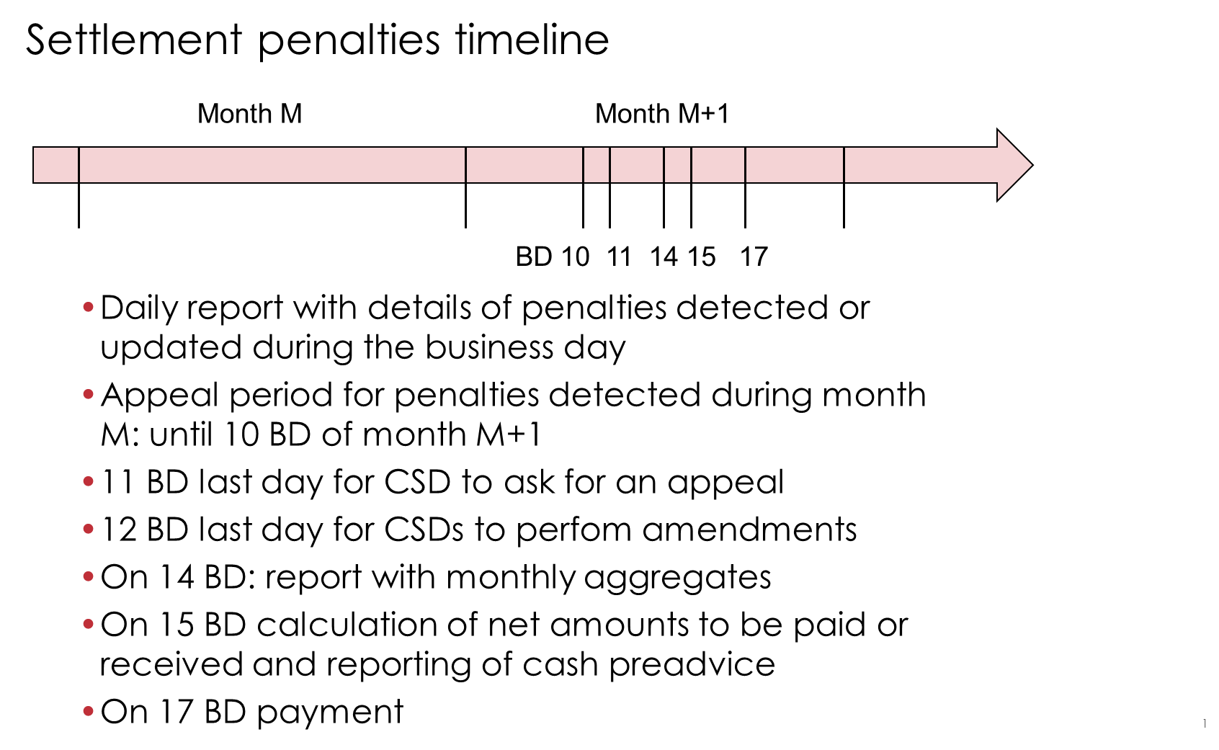
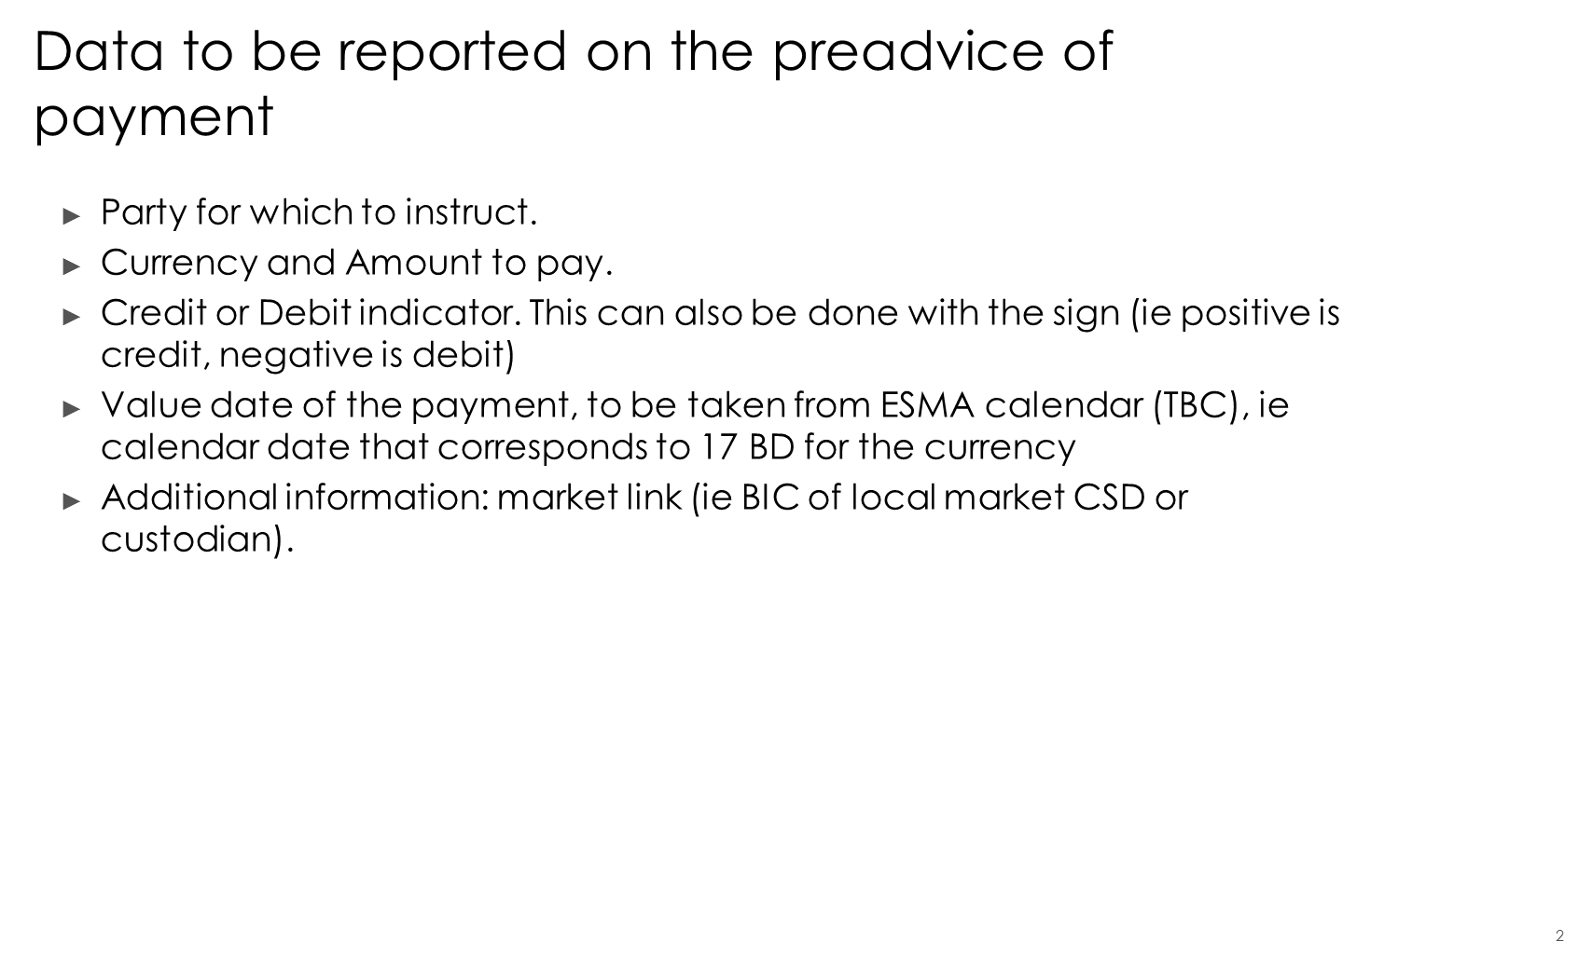
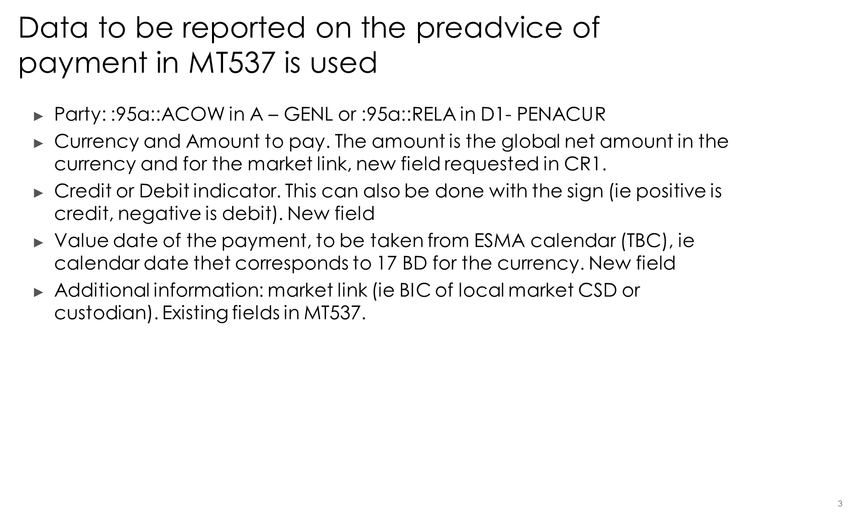

Standards Illustration
##ILLUSTRATION##
SWIFT Comment

Working Group Meeting
To be completed by Standards after the meeting in August.

Discussion
Decision

CR 001522: New fields for follow-up of buy-in process
Origin of request
Requesting Group: | Euroclear UK and Ireland
Sponsors
Euroclear UK and Ireland
Message type(s) impacted
MT 537, MT 548
Complies with regulation
Regulation (EU) no 909/2014 of the European Parliament and of the Council of 23 July 2014 on improving securities settlement in the European Union and on central securities depositories and amending Directives 98/26/EC and 2014/65/EU and Regulation (EU) No 236/2012 (“EU CSD-Regulation”).
Delegated Regulation (DR) 2018/1229, supplementing Regulation (EU) No 909/2014 of the European Parliament and of the Council with regard to regulatory technical standards on the settlement discipline regime (SDR)2.
RTS: Regulatory Technical Standard, which are endorsed by the European Commission by means of a delegated act supplementing an EU Regulation or a Directive
Business impact of this request
low
Optional new fields that are only relevant in the CSDR context.
Commitment to implement the change
Number of messages sent and received:
Percentage of messages impacted:
Commits to implement and when: EUI 2020
Business context
EUI's approach for the Buy-in functionality is to allow clients to update the results of buy-in against the transaction for which buy-in has been initiated. As the buy-in trades could take place in tranches during the buy-in process, EUI intends to allow participants to make multiple updates to the buy-in result attributes and this means they must be able to view the current state of the transaction.

The CREST proprietary communication channels will be amended to allow the above described update of the instruction and follow-up of the value in the system.

For the ISO interface, the MT 530 message will be used to amend the original instruction, using the same fields as described in the CR 2. In CREST the MT537 is used to provide reporting on pending instructions, so the same fields as introduced on the M530 should also be available on the MT 537 to allow for the reporting.
This message is sent by CREST either in response to an MT549 Request for a statement of pending transactions, or as an end-of-day report. The message contains details of unsettled matched and / or unmatched transactions that exists in CREST. To allow the clients to view the updates they conduct with the MT530, EUI are intending to update the MT537 to include the buy-in results.
Nature of change
The following fields should be added to the message in sequences B2b Transaction Details and C2 Transaction Details:

Cash compensation amount:
field :19A: with a 4 char qualifier, e.g. CCAM

Quantity of securities bought in
:36B: with a 4 char qualifier, eg BYIY

Value of the securities bought in
:19A: with a 4 char qualifier, e.g. also BYIY

New qualifier in 22F for reporting Buy-in processing indicator with three new codes (e.g. BYST):
- successful, e.g. BSSY
- unsuccessful, e.g. BSSN
- partially successful, e.g. BSSP

New qualifier in 22F for cash compensation indicator (e.g. CACC) with two new codes:
- cash compensation payment, e.g. BCCY
- no cash compensation payment, e.g. BCCN

The same fields are needed in the MT548, in sequence B Settlement Transaction Details.
Workaround
If no structured fields exist, the relevant information will be reported in the narrative fields in the message.
Examples
1. Failing transaction reaches the end of its extension period. Failing trading party initiated the buy-in. The buy-in has settled successfully for the full amount. The failing trading party updates the settlement instruction in EUI using the MT530 message
=> MT 530 example:
:22F::BYST//BSSY
:36B::BYIY//FAMT/1000,
:19A::BYIY//EUR1100,
EUI informs the party of this update using an MT537 with as fields:
:22F::BYST//BSSY
:36B::BYIY//FAMT/1000
:19A::BYIY//EUR1100,
2. Failing transaction reaches the end of its extension period. Failing trading party initiated the buy-in. The buy-in cannot be initated and a cash compensation has settled. The party sends an MT530 to update the instruction with the following fields:
=> MT530 example:
:22F::BYST//BSSN
:22F::CACC//BCCY
:19A::CCAM//EUR1200,
EUI informs the party of this update using an MT537 with as fields:
:22F::BYST//BSSN
:22F::CACC//BCCY
:19A::CCAM//EUR1200,
3. Failing transaction reaches the end of its extension period. Failing trading party initiated the buy-in. The buy-in settled partially and a cash compensation was paid for the outstanding amount. The party sends an MT530 to update the instruction:
=> MT530 example:
:22F::BYST//BSSP
:22F::CACC//BCCY
:19A::CCAM//EUR600,
:36B::BYIY//FAMT/400,
:19A::BYIY//EUR450,
EUI confirms the update by sending an MT537 with the following information
:22F::BYST//BSSP
:22F::CACC//BCCY
:19A::CCAM//EUR600,
:36B::BYIY//FAMT/400,
:19A::BYIY//EUR450,

Standards Illustration
##ILLUSTRATION##
SWIFT Comment

Working Group Meeting
To be completed by Standards after the meeting in August.

Discussion
Decision

CR 001532: Add new narrative field
Origin of request
Requesting Country: | BE Belgium
Sponsors
Febelfin WG MT586 (portfolio transfers)
Message type(s) impacted
MT 586
Complies with regulation
None
Business impact of this request
MEDIUM
Commitment to implement the change
Number of messages sent and received: /
Percentage of messages impacted: /
Commits to implement and when: BE Belgian Febelfin WG transfers MT586 2020
Business context
1. All banks who use the MT586 for portfolio transfers
2. The status code field 25D in subsequence B contains the reject code when transfers are not accepted for whatever reason. There is no narrative field underneath this field to describe the actual reject reason.
Nature of change
Addition of a narrative field 70E underneath the field 25D status code in Sequence B.
Workaround
Field 70E only exists underneath certain fields in Sequence B, eg field 35B (Identification of the financial instrument), so this can be used to add a narrative concerning the reject reason. But since this field belongs to field 35B, this is not adequate when the reject reason concerns some other particular field.
Examples
No actual example available, if field 70E is added underneath field 25D, it can serve as free field for explaining the reject reason, eg:
- account not known in our books
- blocked security because of…

Standards Illustration
##ILLUSTRATION##
SWIFT Comment

Working Group Meeting
To be completed by Standards after the meeting in August.

Discussion
Decision

Overview of SWIFT Change requests
None

Legal Notices
Copyright

SWIFT SCRL © 2019. All rights reserved.
Disclaimer
The information in this publication may change from time to time. You must always refer to the latest available version.
SWIFT Standards Intellectual Property Rights (IPR) Policy - End-User License Agreement

SWIFT Standards are licensed subject to the terms and conditions of the SWIFT Standards IPR Policy -
End-User License Agreement, available at www.swift.com > About Us > Legal > IPR Policies > SWIFT Standards IPR Policy.
Translations
The English version of SWIFT documentation is the only official and binding version.
Trademarks
SWIFT is the trade name of S.W.I.F.T. SCRL. The following are registered trademarks of SWIFT:
3SKey, Innotribe, MyStandards, Sibos, SWIFT, SWIFTNet, SWIFT Institute, the Standards Forum logo, the SWIFT logo and UETR. Other product, service, or company names in this publication are trade names, trademarks, or registered trademarks of their respective owners.

