Change Request
for the update of ISO 20022 financial repository items

- Origin of the request:
A.1 Submitter: The Clearing House on behalf of CHIPS
1114 Ave of Americas
New York 10036
USA
A.2 Contact person:
Mr. Robert Pepitone - Robert.Pepitone@theclearinghouse.org (212-613-9874)
A.3 Sponsors:
The Clearing House – Robert Pepitone
Federal Reserve Bank of New York - Frank VanDriessche
SWIFT Cash and Trade - Michael Mangieri

- Related messages:
pacs.004.001.09 – Payment Return

- Description of the change request:
This request is to add elements to the pacs.004 Return Payment. Currently, the Return Chain block of the pacs.004 contains all the necessary Creditor, Debtor and Agents elements necessary to direct the forward Return payment instruction. However, the Return Chain block should also include an Account element associated with each Creditor, Debtor and Agent element necessary to process the Return payment instruction. This change will necessitate adding the following elements to the Return Chain block of the pacs.004:
- Return Chain block – (see diagram figure #1 below)
  - the Account elements to be added are indicated with red arrows.
- These elements are found in the TransactionInformation in the Return Chain Block (TxInf/RtrChain).

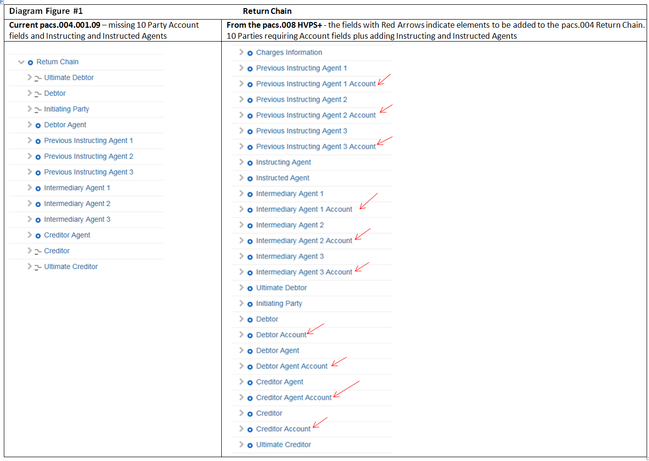

- Purpose of the change:
The Return Chain of the original payment was added in 2017/2018 (CR0687) to include the parties involved in the return. However, the associated Account elements for each party were not included in that change request. In order to provide all of the possible information on a party related to a payment party identification and payment processing, the Account elements must be included in the Return Chain block.

- Background, business context, community of users interested by the change and expected benefits/savings:
During the March/April 2019 meetings of the HVPS+ group, the represented communities recognized that although it might not be a regulatory requirement in all communities, that the explicit inclusion of the ‘Parties’ and associated Accounts in the return chain are needed in instances when the payment is not returned via the same route that the original payment order was executed. This will enable the ability to provide clarity and increase transparency of payment returns, thereby enabling financial institutions to perform the required controls in more automated ways.

- Urgency of the request:
TCH ISO 20022 for CHIPS will be in production in March 2022 and available for bank testing starting April 2021. This necessitates the inclusion of these elements in the pacs.004 message to enable coding to begin with the ISO 20022 2020 release.

- Business examples:
/

- SEG/TSG recommendation:
This section is not to be taken care of by the submitter of the change request. It will be completed in due time by the SEG(s) in charge of the related ISO 20022 messages or the TSG for changes related to the BAH.

Consider |  | X | Timing
 |  |  | - Next yearly cycle: 2019/2020  (the change will be considered for implementation in the yearly maintenance cycle which starts in 2019 and completes with the publication of new message versions in the spring of 2020) |  | X
- At the occasion of the next maintenance of the messages
(the change will be considered for implementation, but does not justify maintenance of the messages in its own right – will be pending until more critical change requests are received for the messages)
- Urgent unscheduled
(the change justifies an urgent implementation outside of the normal yearly cycle)
 |  |  | - Other timing:
Comments:
Decided during Payments SEG on 1 July 2019

Reject
Reason for rejection:

The High-value Payment Systems Plus (HVPS+) is a SWIFT convened group of high-value market infrastructures and banks to establish suggested practices for implementing ISO 20022 messages across high-value payment systems with enhanced features that are not supported today in legacy formats. Members include representatives from Australia, Canada, the European Union, Japan, Hong Kong, South Africa, the UK, and the US.

