Change Request
for the update of ISO 20022 financial repository items

- Origin of the request:
A.1 Submitter: The Clearing House on behalf of CHIPS
1114 Ave of Americas
New York 10036
USA
A.2 Contact person:
Mr. Robert Pepitone - Robert.Pepitone@theclearinghouse.org (212-613-9874)
A.3 Sponsors:
The Clearing House – Robert Pepitone

- Related messages:
pacs.004.001.09 – Payment Return

- Description of the change request:
This request is to add an optional element block to the pacs.004 Return Payment. When the pacs.004 is used to return a pacs.009COV, there should be available elements in the pacs.004 to contain the Underlying Customer Credit Transfer (/Document/FICdtTrf/CdtTrfTxInf/UndrlygCstmrCdtTrf) from pacs.009COV being returned.
The Clearing House (CHIPS) recommends adding a new, optional element block Underlying Customer Credit Transfer (/Document/PmtRtr/TxInf/UndrlygCstmrCdtTrf) to the Transaction Information block of the pacs.004 only to be used when returning a pacs.009COV. Including the Underlying Customer Credit block from the pacs.009COV is the most transparent way to ensure all Travel Rule required information is captured and provides for differentiation between the Original Transaction Information section and the Underlying Customer Credit Transfer. See pic below extracted from the Financial Institution Credit Transfer V07 (pacs.009.001.07).

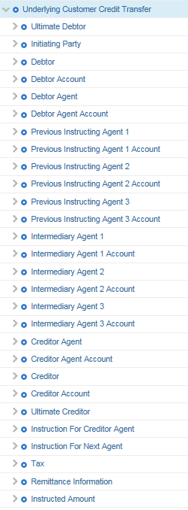

- Purpose of the change:
In order to be compliant with FinCEN regulation U.S. Travel Rule (31 C.F.R. § 1010.410(f)(1)) banks must have the ability to transport originator and beneficiary related information associated with the underlying credit payment when sending a pacs.004 (Return Payment Instruction) used to return a COVER payment (pacs.009COV in ISO 20022/MT202COV in Legacy SWIFT MT).

- Background, business context, community of users interested by the change and expected benefits/savings.
In current Legacy SWIFT messaging, the MT202COV carries the underlying credit information (beneficiary and originator) from the MT103 in the MT202COV Sequence B section of the message.
It is The Clearing House Legal Opinion that US banks processing return payments where the return is of a COVER payment, that the pacs.004 must be able to include beneficiary and originator information (Seq B).

The U.S. Travel Rule (31 C.F.R. § 1010.410(f)(1)) is a FinCEN regulation that requires that certain information be included and carried forward in "transmittals of funds" which include wires. Specifically, the Travel Rule requires that an originating bank include the following information about the recipient (beneficiary) of a wire to the extent such information is provided at the time the wire is instructed: (1) The name and address of the recipient; (2) The account number of the recipient; and (3) Any other specific identifier of the recipient. Under the Travel Rule a return of funds is a transmittal of funds that must include this recipient information. In a return of funds, the recipient of the returned funds is the originator of the original wire. To the extent the original wire was a cover payment and included information about an underlying originator (i.e., Sequence B information), the return of funds must include the Sequence B information as recipient information since the bank that is originating the return of funds has been provided the information. However, the pacs.004 does not accommodate Sequence B information and thus, banks that are returning funds related to a cover payment cannot meet their Travel Requirements if they use the pacs.004.

- Urgency of the request:
TCH ISO 20022 for CHIPS will be in production in March 2022 and available for bank testing starting April 2021. This necessitates the inclusion of this block of elements in the pacs.004 message to enable coding to begin with the ISO 20022 2020 release.

- Business examples:

- SEG/TSG recommendation:
This section is not to be taken care of by the submitter of the change request. It will be completed in due time by the SEG(s) in charge of the related ISO 20022 messages or the TSG for changes related to the BAH.

Consider |  | X | Timing
 |  |  | - Next yearly cycle: 2018/2019  (the change will be considered for implementation in the yearly maintenance cycle which starts in 2018 and completes with the publication of new message versions in the spring of 2019) |  | X
- At the occasion of the next maintenance of the messages
(the change will be considered for implementation, but does not justify maintenance of the messages in its own right – will be pending until more critical change requests are received for the messages)
- Urgent unscheduled
(the change justifies an urgent implementation outside of the normal yearly cycle)
 |  |  | - Other timing:
Comments: Decided during Payments SEG on 1 July 2019

Reject
Reason for rejection:

