Change Request
for the update of ISO 20022 financial repository items
- Origin of the request:
A.1 Submitter: SWIFT
A.2 Contact person: Jacques Littré – Jacques.littre@swift.com - +3226554335
A.3 Sponsors: None

- Related messages:
Seev.032.00x.06

- Description of the change request:
Add the reason code value “Missing or Invalid Certification” [MCER] as a pending reason code in the CAEventProcessingStatus message.

- Purpose of the change:
The MCER reason code is part of the SMPG CA WG MP part 3 and should be one of the reason code that can be provided for an event processing status “pending”.
The reason code is available in ISO 15022 for the MT567 for the 25D::EPRC status but is missing in the ISO 20022 equivalent status in the seev.032 message.
Due to the coexistence between ISO 15022 and ISO20022, this misalignment should be corrected.
- Urgency of the request:
For SR2020 release
- Business examples:
Examples illustrating the change request.

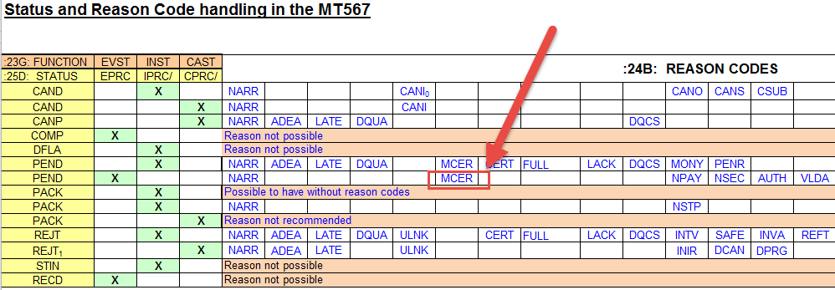

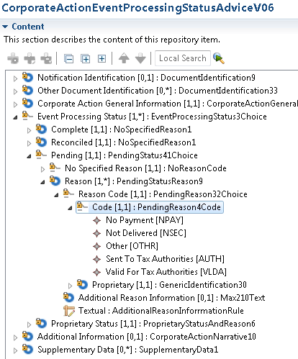
SEG/TSG recommendation:
This section is not to be taken care of by the submitter of the change request. It will be completed in due time by the SEG(s) in charge of the related ISO 20022 messages or the TSG for changes related to the BAH.

Consider |  | X | Timing
 |  |  | - Next yearly cycle: 2019/2020  (the change will be considered for implementation in the yearly maintenance cycle which starts in 2018 and completes with the publication of new message versions in the spring of 2019) |  | X
- At the occasion of the next maintenance of the messages
(the change will be considered for implementation, but does not justify maintenance of the messages in its own right – will be pending until more critical change requests are received for the messages)
- Urgent unscheduled
(the change justifies an urgent implementation outside of the normal yearly cycle)
 |  |  | - Other timing:
Comments:
ISO20022 CA Evaluation Team comments:
Group agreed that this request should move forward.

Reject
Reason for rejection:

