Change Request
for the update of ISO 20022 financial repository items

- Origin of the request:
A.1 Submitter: nexo A.I.S.B.L.
A.2 Contact person: person(s) Philippe CECE (Philippe.cece@ingenico.com) / Pierre PETITCUENOT (pierre.petitcuenot@e-i.com) / Pierre MOURA (pierre.moura@frenchsys.com)
A.3 Sponsors: nexo A.I.S.B.L.

- Related messages:

- AcceptorAuthorisationRequestV08 (caaa.001.001.08)
- AcceptorAuthorisationResponseV08 (caaa.002.001.08)
- AcceptorCompletionAdviceV08 (caaa.003.001.08)
- AcceptorCompletionAdviceResponseV07 (caaa.004.001.07)
- AcceptorCancellationRequestV08 (caaa.005.001.08)
- AcceptorCancellationResponseV07 (caaa.006.001.07)
- AcceptorCancellationAdviceV08 (caaa.007.001.08)
- AcceptorCancellationAdviceResponseV07 (caaa.008.001.07)
- AcceptorReconciliationRequestV07 (caaa.009.001.07)
- AcceptorReconciliationResponseV06 (caaa.010.001.06)
- AcceptorBatchTransferV08 (caaa.011.001.08)
- AcceptorBatchTransferResponseV07 (caaa.012.001.07)
- AcceptorDiagnosticRequestV07 (caaa.013.001.07)
- AcceptorDiagnosticResponseV06 (caaa.014.001.06)
- AcceptorCurrencyConversionRequestV06 (caaa.016.001.06)
- AcceptorCurrencyConversionResponseV06 (caaa.017.001.06)
- AcceptorCurrencyConversionAdviceV03 (caaa.018.001.03)
- AcceptorCurrencyConversionAdviceResponseV02 (caaa.019.001.02)

- StatusReportV08 (catm.001.001.08)
- ManagementPlanReplacementV07 (catm.002.001.07)
- AcceptorConfigurationUpdateV08 (catm.003.001.08)
- TerminalManagementRejectionV04 (catm.004.001.04)
- MaintenanceDelegationRequestV05 (catm.005.001.05)
- MaintenanceDelegationResponseV03 (catm.006.001.03)
- CertificateManagementRequestV02 (catm.007.001.02)
- CertificateManagementResponseV02 (catm.008.001.02)

- SaleToPOIServiceRequest V01 casp.001.001.01
- SaleToPOIServiceResponse V01 casp.002.001.01
- SaleToPOIReconciliationRequest V01 casp.003.001.01
- SaleToPOIReconciliationResponse V01 casp.004.001.01
- SaleToPOISessionManagementRequest V01 casp.005.001.01
- SaleToPOISessionManagementResponse V01 casp.006.001.01
- SaleToPOIAdministrativeRequest V01 casp.007.001.01
- SaleToPOIAdministrativeResponse V01 casp.008.001.01
- SaleToPOIReportRequest V01 casp.009.001.01
- SaleToPOIReportResponse V01 casp.010.001.01
- SaleToPOIAbort V01 casp.011.001.01
- SaleToPOIEventNotification V01 casp.012.001.01
- SaleToPOIMessageStatusRequest V01 casp.014.001.01
- SaleToPOIMessageStatusResponse V01 casp.015.001.01
- SaleToPOIDeviceRequest V01 casp.016.001.01
- SaleToPOIDeviceResponse V01 casp.017.001.01

- Description of the change request:

Firstly we want to create from AcquirerProtocolParameters8 a new component named AcquirerProtocolExchangeBehavior1 defined as Set of parameters to define the behavior of the acquirer protocol.

Secondly we want to update GenericIdentification53, GenericIdentification71, GenericIdentification71 to GenericIdentificationXX since the only difference reside on the addition of an optional message element with different possible values from the same codeset. GenericIdentification92, GenericIdentification93, GenericIdentification94 and GenericIdentification165 to PartyDetails01 since the only difference reside also on the addition of two optional message elements with different possible values from the same codeset.

Thirdly we want to create a new Header message component to be used by every TMS messages.

Fourthly, we want to dissociate MaintenanceDelegation6 from MaintenanceDelegation8 by respectively creating through copy paste management new components MaintenanceDelegationResponseContent1 and MaintenanceDelegationRequestContent1.

- Purpose of the change:

This change request aims to simplify the TMS protocol and will try to remove multiple instances of the same "message component".

This might happen when after a modification the aim of a message component has been twisted or when some modifications have been forgotten in a past maintenance. After multiple maintenance process we reach our current point where 2 data elements with roughly the same name means something different or where a same element is symbolized by 2 different message components.

For instance, in the current repository, AcquirerProtocolParameters8 and AcquirerProtocolParameters12 are active, but with a different functional meaning. We will solve it by creating a new message components. This modification has little impact except for implementers who are generating software from XSD. MaintenanceDelegation6 and MaintenanceDelegation8 share the same conclusion than before.

The second example could be GenericIdentification53, GenericIdentification71, GenericIdentification72, GenericIdentification92, GenericIdentification93, GenericIdentification94 and GenericIdentification165.
The harmonization of the GenericIdentification will be done by defining 2 new message components to simplify existing message components
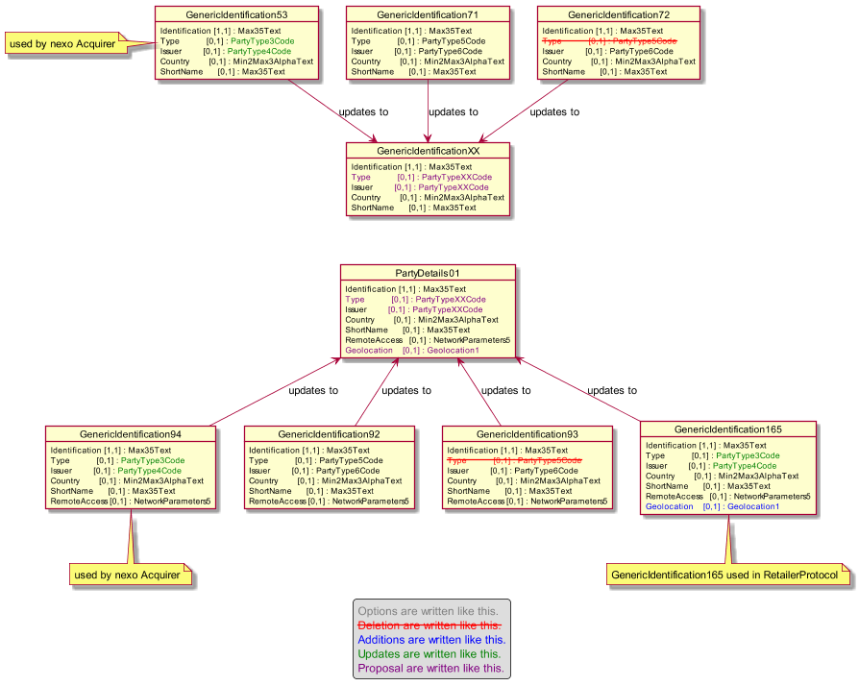

TMSHeader falls into the same category. The harmonization of the TMS header will be done by defining the least common multiple from Header27, Header28 and Header29 message components.

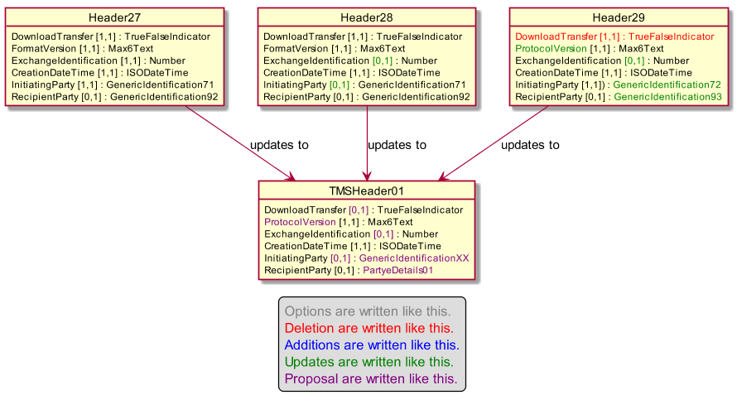

Regarding the PointOfInteraction6 and PointOfInteraction9, we believe that it would be better to reuse the PointOfInteractionComponentIdentification1.

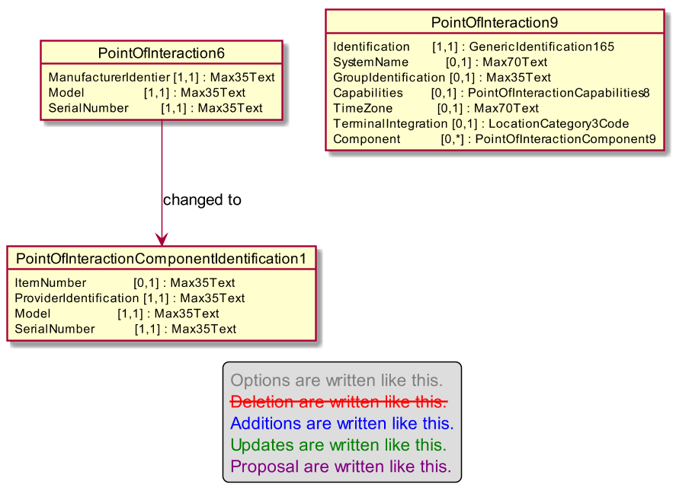

Finally, the last modifications aims to split the message component TerminalManagementDataSet according to its purpose.
TerminalManagementDataSet24 is used as the content of a ManagementPlan.
TerminalManagementDataSet25 is used to identify a Dataset required in a StatusReport, so we will create a new message component copied from this one named DataSetRequest1.
TerminalManagementDataSet27 is used to the content of an AcceptorConfigurationUpdate message. So we will create a new message component copied from this one named AcceptorConfigurationDataSet1.
TerminalManagementDataSet28 is used to provide DataSet of StatusReport, so we will create a new message component copied from this one named StatusReportDataSetRequest1.

- Urgency of the request:

Not urgent.

- Business examples:
Examples illustrating the change request.
- SEG/TSG recommendation:
This section is not to be taken care of by the submitter of the change request. It will be completed in due time by the SEG(s) in charge of the related ISO 20022 messages or the TSG for changes related to the BAH.

Consider |  | X | Timing
 |  |  | - Next yearly cycle: 2019/2020  (the change will be considered for implementation in the yearly maintenance cycle which starts in 2019 and completes with the publication of new message versions in the spring of 2020) |  | X
- At the occasion of the next maintenance of the messages
(the change will be considered for implementation, but does not justify maintenance of the messages in its own right – will be pending until more critical change requests are received for the messages)
- Urgent unscheduled
(the change justifies an urgent implementation outside of the normal yearly cycle)
 |  |  | - Other timing:
Comments:

Reject
Reason for rejection:

