Change Request
for the update of ISO 20022 financial repository items

- Origin of the request:
A.1 Submitter: nexo A.I.S.B.L.
A.2 Contact person: person(s) Philippe CECE (Philippe.cece@ingenico.com) / Theophane LUMINEAU (theophane.lumineau@ca-cp.fr)
A.3 Sponsors: nexo A.I.S.B.L.

- Related messages:

- AcceptorAuthorisationRequestV08 (caaa.001.001.08)
- AcceptorAuthorisationResponseV08 (caaa.002.001.08)
- AcceptorCompletionAdviceV08 (caaa.003.001.08)
- AcceptorCompletionAdviceResponseV07 (caaa.004.001.07)
- AcceptorCancellationRequestV08 (caaa.005.001.08)
- AcceptorCancellationResponseV07 (caaa.006.001.07)
- AcceptorCancellationAdviceV08 (caaa.007.001.08)
- AcceptorCancellationAdviceResponseV07 (caaa.008.001.07)
- AcceptorReconciliationRequestV07 (caaa.009.001.07)
- AcceptorReconciliationResponseV06 (caaa.010.001.06)
- AcceptorBatchTransferV08 (caaa.011.001.08)
- AcceptorBatchTransferResponseV07 (caaa.012.001.07)
- AcceptorDiagnosticRequestV07 (caaa.013.001.07)
- AcceptorDiagnosticResponseV06 (caaa.014.001.06)
- AcceptorCurrencyConversionRequestV06 (caaa.016.001.06)
- AcceptorCurrencyConversionResponseV06 (caaa.017.001.06)
- AcceptorCurrencyConversionAdviceV03 (caaa.018.001.03)
- AcceptorCurrencyConversionAdviceResponseV02 (caaa.019.001.02)

- StatusReportV08 (catm.001.001.08)
- ManagementPlanReplacementV07 (catm.002.001.07)
- AcceptorConfigurationUpdateV08 (catm.003.001.08)
- MaintenanceDelegationRequestV05 (catm.005.001.05)
- MaintenanceDelegationResponseV03 (catm.006.001.03)
- CertificateManagementRequestV02 (catm.007.001.02)
- CertificateManagementResponseV02 (catm.008.001.02)

- SaleToPOIServiceRequestV01 (casp.001.001.01)
- SaleToPOIServiceResponseV01 (casp.001.001.01)
- SaleToPOIReconciliationRequestV01 (casp.003.001.01)
- SaleToPOIReconciliationResponseV01 (casp.004.001.01)
- SaleToPOIManagementRequestV01 (casp.011.001.01)
- SaleToPOIManagementResponseV01 (casp.012.001.01)
- SaleToPOIAdministrativeRequestV01 (casp.013.001.01)
- SaleToPOIAdministrativeResponseV01 (casp.014.001.01)
- SaleToPOIReportRequestV01 (casp.015.001.01)
- SaleToPOIReportResponseV01 (casp.016.001.01)
- SaleToPOIAbortV01 (casp.021.001.07)
- SaleToPOIEventNotification (casp.022.001.01)
- SaleToPOIMessageStatusRequestV01 (casp.024.001.01)
- SaleToPOIMessageStatusResponseV01 (casp.025.001.01)
- SaleToPOIDeviceRequestV01 (casp.031.001.01)
- SaleToPOIDeviceResponseV01 (casp.032.001.01)

- Description of the change request:

Firstly we need to add in the Algorithm18Code these new codeset:
- UKA2 : UKPT With AES192
- UKA3 : UKPT With AES256

Secondly, we want to update CryptographicKey13 message component by:
- adding a message element Name defined as Name of the Cryptographic Element with multiplicity [0.1] and type Max140Text
- adding a message element SecurityProfile defined as Identification of the set of security elements to which this element belongs. with multiplicity [0.1] and type Max35Text
- adding a message element ItemNumber defined as Hierarchical identification of a key inside all the key system. It is composed of all item numbers of the upper level components, separated by the '.' character, ended by the item number of the current component. with multiplicity [0.1] and type Max35Text

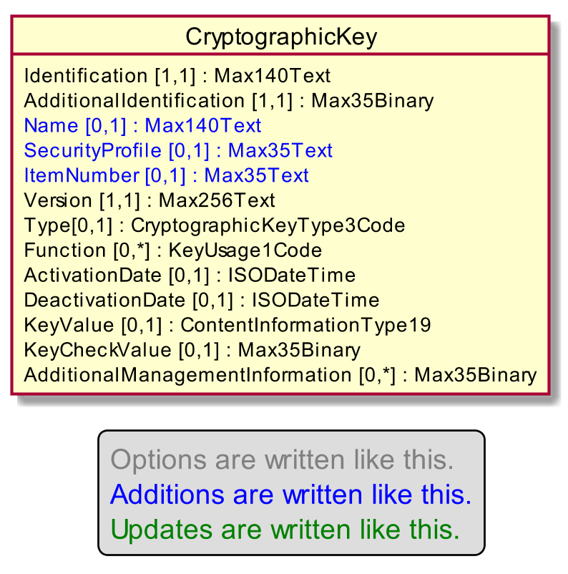

Modification on the CryptographicKey message component.

- Purpose of the change:

This change request aims to solve 2 missing functionalities in the CAPE protocols.

Firstly, we need to slightly improve the list of supported algorithm to add Unique Key Per Transaction with AES192 and AES 256.

Secondly, in order to ease the maintenance on the field of CAP solution, it might be interesting to provide additional information:
- A human understandable label to any cryptographic element, rather than Identification that may be a UUID.
- The group or profile of the key represented by the element,
- The hierarchy of this key in the overall system.

- Urgency of the request:

Necessary.

- Business examples:
Examples illustrating the change request.
- SEG/TSG recommendation:
This section is not to be taken care of by the submitter of the change request. It will be completed in due time by the SEG(s) in charge of the related ISO 20022 messages or the TSG for changes related to the BAH.

Consider |  | X | Timing
 |  |  | - Next yearly cycle: 2019/2020  (the change will be considered for implementation in the yearly maintenance cycle which starts in 2019 and completes with the publication of new message versions in the spring of 2020) |  | X
- At the occasion of the next maintenance of the messages
(the change will be considered for implementation, but does not justify maintenance of the messages in its own right – will be pending until more critical change requests are received for the messages)
- Urgent unscheduled
(the change justifies an urgent implementation outside of the normal yearly cycle)
 |  |  | - Other timing:
Comments:

Reject
Reason for rejection:

