Change Request IT097-2019
for the update of ISO 20022 financial repository items

- Origin of the request:
A.1 Submitter : NMPG / Italy
A.2 Contact person: Andrea Milanesio andmilanesio@gmail.com +393479837483

- Related messages:

*AccountOpeningInstructionV07 acmt.001.001.07
*AccountDetailsConfirmationV07 acmt.002.001.07
*AccountModificationInstructionV07 acmt.003.001.07
- Description of the change request:
Due to introduction of Regulation (EU) 2016/679 of the European Parliament and of the Council of 27 April 2016 on the protection of natural persons with regard to the processing of personal data and on the free movement of such data, and repealing Directive 95/46/EC (General Data Protection Regulation),
Add a new optional and multiple section GDPRData where are managed different type of consent for the processing of personal data collected from the investor and the related consent date.
Introduce this new data under all section of IndividualPerson for any current role in AccountParties.

Example:
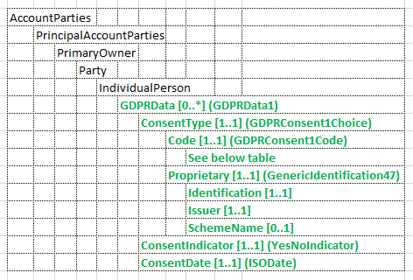
GDPRConsent1Code:

DP00 | Consent to authorize the controller of personal data processing to process personal data for marketing purposes
DP01 | Consent to authorize the controller of personal data processing to transfer personal data to other companies belonging to the same group for independent processing for marketing purposes
DP02 | Consent to authorize the controller of personal data processing to transfer personal data to third party companies for independent processing for marketing purposes
DP03 | Consent to authorize the controller of personal data processing to process personal data for profiling purposes in order to formulate customized and targeted product and service offers

- Purpose of the change:
In accordance to European Regulation 2016/679 (General Data Protection Regulation).

- Urgency of the request:
Next yearly cycle.

- Business examples:

- SEG/TSG recommendation:
This section is not to be taken care of by the submitter of the change request. It will be completed in due time by the SEG(s) in charge of the related ISO 20022 messages or the TSG for changes related to the BAH.

Consider |  | X | Timing
 |  |  | - Next yearly cycle: 2019/2020  (the change will be considered for implementation in the yearly maintenance cycle which starts in 2019 and completes with the publication of new message versions in the spring of 2020) |  | X
- At the occasion of the next maintenance of the messages
(the change will be considered for implementation, but does not justify maintenance of the messages in its own right – will be pending until more critical change requests are received for the messages)
- Urgent unscheduled
(the change justifies an urgent implementation outside of the normal yearly cycle)
 |  |  | - Other timing:
Comments:

Reject
Reason for rejection:

