Change Request
for the update of ISO 20022 financial repository items
- Origin of the request:
A.1 Submitter: Janice Chapman, on behalf of Funds UK NMPG - UK Electronic Transfer and Re-Registrations Group (UKETRG)
A.2 Contact person: Janice.chapman@swift.com
A.3 Sponsors:
- Related messages:
# | Name | Message Identifier
1 | Transfer Out Instruction | sese.001.001.08
2 | Transfer Out Confirmation | Sese.003.001.08
3 | Transfer In Instruction | sese.005.001.08
4 | Transfer In Confirmation | sese.007.001.08
- Description of the change request:
In the Transfer Details sequence, add an optional Original Cost element.
Using sese.005 as the example:
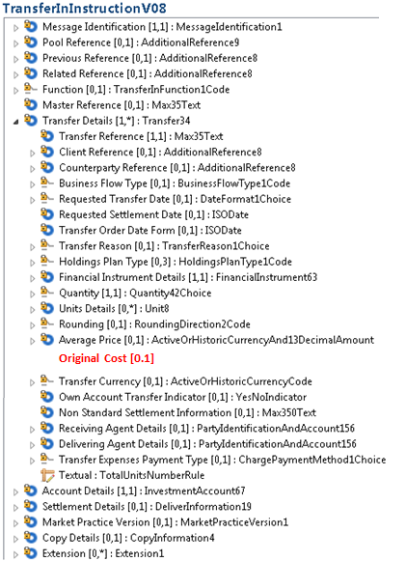

Definition
Original Cost | [0.1] | Original amount paid for the asset at the point of purchase. May also be known as the book cost. | ActiveCurrencyAnd13DecimalAmount

- Purpose of the change:
- To enable the transfers message set to meet the requirements of the UK transfers market. In particular, this is required in those scenarios in which a custodian also offers some administrative outsourcing capabilities and they actually store data on a per client basis and so need this type of information rather than just nominee asset holding positions.
- Urgency of the request:
Next maintenance cycle, 2019-2020.
- Business examples:

- SEG/TSG recommendation:
This section is not to be taken care of by the submitter of the change request. It will be completed in due time by the SEG(s) in charge of the related ISO 20022 messages or the TSG for changes related to the BAH.

Consider |  | X | Timing
 |  |  | - Next yearly cycle: 2019/2020  (the change will be considered for implementation in the yearly maintenance cycle which starts in 2019 and completes with the publication of new message versions in the spring of 2020) |  | X
- At the occasion of the next maintenance of the messages
(the change will be considered for implementation, but does not justify maintenance of the messages in its own right – will be pending until more critical change requests are received for the messages)
- Urgent unscheduled
(the change justifies an urgent implementation outside of the normal yearly cycle)
 |  |  | - Other timing:
Comments:

Reject
Reason for rejection:

