Change Request
for the update of ISO 20022 financial repository items
- Origin of the request:
A.1 Submitter: Janice Chapman, on behalf of Funds UK NMPG - UK Electronic Transfer and Re-Registrations Group (UKETRG) and SMPG IF
A.2 Contact person: Janice.chapman@swift.com
A.3 Sponsors:
- Related messages:
# | Name | Message Identifier
1 | Transfer Out Instruction | sese.001.001.08
2 | Transfer Out Confirmation | Sese.003.001.08
3 | Transfer In Instruction | sese.005.001.08
4 | Transfer In Confirmation | sese.007.001.08
- Description of the change request:
In the Settlement Details sequence, add an optional Requested Trade Date:
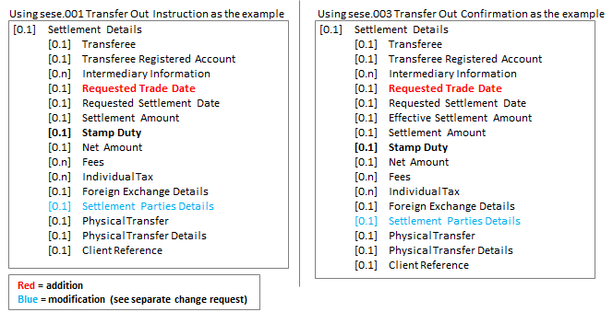

Definition
Requested Trade Date | [0.1] | Date to be used as the trade date when securities are settled through an International Central Securities Depository (ICSD) or Central Securities Depository (CSD). | ISO Date

- Purpose of the change:
This is required for the transfer of fund units via an ICSD or CSD in a matched leg scenario. In some systems, both 98A TRAD (trade date) and 98A SETT (settlement date) are required to match the two legs of the transfer.
- Urgency of the request:
Next maintenance cycle, 2019-2020.
- Business examples:

- SEG/TSG recommendation:
This section is not to be taken care of by the submitter of the change request. It will be completed in due time by the SEG(s) in charge of the related ISO 20022 messages or the TSG for changes related to the BAH.

Consider |  | X | Timing
 |  |  | - Next yearly cycle: 2019/2020  (the change will be considered for implementation in the yearly maintenance cycle which starts in 2019 and completes with the publication of new message versions in the spring of 2020) |  | X
- At the occasion of the next maintenance of the messages
(the change will be considered for implementation, but does not justify maintenance of the messages in its own right – will be pending until more critical change requests are received for the messages)
- Urgent unscheduled
(the change justifies an urgent implementation outside of the normal yearly cycle)
 |  |  | - Other timing:
Comments:

Reject
Reason for rejection:

