Change Request
for the update of ISO 20022 financial repository items
- Origin of the request:
A.1 Submitter: Janice Chapman, on behalf of Funds UK NMPG - UK Electronic Transfer and Re-Registrations Group (UKETRG) and SMPG IF.
A.2 Contact person: Janice.chapman@swift.com
A.3 Sponsors:
- Related messages:
# | Name | Message Identifier
1 | Transfer Out Instruction | sese.001.001.08
2 | Transfer Out Confirmation | sese.003.001.08
3 | Transfer In Instruction | sese.005.001.08
4 | Transfer In Confirmation | sese.007.001.08
- Description of the change request:
This change request is complimentary to change request ID 0713, submitted by Clearstream and change request ID 0714 submitted by SWIFT Standards for SMPG IF and UK NMPG in 2018.
Change request ID 0713, the Clearstream change request, is a change request for the funds order (setr) messages. It was approved by the securities SEG but the implementation in the funds (setr) order messages was deferred. This proposes the alignment of the Settlement and Custody Details sequences with those in the Securities Settlement Transaction Instruction (sese.023) message in which a depository is available on both the delivery and receive sides of the settlement chain parties and concepts such as ‘receiving agent’, receiver’s custodian, etc, have element names such as ‘party 1’, ‘party 2’ and so on.
To keep the funds messages in alignment and consistent with each other, change request ID 0714 was submitted in 2018 for the 2019 maintenance which proposed a similar change for the funds ‘discovery’ and portfolio transfer messages, sese.018, 019 012, 013.
This particular change request goes a step further in this alignment and harmonisation process and proposes a similar change for the funds ‘asset transfer’ messages, sese.001, 003, 005 and 007.
Illustration of change
[1] Transfer Out Instruction (sese.001) & Transfer Out Confirmation (sese.003):

Using the Transfer Out Instruction sese.001 as an example:
Account Details sequence (delivering side)
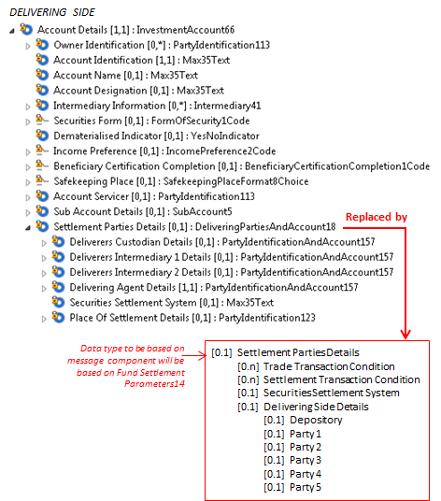

Settlement Details sequence (delivering side):
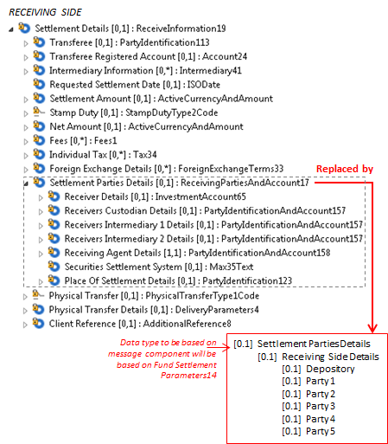

Illustration of change
[2] Transfer In Instruction (sese.005) & Transfer In Confirmation (sese.007):

Using the Transfer In Instruction sese.005 as an example:
Account Details sequence (receiving side)

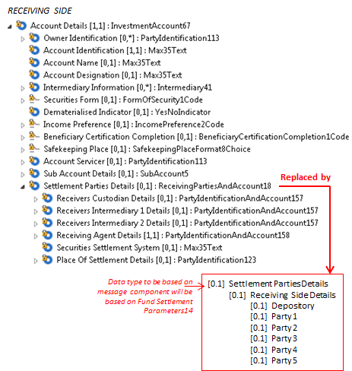
Settlement Details sequence (delivering side)

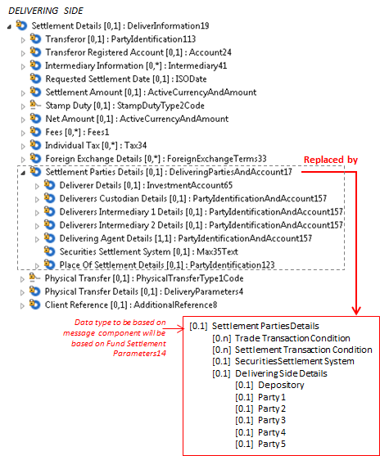
- Purpose of the Change:
This change requested is submitted so that the settlement chain parties in the funds asset transfer (sese.001, 003, 005, 007) messages are aligned with the settlement chain parties in the funds order (setr) messages (change request 0713) and the funds discovery and portfolio transfer messages (sese.018, 019, 012, 013) which have already been updated as a result of change request ID 0714 for 2019
(Change request 0713 was submitted by Clearstream so that the funds order (setr) messages are consistent with the settlement details defined in the ISO 20022 sese.023 and sese.028 messages, particularly when two places of settlement are involved as, for example, in the case of T2S cross-CSD settlement.)
- Urgency of the request:
For the next maintenance.
- Business examples:
- SEG/TSG recommendation:
This section is not to be taken care of by the submitter of the change request. It will be completed in due time by the SEG(s) in charge of the related ISO 20022 messages or the TSG for changes related to the BAH.
Consider |  | X | Timing
 |  |  | - Next yearly cycle: 2019/2020  (the change will be considered for implementation in the yearly maintenance cycle which starts in 2019 and completes with the publication of new message versions in the spring of 2020) |  | X
- At the occasion of the next maintenance of the messages
(the change will be considered for implementation, but does not justify maintenance of the messages in its own right – will be pending until more critical change requests are received for the messages)
- Urgent unscheduled
(the change justifies an urgent implementation outside of the normal yearly cycle)
 |  |  | - Other timing:
Comments:

Reject
Reason for rejection:

