Change Request
for the update of ISO 20022 financial repository items
- Origin of the request:
A.1 Submitter: Janice Chapman, on behalf of SMPG IF.
A.2 Contact person: Janice.chapman@swift.com
A.3 Sponsors:
- Related messages:
# | Name | Message Identifier
1 | Reversal of Transfer Out Confirmation | sese.004.001.08
2 | Transfer In Cancellation Request | sese.006.001.08
- Description of the change request:
Reversal Of Transfer Out Confirmation sese.004
Add Master Reference
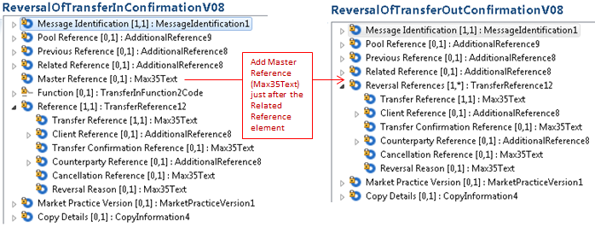
Transfer In Cancellation Request sese.006
Add Master Reference:
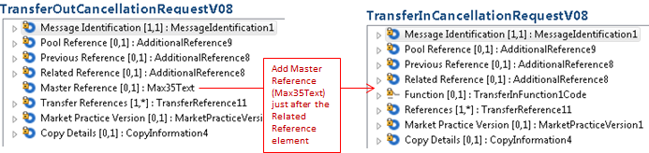

- Purpose of the Change:
A structural change was made to the funds transfer (sese) cancellation messages (sese.002 & sese.006) and the reversal messages (sese.004 & sese.008) in the 2017-2018 maintenance cycle. By mistake, the Master Reference was dropped from sese.004 and sese.006 and so needs to be restored.
- Urgency of the request:
For the next maintenance when sese.001, 003, 005 and 007 are maintained.
- Business examples:

- SEG/TSG recommendation:
This section is not to be taken care of by the submitter of the change request. It will be completed in due time by the SEG(s) in charge of the related ISO 20022 messages or the TSG for changes related to the BAH.
Consider |  |  | Timing
- Next yearly cycle: 2019/2020
(the change will be considered for implementation in the yearly maintenance cycle which starts in 2019 and completes with the publication of new message versions in the spring of 2020)
- At the occasion of the next maintenance of the messages
(the change will be considered for implementation, but does not justify maintenance of the messages in its own right – will be pending until more critical change requests are received for the messages)
- Urgent unscheduled
(the change justifies an urgent implementation outside of the normal yearly cycle)
 |  |  | - Other timing:
Comments:

Reject
Reason for rejection:

