Change Request
for the update of ISO 20022 financial repository items
- Origin of the request:
A.1 Submitter: Janice Chapman, on behalf of Funds UK NMPG - UK Electronic Transfer and Re-Registrations Group (UKETRG)
A.2 Contact person: Janice.chapman@swift.com, Helen Scriminger (TeX) consulting@scriminger.com
A.3 Sponsors:
- Related messages:
# | Name | Message Identifier
1 | Account Holding Information Request | sese.019.001.06
2 | Account Holding Information | Sese.018.001.07
3 | Portfolio Transfer Instruction | sese.012.001.09
4 | Portfolio Transfer Confirmation | sese.013.001.09
- Description of the change request:
New codes in the code list for Product Transfer / Financial Instrument Asset For Transfer / Instrument / Other Asset / Other Asset Type / Code:
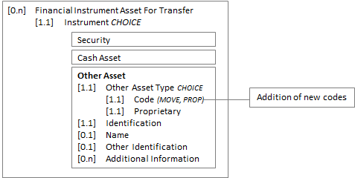
Code list, red shows the new code
 | Code | Code Name | Definition
1 | MOVE | MovableProperty | Property that is not real estate. Also known as 'movable chattels'.
2 | PROP | Property | Property that is real estate.
New 1 | EXI | External Account | Asset is an external investment account.
New 2 | DIMA | Discretionary Account | Asset is a discretionary investment manager account
New 3 | TIPP | Trustee Investment Plan | Asset is a trustee investment plan (TIP)
- Purpose of the change:
Correction. These codes should have been specified in the 2018-2019 maintenance cycle. Additional codes are needed to support the UK transfers market.
- Urgency of the request:
Next maintenance cycle, 2019-2020, in readiness for adoption by the UK users of the ‘old’ versions of the messages
- Business examples:

- SEG/TSG recommendation:
This section is not to be taken care of by the submitter of the change request. It will be completed in due time by the SEG(s) in charge of the related ISO 20022 messages or the TSG for changes related to the BAH.

Consider |  | X | Timing
 |  |  | - Next yearly cycle: 2019/2020  (the change will be considered for implementation in the yearly maintenance cycle which starts in 2019 and completes with the publication of new message versions in the spring of 2020) |  | X
- At the occasion of the next maintenance of the messages
(the change will be considered for implementation, but does not justify maintenance of the messages in its own right – will be pending until more critical change requests are received for the messages)
- Urgent unscheduled
(the change justifies an urgent implementation outside of the normal yearly cycle)
 |  |  | - Other timing:
Comments:

Reject
Reason for rejection:

