Change Request
for the update of ISO 20022 financial repository items
- Origin of the request:
A.1 Submitter: Janice Chapman, on behalf of Funds UK NMPG - UK Electronic Transfer and Re-Registrations Group (UKETRG)
A.2 Contact person: Janice.chapman@swift.com, Helen Scriminger (TeX) consulting@scriminger.com
A.3 Sponsors:
- Related messages:
# | Name | Message Identifier
1 | Account Holding Information Request | sese.019.001.06
2 | Account Holding Information | Sese.018.001.07
3 | Portfolio Transfer Instruction | sese.012.001.09
4 | Portfolio Transfer Confirmation | sese.013.001.09
- Description of the change request:
New codes in the code list for element Portfolio / Tax Efficient Product / Tax Efficient Product Type.
Using sese.012 as the illustration:
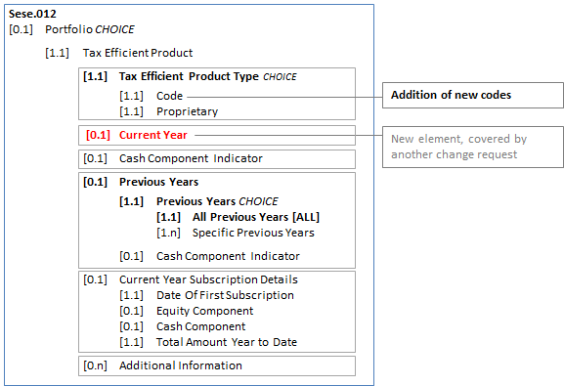
Code list updates
 | Code | Code Name | Current Definition | Proposed Definition
1 | CASH | Cash | Cash individual savings account. In the UK, this is known as a cash ISA. | Not applicable
2 | EQUI | StocksAndShares | Stocks and shares individual savings account. In the UK, this is known as a stocks and shares ISA. | Not applicable
3 | CCTF | CashChildTrustFund | Cash child trust fund individual savings account. In the UK, this is known as a CTF ISA. | Cash child trust fund individual savings account. In the UK, this is known as a cash CTF ISA.
New 1 | SCTF | StocksAndSharesChildTrustFund |  | Stocks and shares child trust fund individual savings account. In the UK, this is known as a stocks and shares CTF ISA
4 | FISA | Flexible | Flexible individual savings account. In the UK, this is known as a FISA. | Not applicable
5 | HISA | HelpToBuy | Help to buy individual savings account. In the UK, this is known as a HISA. | Not applicable
6 | INNF | StocksAndSharesInnovativeFinance | Innovative finance individual savings account. In the UK, this is known as an innovative ISA. | Innovative finance individual savings account. In the UK, this is known as a stocks and shares innovative ISA.
New 2 | CINF | CashInnovativeFinance |  | Innovative finance individual savings account. In the UK, this is known as a cash innovative ISA.
7 | JCSH | JuniorCash | Junior cash individual savings account. In the UK, this is known as a junior cash ISA. | Junior cash individual savings account. In the UK, this is known as a cash JISA.
8 | JISA | JuniorStocksAndSharesISA | Junior stocks and shares individual savings account. In the UK, this is known as an JISA. | Junior stocks and shares individual savings account. In the UK, this is known as a stocks and shares JISA.
9 | LISA | Lifetime | Lifetime individual savings account. In the UK, this is known as a LISA. | Stocks and shares lifetime individual savings account. In the UK, this is known as a Stocks and shares LISA.
New 3 | CLIS | CashLISA |  | Cash lifetime individual savings account. In the UK, this is known as a cash LISA.
10 | SCTF | StocksAndSharesStakeholderChildTrustFund | Stakeholder child trust fund individual savings account. In the UK, this is known as a stakeholder CTF ISA. | Stakeholder child trust fund individual savings account. In the UK, this is known as a stocks and shares stakeholder CTF ISA.
New 4 | CSCT | CashStakeholderChildTrustFund |  | Stakeholder child trust fund individual savings account. In the UK, this is known as a cash stakeholder CTF ISA.
11 | GISK | GeneralInvestmentSavingsAccount | General investment savings account. (Known as Investeringssparkonto (ISK) in some markets.) | Not applicable
12 | GASK | GeneralShareSavingsAccount | General shares or equity savings account. (Known as ASK in some markets.) | Not applicable
To support these different tax efficient products, there may be other elements needed, specifically for LISA and INNF. This information will be available in the coming month.
- Purpose of the change:
Correction. These codes should have been specified in the 2018-2019 maintenance cycle. Additional codes are needed to support the UK transfers market.
- Urgency of the request:
Next maintenance cycle, 2019-2020, in readiness for adoption by the UK users of the ‘old’ versions of the messages
- Business examples:

- SEG/TSG recommendation:
This section is not to be taken care of by the submitter of the change request. It will be completed in due time by the SEG(s) in charge of the related ISO 20022 messages or the TSG for changes related to the BAH.

Consider |  | X | Timing
 |  |  | - Next yearly cycle: 2019/2020  (the change will be considered for implementation in the yearly maintenance cycle which starts in 2019 and completes with the publication of new message versions in the spring of 2020) |  | X
- At the occasion of the next maintenance of the messages
(the change will be considered for implementation, but does not justify maintenance of the messages in its own right – will be pending until more critical change requests are received for the messages)
- Urgent unscheduled
(the change justifies an urgent implementation outside of the normal yearly cycle)
 |  |  | - Other timing:
Comments:

Reject
Reason for rejection:

