Change Request
for the update of ISO 20022 financial repository items
- Origin of the request:
A.1 Submitter: Janice Chapman, on behalf of Funds UK NMPG - UK Electronic Transfer and Re-Registrations Group (UKETRG)
A.2 Contact person: Janice.chapman@swift.com, Helen Scriminger (TeX) consulting@scriminger.com
A.3 Sponsors:
- Related messages:
# | Name | Message Identifier
1 | Account Holding Information | sese.018.001.07
2 | Portfolio Transfer Instruction | sese.012.001.09
3 | Portfolio Transfer Confirmation | sese.013.001.09

- Description of the change request:

[A] sese.018: Addition of ‘Partial Holding Indicator’ at the level of the portfolio.
New optional element, Partial Holding
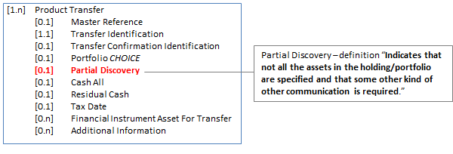
New optional element ‘Partial Holding’
Element | Definition | Data Type
Partial Discovery | Indicates that not all the assets in the holding/portfolio are specified and that some other kind of other communication is required. | YesNoIndicator
[B] sese.012-013: Addition of ‘Instructed Partial Quantity’ at the level of the asset.
Update the definition of Quantity element. New optional element, Instructed Partial Quantity.
[1] Portfolio Transfer Instruction sese.012.001.09:
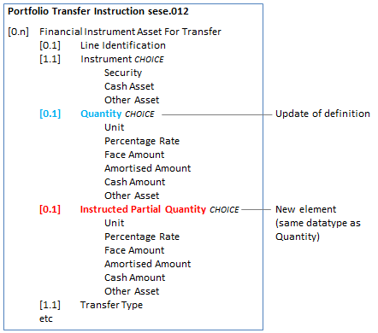
Quantity : definition update
Element | Current Definition | Revised Definition
Quantity | Quantity of asset to be transferred. | Quantity of asset in the holding. If Instructed Partial Quantity is not present then Quantity (when present) is the quantity to be transferred
New optional element ‘Instructed Partial Quantity’
Element | Definition | Data Type
Instructed Partial Quantity | Quantity of asset to be transferred when a partial quantity of the asset is to be transferred | Quantity44Choice (same as Quantity)

[2] Portfolio Transfer Confirmation sese.013.001.09:
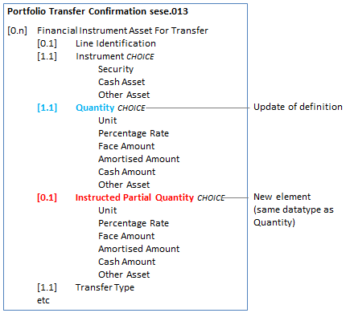
Quantity : definition update
Element | Current Definition | Revised Definition
Quantity | Quantity of asset to be transferred. | Quantity of asset transferred or to be transferred
New optional element ‘Instructed Partial Quantity’
Element | Definition | Data Type
Instructed Partial Quantity | Quantity of asset instructed | Quantity44Choice (same as Quantity)
- Purpose of the change:
Currently, the UK funds market is using an earlier version of the message standard, dating from 2011/2012, of the ISO 20022 investment funds transfers (sese) messages in the SWIFTNet Funds solution. The UK market has been live with an automated solution for both portfolio transfers and the subsequent financial instrument asset transfers for several years
In order for the UK to make this work, there are a number of ‘work-arounds’ (using the text field of the extension sequence) and a number of element misuses. The UK publishes its market practice and message usage guidelines on the MyStandards platform. The work-arounds and element misuses are documented in the message usage guidelines.
Most of the work-arounds have already been solved by the addition of functionality into the messages in the 2018-2019 maintenance cycle.
This particular work-around was discussed in a workshop with the UK EFTRG that took place on 11 January 2018 and at the time, it was agreed this was not necessary, but this was a misunderstanding. More recent analysis work (March 2019) has led to a correct understanding of the functionality required.
In the sese.018 information response, currently, if the response message does not contain all the assets in the holding, this is specified in an Extension (text) sequence – this is functionality missing from the message standard.
In the sese.012 portfolio instruction, currently, the instructed partial quantity is specified in an Extension (text) sequence – this is functionality missing from the message standard.
In sese.013 confirmation, the instructed partial quantity is echoed back. Currently this is specified in an Extension (text sequence) – this is the functionality that is missing from the message standard.

- Urgency of the request:
Next maintenance cycle, 2019-2020, in readiness for adoption by the UK users of the ‘old’ versions of the messages
- Business examples:

- SEG/TSG recommendation:

Consider |  | X | Timing
 |  |  | - Next yearly cycle: 2019/2020  (the change will be considered for implementation in the yearly maintenance cycle which starts in 2019 and completes with the publication of new message versions in the spring of 2020) |  | X
- At the occasion of the next maintenance of the messages
(the change will be considered for implementation, but does not justify maintenance of the messages in its own right – will be pending until more critical change requests are received for the messages)
- Urgent unscheduled
(the change justifies an urgent implementation outside of the normal yearly cycle)
 |  |  | - Other timing:
Comments:

Reject
Reason for rejection:

