Change Request
for the update of ISO 20022 financial repository items
- Origin of the request:
A.1 Submitter: Janice Chapman, on behalf of SMPG IF
A.2 Contact person: Janice.chapman@swift.com
A.3 Sponsors:
- Related messages:
# | Name | Message Identifier
1 | Account Holding Information Request | sese.019.001.06
2 | Account Holding Information | Sese.018.001.07
3 | Portfolio Transfer Instruction | sese.012.001.09
4 | Portfolio Transfer Confirmation | sese.013.001.09
- Description of the change request:
Portfolio Transfer Instruction sese.012 and Portfolio Transfer Confirmation sese.013
The three elements All Other Cash, Cash All and Residual Cash are to updated so a currency can be specified.
Using sese.012 as the example:
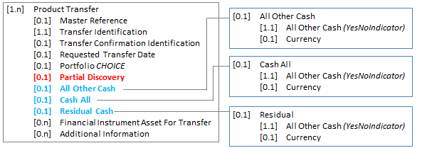

Definitions
All Other Cash
All Other Cash |  | [0.1] | Specifies whether all remaining assets in the portfolio not listed for transfer are to be be/were liquidated and transferred as cash.
 | All Other Cash | [1.1] | Indicator whether all remaining assets in the portfolio not listed for transfer are to be be/were liquidated and transferred as cash. | YesNoIndicator
 | Currency | [0.1] | Currency for the transfer of the cash. | ActiveCurrencyCode

Cash All
Cash All |  | [0.1] | Specifies whether all assets in the portfolio are to be be/were liquidated and transferred as cash.
 | All Other Cash | [1.1] | Indicates whether all assets in the portfolio are to be be/were liquidated and transferred as cash. | YesNoIndicator
 | Currency | [0.1] | Currency for the transfer of the cash. | ActiveCurrencyCode

Residual
Residual Cash |  | [0.1] | Specifies what must be done with cash in the account that is awaiting investment.
 | All Other Cash | [1.1] | Indicates whether the cash in the account that is awaiting investment is to be/was transferred. | YesNoIndicator
 | Currency | [0.1] | Currency for the transfer of the cash. | ActiveCurrencyCode

Account Holding Information Request sese.019 and Account Holding Information sese.018
The elements All Other Cash, Cash All and Residual Cash are to be removed as they are not relevant in these specific messages.
- Purpose of the change:
- The original requirements for the discovery and portfolio messages created in 2005-2007 were based on information from the UK market and all cash is GBP. The messages are now being looked at for use in other markets and when all assets are to be liquidated and transferred as cash, it should be possible to specify the currency of the cash. This also applies to the instructions about what to do with ‘other cash’ and ‘residual cash’.
- Urgency of the request:
Next maintenance cycle, 2019-2020.
- Business examples:

- SEG/TSG recommendation:
This section is not to be taken care of by the submitter of the change request. It will be completed in due time by the SEG(s) in charge of the related ISO 20022 messages or the TSG for changes related to the BAH.

Consider |  | X | Timing
 |  |  | - Next yearly cycle: 2019/2020  (the change will be considered for implementation in the yearly maintenance cycle which starts in 2019 and completes with the publication of new message versions in the spring of 2020) |  | X
- At the occasion of the next maintenance of the messages
(the change will be considered for implementation, but does not justify maintenance of the messages in its own right – will be pending until more critical change requests are received for the messages)
- Urgent unscheduled
(the change justifies an urgent implementation outside of the normal yearly cycle)
 |  |  | - Other timing:
Comments:

Reject
Reason for rejection:

