Change Request
for the update of ISO 20022 financial repository items
- Origin of the request:
A.1 Submitter: Janice Chapman, on behalf of Funds UK NMPG - UK Electronic Transfer and Re-Registrations Group (UKETRG)
A.2 Contact person: Janice.chapman@swift.com, Helen Scriminger (TeX) consulting@scriminger.com
A.3 Sponsors:
- Related messages:
# | Name | Message Identifier
1 | Account Holding Information Request | sese.019.001.06
2 | Account Holding Information | Sese.018.001.07
3 | Portfolio Transfer Instruction | sese.012.001.09
4 | Portfolio Transfer Confirmation | sese.013.001.09
- Description of the change request:
New optional element ‘Current Year’.
[1] sese.018 Account Holding Information
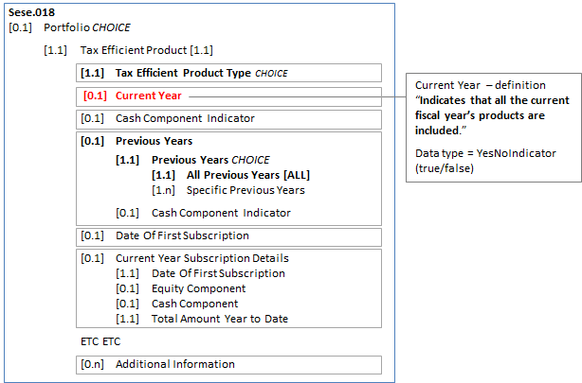
Component to be updated is TaxEfficientProduct2 (sese.013 uses the same component as sese.018).
Definition
Element | Definition | Data Type
Current Year | Indicates that all the current fiscal year’s products are included. | YesNoIndicator
[2] sese.012 Instruction
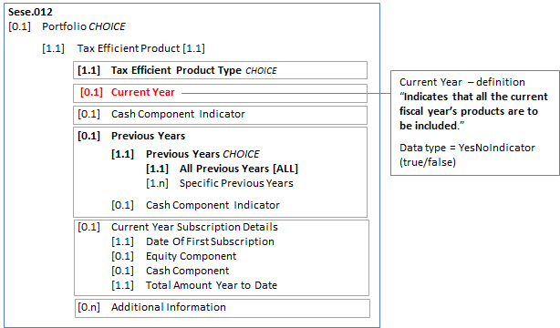
Component to be updated is TaxEfficientProduct3
Definition
Element | Definition | Data Type
Current Year | Indicates that all the current fiscal year’s products are to be included. | YesNoIndicator

[3] sese.013 Confirmation
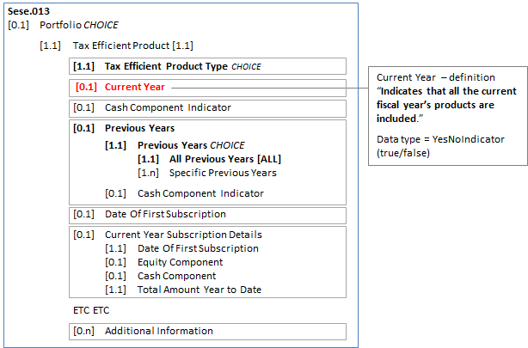
Component to be updated is TaxEfficientProduct2 (sese.013 uses the same component as sese.018).
Definition
Element | Definition | Data Type
Current Year | Indicates that all the current fiscal year’s products are included. | YesNoIndicator
[4] sese.019 Request
Move existing ‘Current Year’ element (alignment) and definition update
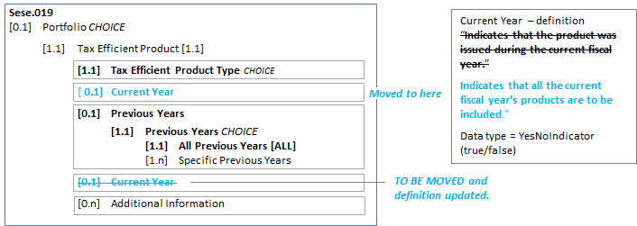
Modification of definition
Element | Current Definition | Revised Definition | Data Type
Current Year | Indicates that the product was issued during the current fiscal year. | Indicates that all the current fiscal year’s products are to be included. | YesNoIndicator
- Purpose of the change:
It should be possible to instruct the transfer of a tax efficient product by saying ‘Current Year’ only. This functionality was possible prior to the 2018-2019 maintenance cycle.
During the 2018-2019 maintenance cycle this item was omitted in error in sese.018, 012 and 013.
This is the correction of an error.
In sese.019, the change is an alignment change, so that the element Current Year appears in the same location in the sequence in all four messages.
- Urgency of the request:
Next maintenance cycle, 2019-2020, in readiness for adoption by the UK users of the ‘old’ versions of the messages
- Business examples:

- SEG/TSG recommendation:
This section is not to be taken care of by the submitter of the change request. It will be completed in due time by the SEG(s) in charge of the related ISO 20022 messages or the TSG for changes related to the BAH.

Consider |  | X | Timing
 |  |  | - Next yearly cycle: 2019/2020  (the change will be considered for implementation in the yearly maintenance cycle which starts in 2019 and completes with the publication of new message versions in the spring of 2020) |  | X
- At the occasion of the next maintenance of the messages
(the change will be considered for implementation, but does not justify maintenance of the messages in its own right – will be pending until more critical change requests are received for the messages)
- Urgent unscheduled
(the change justifies an urgent implementation outside of the normal yearly cycle)
 |  |  | - Other timing:
Comments:

Reject
Reason for rejection:

