Change Request
for the update of ISO 20022 financial repository items
- Origin of the request:
A.1 Submitter:
Payments Canada
A.2 Contact person:
Isak Penttila – ipenttila@payments.ca - +1 613 315 4075
Malene McMahon – mmcmahon@payments.ca - +1 613 315 4991

- Related messages:
camt.048

- Description of the change request:
This change request seeks to change the name and scope description of the camt.048 – ModifyReservation message to also allow for the ability to create as well as modify a reservation. The proposed change would also include the addition of a new component in the message.
Change Name:
From: Modify Reservation
To: Create/Modify Reservation

Change Scope Description:
From: The ModifyReservation message is used to request modifications in the details of one particular reservation set by the member and managed by the transaction administrator.
To: The CreateModifyReservation message is used to create a new reservation, or request modifications in the details of one particular reservation set by the member and managed by the transaction administrator.

Additional elements:
In order to allow the member to provide information regarding a ‘New’ reservation under Reservation Identification a net new component, seen in green below, needs to be created. Currently only ‘Current’ and ‘Default’ is present, see blue below.
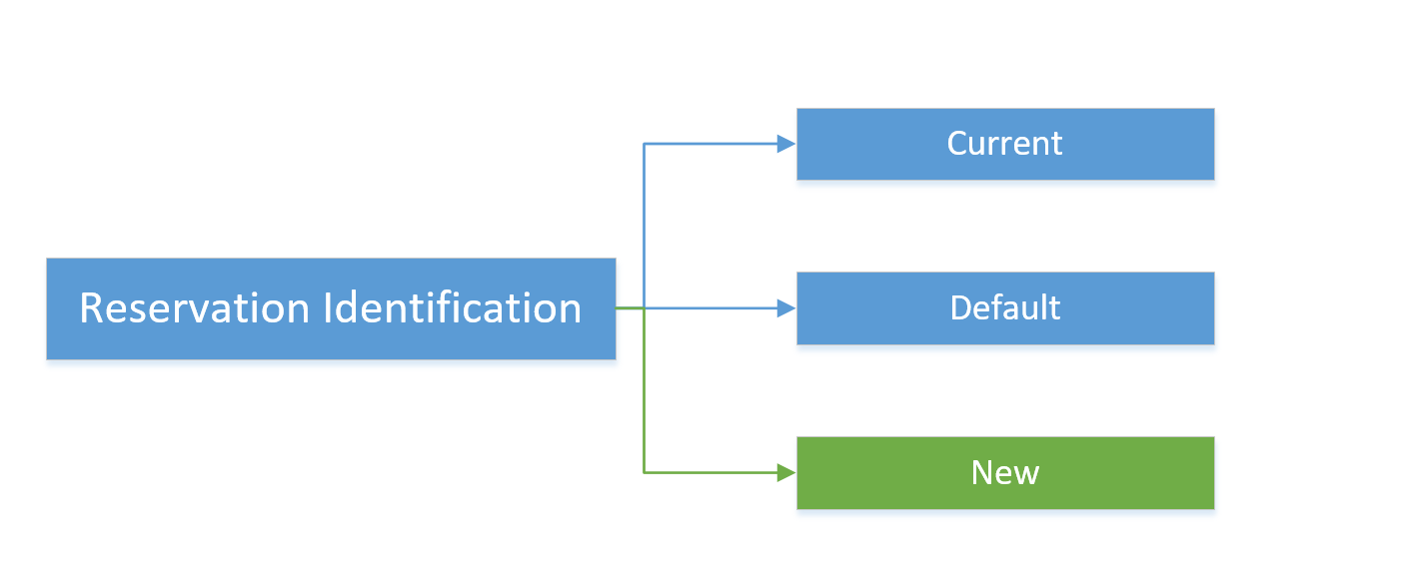
The structure under the ‘New’ component is suggested to be copied from the ‘Current’ component, see below.
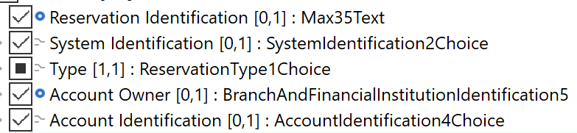

- Purpose of the change:
The current message set allows for the following functions for reservations:
camt.046 – Get Reservation
camt.047 – Return Reservation
camt.048 – Modify Reservation
camt.049 – Delete Reservation
A member can only get, modify and delete an existing reservation, not create a new reservation. The proposed change to the camt.048 would allow for members to request a new reservation to be created by the transaction administrator.

- Urgency of the request:
It is proposed to include this change request in the next regular maintenance cycle.

- Business examples:
/
SEG/TSG recommendation:
This section is not to be taken care of by the submitter of the change request. It will be completed in due time by the SEG(s) in charge of the related ISO 20022 messages or the TSG for changes related to the BAH.

Consider |  | X | Timing
 |  |  | - Next yearly cycle: 2019/2020  (the change will be considered for implementation in the yearly maintenance cycle which starts in 2019 and completes with the publication of new message versions in the spring of 2020) |  | X
- At the occasion of the next maintenance of the messages
(the change will be considered for implementation, but does not justify maintenance of the messages in its own right – will be pending until more critical change requests are received for the messages)
- Urgent unscheduled
(the change justifies an urgent implementation outside of the normal yearly cycle)
 |  |  | - Other timing:
Comments:
Decided during Payments SEG on 1 July 2019

Reject
Reason for rejection:

