Change Request
for the update of ISO 20022 financial repository items
- Origin of the request:
A.1 Submitter:
European Payments Council
Cours Saint Michel 30a
B-1040 Brussels
Belgium

A.2 Contact person:
Christophe Godefroi
Senior Expert, Standards & New Developments
Tel: +32.2.739.16.93
e-mail: Christophe.godefroi@epc-cep.eu

A.3 Sponsors: The payment service provider (PSP) community of SEPA (Single Euro Payments Area)

- Related messages:
camt.029.001.09 – ResolutionOfInvestigation

- Description of the change request:
Include an ‘Agent Account’ under ‘Compensation/Creditor Agent’, ‘Compensation/Debtor Agent’ and under ‘Charges/Agent’, in message building block I “Resolution Related Information” of the camt.029 message, in order to be able to specify the account of the agent to which interest compensation or charges need to be paid.

- Purpose of the change:
The SEPA Credit Transfer (SCT) inquiry process in the 2019 SCT Rulebook stipulates that a Creditor/Beneficiary Bank can request interest compensation from the Debtor/Originator Bank when sending a positive response to a Request to Modify Payment (camt.087). Likewise, a Creditor/Beneficiary Bank when sending a positive response to a Claim Non-Receipt (camt.027) can request the Debtor/Originator Bank to pay some charges for handling the inquiry. The current camt.029 message does not foresee the possibility to include creditor agent account details under ‘Compensation’ or ‘Charges’.

Camt.029
- Under ‘ResolutionRelatedInformation/Compensation/CreditorAgent’, add a new optional element ‘CreditorAgentAccount’, containing the following CashAccount38 sub-elements:
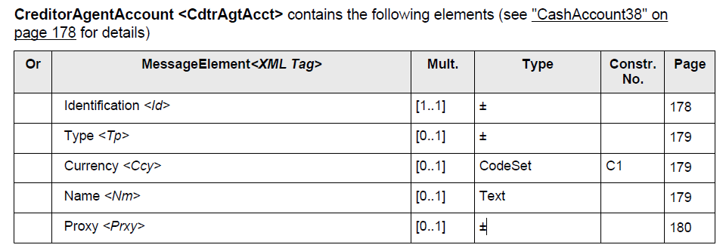
The IBAN of the Creditor/Beneficiary Bank can hence be provided under ‘Identification’:
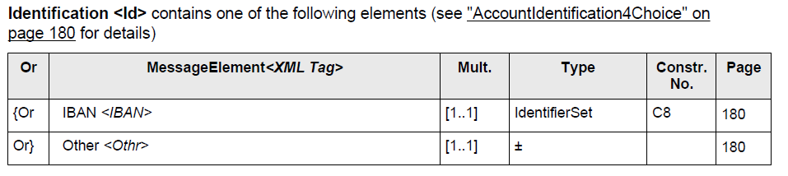
- For the sake of consistency and in order to accommodate all possible future situations (linked for instance with direct debits) a ‘DebtorAgentAccount’ should symmetrically be added under ‘ResolutionRelatedInformation/Compensation/DebtorAgent’.
- Under ‘ResolutionRelatedInformation/Charges/Agent’, add a new optional element ‘AgentAccount’, based on the same CashAccount38 as mentioned above.
- Business example
A credit transfer is made from agent A (the payer’s agent) to agent B (the payee’s agent). Upon a complaint from the payee, the payer requests its agent to ask the payee’s agent for a value date correction.
A request for value date correction (camt.087 RequestToModify) is then sent from agent A to agent B. Agent B agrees to perform the value date correction but subject to receiving interest compensation from agent A.
When answering to the request (camt.029 ResolutionOfInvestigation), agent B indicates the amount of the compensation as well as the account on which this needs to be paid.
Upon receipt of the answer, agent A transfers the compensation amount to agent B, for example through a pacs.008.

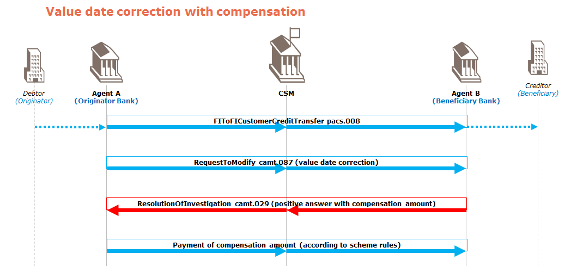

- Urgency of the request:
Inclusion of the updated version of the camt.029 message in the 2019/2020 release of ISO 20022.
- SEG/TSG recommendation:
This section is not to be taken care of by the submitter of the change request. It will be completed in due time by the SEG(s) in charge of the related ISO 20022 messages or the TSG for changes related to the BAH.

Consider |  | X | Timing
 |  |  | - Next yearly cycle: 2019/2020  (the change will be considered for implementation in the yearly maintenance cycle which starts in 2019 and completes with the publication of new message versions in the spring of 2020) |  | X
- At the occasion of the next maintenance of the messages
(the change will be considered for implementation, but does not justify maintenance of the messages in its own right – will be pending until more critical change requests are received for the messages)
- Urgent unscheduled
(the change justifies an urgent implementation outside of the normal yearly cycle)
 |  |  | - Other timing:
Comments:
Decided during Payments SEG on 1 July 2019

Reject
Reason for rejection:

