Change Request
for the update of ISO 20022 financial repository items
- Origin of the request:
A.1 Submitter:
SWIFT

A.2 Contact person:
Mrs Evelyne Piron – evelyne.piron@swift.com

- Related messages:
camt.029 – ResolutionOfInvestigation

- Description of the change request:
For the maintenance 2018, a change request was submitted by the EPC for the addition of elements to cater for the Claim Non Receipt process.
Extract from maintenance 2018 Change Request:
“The EPC 2017 SCT Rulebook v1.0 requires that the Request to Modify Payment message (camt.087) and the ResolutionOfInvestigation (camt.029) and the ClaimNonReceipt (camt.027) contain the complete set of information transported in the underlying payment instruction that is being modified.
Additionally, the camt.029 which must confirm or reject the Request to Modify Payment must also transport compensation and charges information which are currently missing.”
The Change request was approved and the required elements were added in the aforementioned messages.
In the camt.029, we had to add the element “ClaimNonReceiptDetails” as shown below:
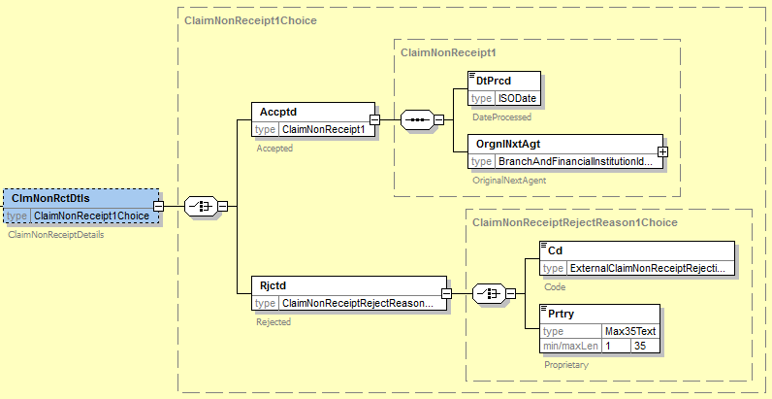
The element OriginalNextAgent has been added as a mandatory element as wrongly indicated in the CR when it should have been added as an optional.

- Purpose of the change:
Correction to be done after changes implemented for maintenance 2018.

- Urgency of the request:
Next release

- Business examples:
N/A

- SEG/TSG recommendation:

Consider | X | Timing
 |  | - Next yearly cycle: 2018/2019  (the change will be considered for implementation in the yearly maintenance cycle which starts in 2018 and completes with the publication of new message versions in the spring of 2019) |  | X
- At the occasion of the next maintenance of the messages
(the change will be considered for implementation, but does not justify maintenance of the messages in its own right – will be pending until more critical change requests are received for the messages)
- Urgent unscheduled
(the change justifies an urgent implementation outside of the normal yearly cycle)
 |  | - Other timing:

Comments:

Reject
Reason for rejection:

