Change Request
for the update of ISO 20022 financial repository items
- Origin of the request:
A.1 Submitter:
SWIFT (SWIFT gpi)
A.2 Contact person:
Dominique Forceville/SWIFT/ +32.2.655.49.48
A.3 Sponsors:
- Related messages:
pain.002.001.09

- Description of the change request:
Context:
Today, the pain.002 is used by Debtor Agents to report status updates related to their corporate customers’ pain.001 payment initiations. Those updates are usually limited to the internal processing of the payment at the Debtor Agents’ side (accept/reject).
SWIFT gpi introduced ‘end-to-end’ interbank payments tracking allowing involved parties to receive regular updates during the life cycle of the payment transaction. These updates provide information about ‘amount transferred or credited’, ‘date & time of transfer or credit’, ‘location’, ‘status’, ‘charge bearer’, ‘deducts’, and FX information’. Each update also includes a historic overview of the information available until the point in time the update is provided.
The new elements that are subject of this request have already been introduced in the currently used version of the pain.002 (pain.002.001.03) via workarounds. CGI MP and an ISO expert group (of gpi banks/corporates) that SWIFT founded have approved these workarounds for version 3.
This change request is targeted to enhance the current pain.002.001.09 (and to go to version 10) allowing Debtor Agents to use it to convey the “interbank status information” (that they receive from the SWIFT gpi Tracker) to their corporate customer via “structured fields”.
Depending on the use case, for one specific gpi payment transaction, Debtor Agents may receive several updates from the Tracker and as such Debtor Agents may send several pain.002 messages to their corporate customers at different moments in time.

Status updates to the corporate customers with a pain.002 should include information about:
- the status & status reason,
- the status originator,
- the date/time when the confirmation to the SWIFT gpi Tracker was generated by the status originator, or the date/time when the creditor was credited and could use the funds (as confirmed by the status originator to the SWIFT gpi Tracker)
- the cash amount transferred in the interbank space (which can change in every leg) or cash amount credited on the creditor’s account,
- the instructed amount,
- the charge bearer (DEBT, CRED, SHAR),
- the deducted charges per involved agent,
- the FX related details (if FX occurred).
Some of the above elements (status/reason, status originator and instructed amount) are existing elements in the pain.002. The other elements currently do not exist in the pain.002 and are therefore subject of this change request.
CHANGE 1: Inclusion of new element ‘Confirmed Date and Time’

Element Name | Element Definition | Multiplicity | DataType | Proposed Location
Confirmed Date and Time  Tag: ConfdDtTm | - Point in time¹ when an agent provides a pending status update to the tracking system  - Point in time² when the creditor has been credited and can use the funds (as confirmed to the tracking system by the creditor agent). | [0..1] | ISO date and time | Level 3, in ‘Transaction Information and Status’ after ‘Status Reason Information’
¹‘Creation Date and Time’ in the Group Header cannot be used as it is the Date and Time when the pain.002 was created. The Date and Time that is to be reflected here is the date and time when the status originator provided a status update to the tracking system.
²‘Interbank Settlement Date’ in ‘Original Transaction Reference’ cannot be used as it is the possibly different from the date (and time) the funds were credited on the creditor’s account. Interbank Settlement Date is also lacking the ‘Time’ element.
CHANGE 2: Inclusion of new element ‘Confirmed Amount’

Element Name | Element Definition | Multiplicity | DataType | Proposed Location
Confirmed Amount¹  Tag: ConfdAmt | Amount confirmed to the tracking system by the agent. For example: Amount credited on the creditor’s account (after possible deducts) | [0..1] | ActiveCurrencyAndAmount | Level 3, in ‘Transaction Information and Status’ after ‘Status Reason Information’
¹‘Interbank Settlement Amount’ in the Original Transaction Reference cannot be used for the following reasons:
a. ‘Interbank Settlement Amount’ reflects the amount exchanged in the pacs.008 with the Creditor Agent. The amount that needs to be reflected here in ‘Confirmed Amount’ is the credited amount, confirmed to the tracking system by the Creditor Agent, after possible deducts.
b. ‘Confirmed Amount’ is also provided by the Tracker to inform about the amount that is transferred through the transaction chain. This amount could be equal to the ‘Interbank Settlement Amount’ but not in all cases.

CHANGE 3: Inclusion of new element ‘Interbank Transaction Information’.

Element Name | Element Definition | Multiplicity | DataType | Proposed Location
Interbank Transaction Information  Tag: IntrBkTxnInf | Provides chronological interbank transaction information per agent involved in the transaction chain. | [0..1] | Includes further element (see below) | Level 3, in ‘Transaction Information and Status’ after ‘Status Reason Information’

Element included in ‘Interbank Transaction Information’

Element Name | Element Definition | Multiplicity | DataType | Proposed Location
TrackedAgent  Tag: TrckdAgt | Provides transaction information for specific agent involved in the transaction chain. | [1..n] | Includes other elements (see below) | Level 4, in ‘Interbank Transaction Information’

Elements included in ‘TrackedAgent’

Element Name | Element Definition | Multiplicity | DataType | Proposed Location
Agent  Tag: Agt | Identification of a financial institution. | [1..1] | BranchAndFinancialInstitutionIdentification5 | Level 5, in ‘TrackedAgent’
Charge Bearer  Tag: ChrgBr | Specifies which party/parties bears the charges associated with the processing of the payment transaction. | [0..1] | ChargeBearerType1Code  (DEBT, CRED, SHAR) | Level 5, in ‘TrackedAgent’
ChargesInformation¹  Tag: ChrgsInf | Provides information on the charges to be paid by the charge bearer(s) related to the payment transaction. | [0..1] | Charges2 without the ‘Agent’ part. | Level 5, in ‘TrackedAgent’
ForeignExchangeDetails  Tag: FXDtls | Specifies the exchange rate details between two currencies. | [0..1] | Structure including: Source Currency, Target Currency, Exchange Rate and Unit Currency. | Level 5, in ‘TrackedAgent’
¹The existing element ‘Charges Information’ cannot be used as the definition clearly indicates that it is exclusively used in ‘reject use cases’. The ‘Charges Information’ inside the new ‘Interbank Transaction Information/Tracked Agent’ reflects the ‘deduct’ that a particular agent has performed on its leg of the payment transaction.

Schema (just provided for clarity and as such xml tags have not been used)
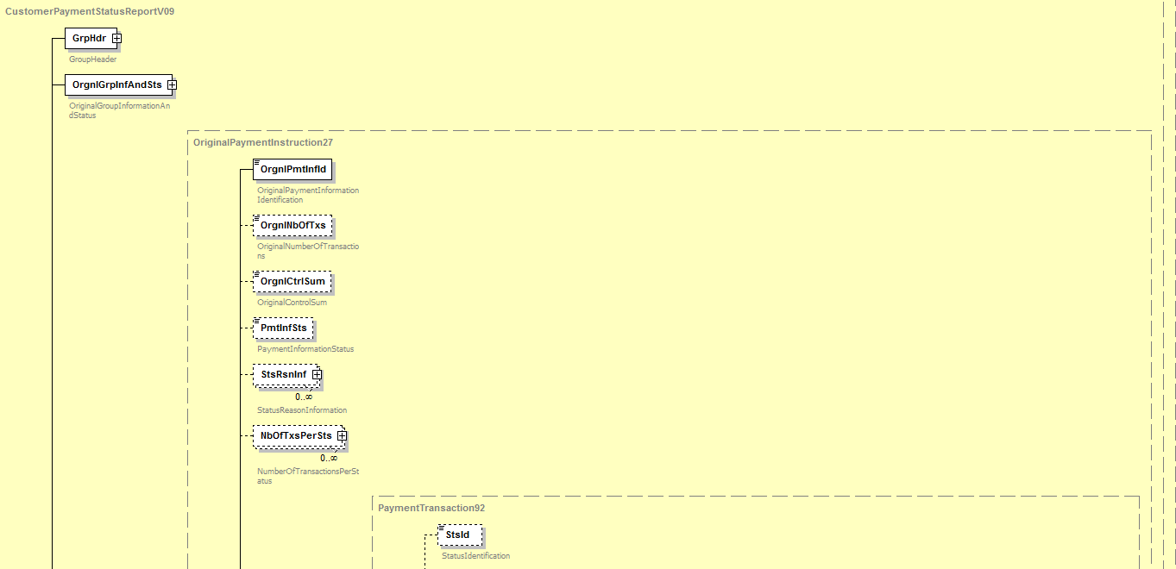
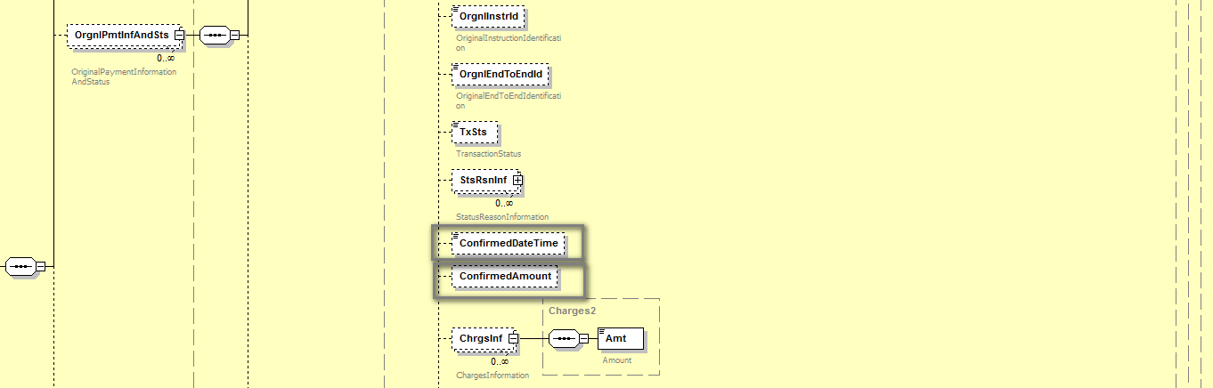
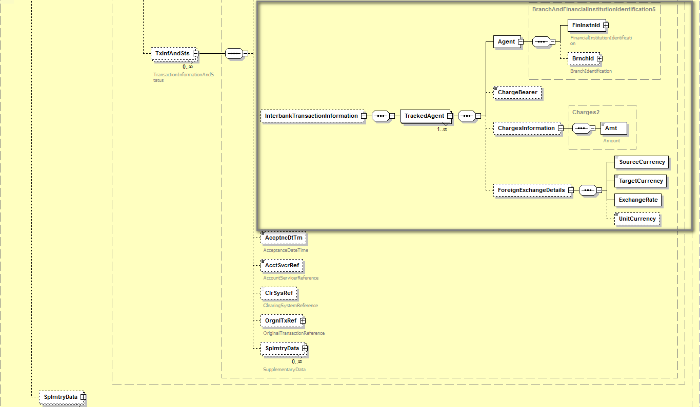

- Purpose of the change:
Enhance the pain.002 to allow (multi-banked) corporates to benefit from “standardization” of ISO bank-to-corporate flows for tracking and confirmation of payments in corporate back-office systems. These flows should be automated and fully integrated in ERP and TMS systems.

- Urgency of the request: SR2019
- Business examples:
Business example:
Business example based on gpi customer payment transaction denominated in USD with Interbank Settlement Date 23 June 2018, involving a corporate (debtor) CORPBEBB and three gpi banks (BANABEBB is the Debtor Agent, BANBUS33 is the Intermediary Agent and BANCFRPP is the Creditor Agent). The Debtor Agent receives two Tracker updates (at different times) regarding this transaction and provides its corporate with two separate pain.002 messages.
Details of first pain.002:
Status: The transaction is confirmed as “received” by creditor agent, but the creditor agent has not confirmed the credit on the creditor’s account (yet).
Instructed amount: 1000 USD
Confirmed amount: 970 USD
Charge bearer: CRED.
Charge information: first gpi bank (deduct: 20 USD), second gpi bank (deduct: 10 USD). No deduct by third bank yet as payment is only “received” by third bank).
Confirmed Date and time: Date and Time when Tracker was updated (that is when the Tracker got acknowledgement that the payment was received at the Creditor Agent): 2018-06-23 at 09:30:11 (UTC)
Creation Date and time: Date and Time when BANABEBB (as Debtor Agent) produced the pain.002 and sent it to its corporate customer: 2018-06-23 at 09:35:00 (UTC)
FX: N/A

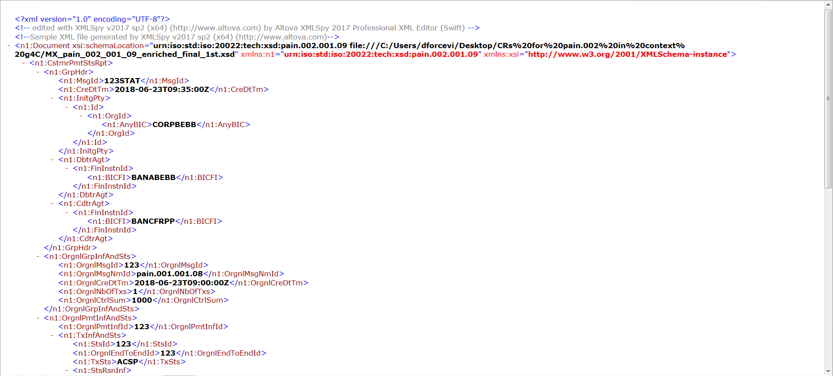
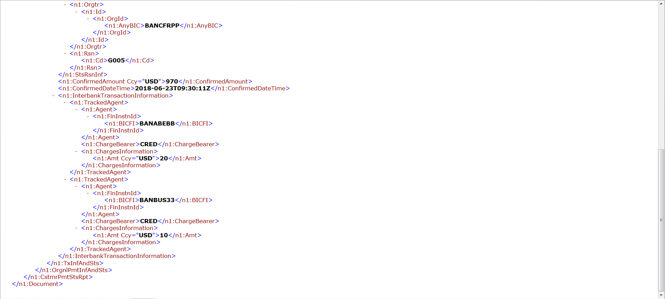
Details of second pain.002:
Status: The Creditor Agent confirmed credit to the creditor’s account.
Instructed amount: 1000 USD
Confirmed amount: 965 USD
Charge bearer: CRED.
Charge information: first gpi bank (deduct: 20 USD), second gpi bank (deduct: 10 USD) and third gpi bank (deduct: 5 USD).
Confirmed Date and time: Date and Time confirmed by the Creditor Agent when the creditor account was credited and Creditor could use the funds. 2018-06-23 at 11:35:27 (UTC)
Creation Date and time: Date and Time when BANABEBB (as Debtor Agent) produced the pain.002 and sent it to its corporate customer: 2018-06-23 at 11:40:00 (UTC)

FX: N/A

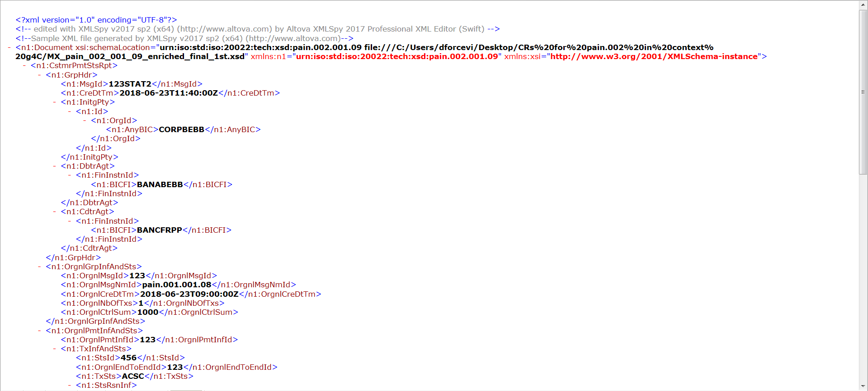
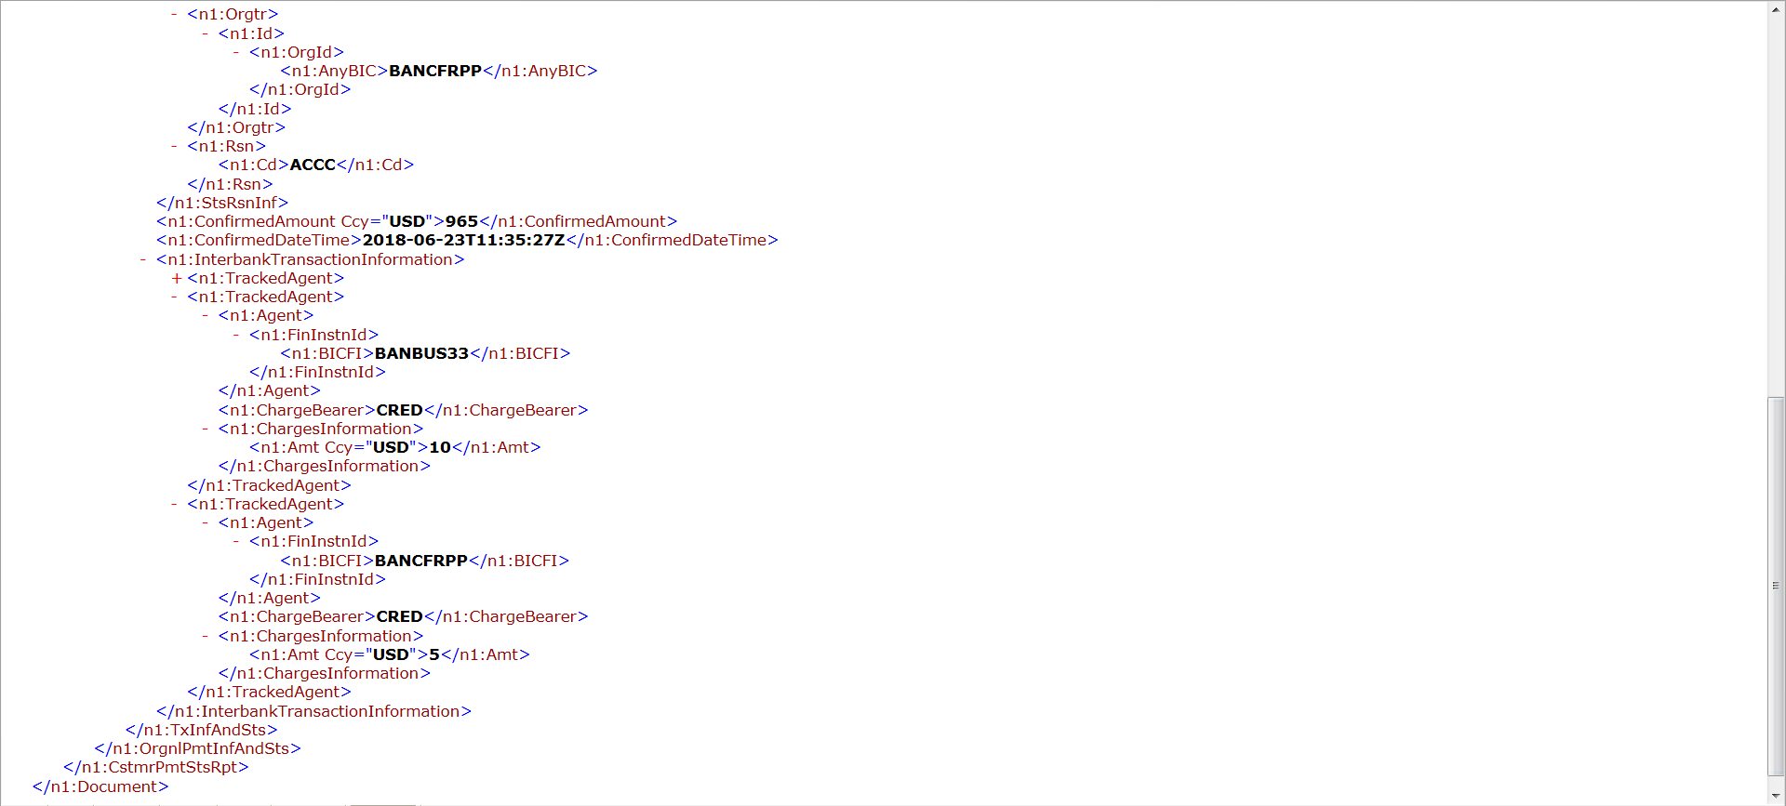

- SEG/TSG recommendation:

Consider |  | X | Timing
 |  |  | - Next yearly cycle: 2018/2019  (the change will be considered for implementation in the yearly maintenance cycle which starts in 2018 and completes with the publication of new message versions in the spring of 2019) |  | X
- At the occasion of the next maintenance of the messages
(the change will be considered for implementation, but does not justify maintenance of the messages in its own right – will be pending until more critical change requests are received for the messages)
- Urgent unscheduled
(the change justifies an urgent implementation outside of the normal yearly cycle)
 |  |  | - Other timing:
Comments:

Reject
Reason for rejection:

