Change Request
for the update of ISO 20022 financial repository items
- Origin of the request:
A.1 Submitter: The New Payment System Operator (NPSO) United Kingdom
A.2 Contact person(s): Helen Bygrave helen.bygrave@newpso.uk +44 (0)20 3217 8398
James Whittle, Director, International Standards and Services james.whittle@newpso.uk +44 (0)20 3217 8209
A.3 Sponsors: Bank of England Real Time Gross Settlement (RTGS) Renewal Programme
Neil Pearston, Analyst, neil.pearston@bankofengland.co.uk + 44 (0) 20 3461 4893

- Related messages:
pacs.002.001.09 - FIToFIPaymentStatusReportV09
pacs.003.001.07 – FIToFICustomerDirectDebitV07
pacs.004.001.08 - PaymentReturnV08
pacs.007.001.08 - FIToFIPaymentReversalV08
pacs.008.001.07 - FIToFICustomerCreditTransferV07
pacs.009.001.07 - FinancialInstitutionCreditTransferV07
pacs.010.001.02 - FinancialInstitutionDirectDebitV02
pacs.028.001.02 - FIToFIPaymentStatusRequestV02

pain.001.001.08 - CustomerCreditTransferInitiationV08
pain.002.001.09 - CustomerPaymentStatusReportV09
pain.007.001.08 - CustomerPaymentReversalV08
pain.008.001.07 - CustomerDirectDebitInitiationV07

camt.052.001.07 - BankToCustomerAccountReportV07
camt.053.001.07 - BankToCustomerStatementV07
camt.054.001.07 - BankToCustomerDebitCreditNotificationV07
camt.056.001.07 - FIToFIPaymentCancellationRequestV07
camt.060.001.04 - AccountReportingRequestV04
- Description of the change request:
For Debtor and Creditor account introduce an optional field to reference an alias for the account. Create a new external code list to record valid alias identification schemes.

Original proposal:
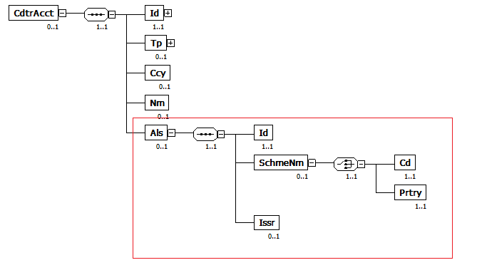
New proposal:
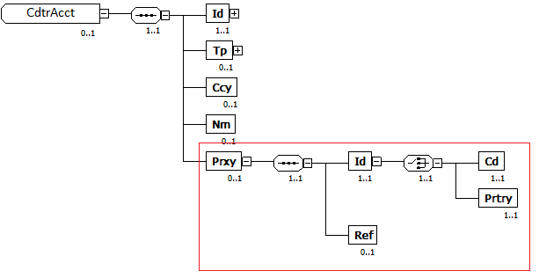
- Purpose of the change:
With the introduction of additional ways of identifying an account, such as mobile phone number, used by PAYM in the UK, and other person to person mobile payments currently being investigated in Europe, there is a need to provide an alias to an account to carry this information. Such an alias is required to be carried throughout the payment chain to identify both the underlying true account and how the account was identified.
An account alias may not always be personal to the account holder. For example, it may in the future, be linked to the International Mobile Equipment Identity (IMEI) number of their mobile phone or even to a retailer’s point of sale terminal. Because of this, we feel that this information should be carried with the account details rather than the account owner’s details.
Crucially the account alias will allow payments to be initiated and processed without the involved parties actually knowing the underlying bank account numbers, which for the purposes of clearing and settlement are essential.
It may not be the alias itself that is carried in the message but rather a reference to that alias thus protecting the underlying information. For example credit card PANs could be tokenised so that these numbers no longer have to be carried as references.

- Urgency of the request:
It is proposed to include this change request in the next regular maintenance cycle.

- Business examples:

An IMEI is directly used as an alias to reference the account.
<CdtrAcct>
<Id>
<IBAN> DE89 3704 0044 0532 0130 00</IBAN>
</Id>
<Tp>
<Cd>CACC</Cd>
</Tp>
<Ccy>EUR</Ccy>
<Als>
<Id>990000862471854</Id>
<SchmeNm>
<Cd>IMEI</Cd>
</SchmeNm>
</Als>
</CdtrAcct>

An underlying reference to an alias is used to reference the account.
<CdtrAcct>
<Id>
<IBAN>FR14 2004 1010 0505 0001 3M02 606</IBAN>
</Id>
<Tp>
<Cd>CACC</Cd>
</Tp>
<Ccy>EUR</Ccy>
<Als>
<Id>ALRF1234567890</Id>
<SchmeNm>
<Cd>ALRF</Cd>
</SchmeNm>
</Als>
</CdtrAcct>

A point of sale terminal ID is used as an alias to reference the account.
<CdtrAcct>
<Id>
<Other>
<Id>12345678</Id>
</Other>
</Id>
<Tp>
<Cd>CACC</Cd>
</Tp>
<Ccy>GBP</Ccy>
<Als>
<Id> POS_ID_123456789</Id>
<SchmeNm>
<Cd>POST</Cd>
</SchmeNm>
</Als>
</CdtrAcct>
- SEG/TSG recommendation:

Consider |  | X | Timing
 |  |  | - Next yearly cycle: 2018/2019  (the change will be considered for implementation in the yearly maintenance cycle which starts in 2018 and completes with the publication of new message versions in the spring of 2019) |  | X
- At the occasion of the next maintenance of the messages
(the change will be considered for implementation, but does not justify maintenance of the messages in its own right – will be pending until more critical change requests are received for the messages)
- Urgent unscheduled
(the change justifies an urgent implementation outside of the normal yearly cycle)
 |  |  | - Other timing:
Comments: Decision made at the Payments SEG meeting on July 9th, 2018.

Reject
Reason for rejection:

